3D printing in Endodontics
Dr. Abdullah AlFadda, BDS, KSU, SA

Abstract:

It is well known that we view X- and Y-planes when we view images generated using digital X-rays. Now, let's embrace the third dimension that is capable of dramatically improving diagnostic interpretations and treatment planning. The aim of this lecture is to describe how endodontic therapy can be achieved by using static and dynamic navigation for complex root canal treatments.

Objectives:
1- Navigation in Dentistry
2- Digital Impression Systems, CAD/CAM, and STL file
3- 3D Printing in Endodontics
4- Static Guided Nonsurgical Approach for Calcified Canals of Anterior Teeth
Image
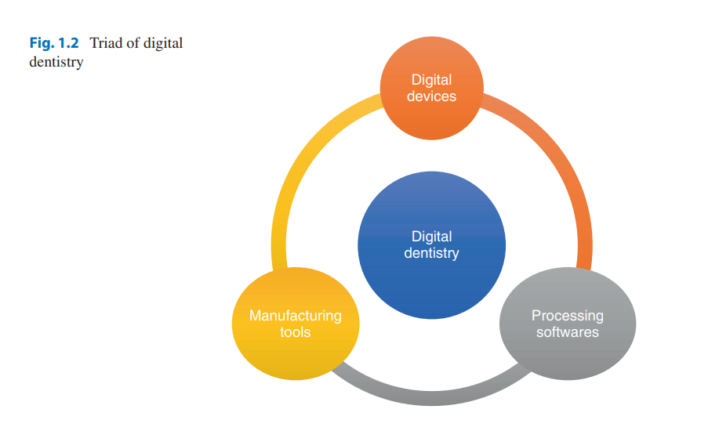
Recent Publications:
- Alqahtani, A., T. Comparison of Marginal Integrity and Surface Roughness of Selective Laser Melting, CAD-CAM and Digital Light Processing Manufactured Co-Cr Alloy Copings. Appl. Sci. 2021, 11, 8328.
- Al-Hamdan, K., Accuracy of Implant Placement Utilizing 3D Printed and Thermoplastic Surgical Guides: A CBCT-Analysis. Biosc.Biotech.Res.Comm. Vol 13 (3) July-Aug-Sep 2020 Pp-1210-1213

Biography:

Dr. Alfadda was born and raised in Riyadh, the capital of Saudi Arabia. He graduated with second class Honors and earned his Bachelor of Dental Surgery (BDS) degree at King Saud University, Collage of Dentistry. Dr. Alfadda enjoys all kinds of art, and considers Endodontics as one he’s very passionate about, which led him to pursue advanced training at King Abdulaziz Medical City. In his free time, he loves to explore new developments in Digital Dentistry and Virtual Planning.

Email: alfadda35@gmail.com

