EFFECT OF DIFFERENT IMPLANT NUMBERS AND LOCATIONS ON STRAINS AROUND IMPLANTS RETAINING MANDIBULAR OVERDENTURES WITH LOCATOR ATTACHMENTS.
AN INVITRO STRAIN GAUGE ANALYSIS

Dr Mona Galal ,PHD , Lecturer of Prosthodontics , Faculty of Dentistry, Modern University of Technology and Information , Egypt

*Abstract* (300 word limit)
ABSTRACT
Aim: This in vitro study was performed to evaluate the effect of different implant numbers and locations on strains around implants retaining mandibular overdentures with locator attachments.
Materials and methods: Five implants were inserted in the interforaminal area of mandibular edentulous acrylic model in the following locations; 1) one in midline areas, 2 in canine areas and 2 in premolar areas. Locator attachments were used to connect mandibular experimental overdentures (n=5) to the implants. Two linear strain gauges were bonded at buccal and lingual surface of each implant. According to the implant number and location of the implants, the strain was measured (during unilateral and bilateral loading) using the following implant overdenture designs: Group 1: strains were measured around mid-line implant only, while the other locator attachments were disconnected. Group 2: strains were measured around the 2 canine implants only. Group 3: strains were measured around the 2 premolar implants only, Group 4: strains were measured around the midline and the 2 canine implants only, Group 5: strains were measured around the midline and the 2 premolar implants only.
Results: For midline implants during bilateral and unilateral loading, the highest strains were noted with group 1 and group 5, and the lowest strain was noted with group 4. For distal implants during bilateral loading, the highest to the lowest were group 3> group 2> group 4> group 5. For distal implants on the loading and non-loading sides during unilateral loading, the highest to the lowest were group 3> group 2> group 5> group 4. For group, 4 and 5, midline implants recorded the highest strain, then distal implants on the loading sides, and the lowest strains were observed on the distal implants of the non-loading sides.

Image
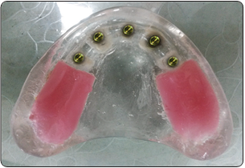

Locator abutments screwed to the implants on the model
*Recent Publications (minimum 5)
- Aboelez MA, Elezz MGA, Abdraboh AE, Elsyad MA. Angled ball and locator attachments for immediate loaded inclined implants used to retain maxillary overdentures: A cross over study of patient satisfaction andoral health related quality of life. Clin Implant Dent Relat Res.2022;1‐10. doi:10.1111/cid.13089
http://wileyonlinelibrary.com/journal/cid
- Mona Galal Abo El-Ezz, EFFECT OF DIFFERENT IMPLANT NUMBERS AND LOCATIONS ON STRAINS AROUND IMPLANTS RETAINING MANDIBULAR OVERDENTURES WITH LOCATOR ATTACHMENTS. AN INVITRO STRAIN GAUGE ANALYSIS, EDJ,Vol.68 ,No.3
http://www.eda-egypt.org
- Mona Galal Mahmoud ¹ (2019) RADIOGRAPHIC EVALUATION OF TRABECULAR METAL DENTAL IMPLANT (TANTLUM) IN IMPLANT RETAINED MADIBULAR OVER DENTURE CASES”. Ain Shams university journal .

- Mona Galal Mahmoud ¹ (2013) RADIOGRAPHIC EVALUATION OF thermoelastic resin on supporting structures of abutment teeh in bounded partial dentures . Ain Shams university journal .

Photograph
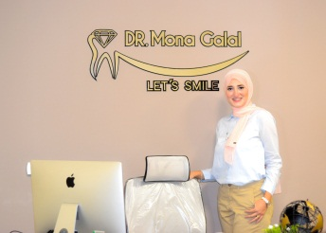

Biography* (150 word limit)
DR. MONA GALAL, an Ain Shams University graduate in 2006, a PHD degree holder in Prosthesis and Dental Implants from Ain Shams University since 2019, a current lecturer of prosthodontics at MTI University, and the founder of Diamond Clinic, ranks among Cairo’s top dentists, and her clinic is widely regarded as one of the best. Dr. Mona has been treating satisfied clients, creating countless smiles, and leading an expert team at her prestigious clinic for over 16 years
*Email: dr.mona21@hotmail.com
*Phone No: (+201006721782___) ____ ____
*Whatsapp no: (_+2 01006721782__) ____ ____
LinkedIn Account Id:dr.mona21@hotmail.com

Notes/Comments:

