Immunohistochemical Based Study on Frequency of HPV in Oral Squamous Cell Carcinoma Biopsies of Iraqi Kurdistan Patients

1- Dr Aween Auda Ablahad, BDS. M.Sc. (Oral pathology.) Department of
Oral and Maxillofacial surgery, College of Dentistry, University of Duhok, Duhok, Iraq
2- Dr. Hashim Dawood Mousa, BDS. M.Sc. PhD (Periodontics) Department of Periodontology and Oral Medicine, College of Dentistry, University of Duhok, Duhok, Iraq
3- Dr. Jalal Ali Jalal MBChB, M.Sc., FIBMS (Pathology) Department of Basic sciences/ Pathology, College of Medicine, Hawler Medical University, Erbil, Iraq

Abstract:
Introduction: Implication of human papilloma virus (HPV) in the carcinogenesis of oral squamous cell carcinoma (OSCC) is debatable subject, p16 overexpression indicates active HPV infection in oropharyngeal squamous cell carcinoma (OPSCC) but in OSCC such relation still needs to be studied. Therefore, we aimed to evaluate the frequency of HPV in OSCC patients in the capital of Kurdistan region of Iraq and its concordance with p16 overexpression. We retrieved Eighty-six formalin-fixed paraffin-embedded (FFPE) samples of OSCC from multi large pathological centers that located in the capital of Kurdistan, we utilized immunohistochemistry (IHC) to detect the HPV by anti-HPV high risk antibody correlated it with p16 overexpression, besides, twenty FFPE samples of healthy gingiva were used as control in this study. Chi square and Fisher’s exact tests were used for correlating the HPV status and p16 overexpression with clinicopathogical patient’s data. The concordance between HPV and p16 overexpression was evaluated by kappa agreement and spearman rank correlation. The frequency of HPV in OSCC patients were 15.1%, tongue was the most common site affected by HPV infection, other patient data including age, gender, grade and stage did not show significant correlation with neither anti-HPV nor P16 antibodies. The concordance level between p16 overexpression and the HPV status according to kappa agreement was (κ = 0.221, p= 0.034), Moreover, the correlation according to spearman correlation coefficient was (r = 0.229, p= 0.034), with 46.15% sensitivity and 80.82% specificity. We concluded that HPV infection is still low in Erbil and p16 biomarker has only diminutive significance as a predictor of HPV infection in the OSCC patients.

Keywords: Human papilloma virus, p16, oral squamous cell carcinoma.

Images:

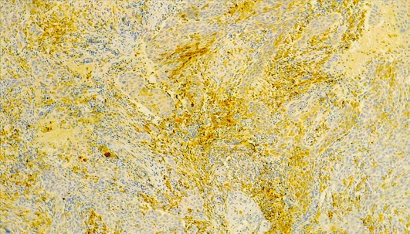

Figure. 1. Representative photomicrographs of positive anti-HPV expression in oral squamous cell carcinoma (x100 )

Recent Publications:
1- Benzerdjeb N, Tantot J, Blanchet C, Philouze P, Mekki Y, Lopez J, Devouassoux‐Shisheboran M (2021). Oropharyngeal squamous cell carcinoma: p16/p53 immunohistochemistry as a strong predictor of HPV tumour status. Histopathology.79(3):381-90. https://doi.org/10.1111/his.14350
2- de C. Ferreira C, Dufloth R, de Carvalho AC, Reis RM, Santana I, Carvalho RS, Gama RR (2021). Correlation of p16 immunohistochemistry with clinical and epidemiological features in oropharyngeal squamous-cell carcinoma. Plos one. 16(6): e0253418.
https://doi.org/10.1371/journal.pone.0253418
3- Jiromaru R, Yamamoto H, Yasumatsu R, Hongo T, Nozaki Y, Nakano T, Hashimoto K, Nakagawa T, Oda Y (2021). p16 overexpression and Rb loss correlate with high‐risk HPV infection in oropharyngeal squamous cell carcinoma. Histopathology. 79(3):358-69.
https://doi.org/10.1111/his.14337
4- de Lima MA, Cavalcante RB, da Silva CG, Nogueira RL, Macedo GE, de Galiza LE, Pinheiro JV, Maia Filho PH, Santos SF, Rabenhorst SH (2022). Evaluation of HPV and EBV in OSCC and the expression of p53, p16, E‐cadherin, COX‐2, MYC, and MLH1. Oral Diseases.28(4):1104-22.
https://doi.org/10.1111/odi.13814
5- Burassakarn A, Phusingha P, Yugawa T, Noguchi K, Ekalaksananan T, Vatanasapt P, Kiyono T, Pientong C (2022). Human Papillomavirus 16 E6 Suppresses Transporter Associated with Antigen-Processing Complex in Human Tongue Keratinocyte Cells by Activating Lymphotoxin Pathway. Cancers.14(8):1944.; https://doi.org/10.3390/cancers14081944

Photograph

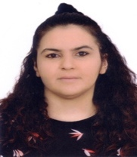 Biography*

Aween Auda Ablahad is a dentist and oral and maxillofacial pathology specialist, graduated from University of Mosul in 2009 with a bachelor degree. She earned her master degree in oral and maxillofacial pathology from college of dentistry/Hawler Medical University in 2016 and now she is a PhD candidate in the same specialty, she has her own private dental clinic from 2013 till now, she is a lecturer and a member in college of dentistry/ University of Duhok/ Iraq.

Email: aween.ablahad@uod.ac
Phone No: (00964) 7501916650
Whats app no: (00964) 7501916650

Notes/Comments:

