International Dental Conference Dubai 2022
Abstract:
Statement of the problem: Anterior disc displacement of the temporomandibular joint is one of the most frequent temporomandibular joint (TMJ) disorders, which often results in clicking, joint pain, a limited range of motion and masticatory difficulties.Methodology: Patients who had significant pain and dysfunction that did not respond to non-surgical therapy went into arthroscopic disc repositioning using wire fixation for 3 weeks then it was removed, and the patient continued on occlusal splints postoperatively.Findings: After six months postoperatively, there was a significant increase in the MIO (Maximum incisal opening) and an insignificant decrease in the pain perception in the VAS (visual analogue scale), the most interested point that there is a little change in the disc position on the MRI which means that disc position is not the main factor in TMJ disorders.Conclusion: The study concluded that arthroscopic temporomandibular joint disc repositioning is an effective minimally invasive procedure for the treatment of some temporomandibular joint internal derangements refractory to conventional conservative therapy in regards to clinical outcomes.Recommendations: Arthroscopic diagnosis better than MRI diagnosis and to increase the time of follow up with larger future sample size.
Image:
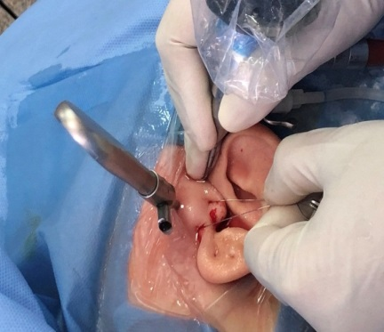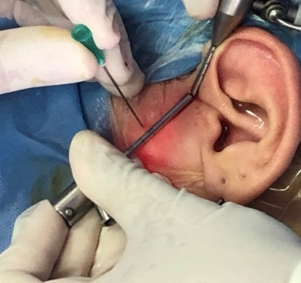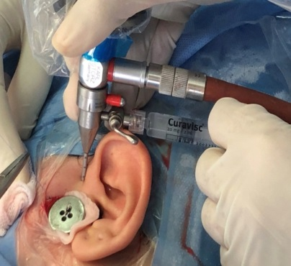
Some images of the new technique for disc repositioning using the wire
Recent publications:
1-Fahmy, Adham; Sliem, Abanoub; Youssef, Yara; Mostafa, Iman; and El-kammar, Hala (2020) "Mesenchymal Chondrosarcoma Simulating a Periodontal Disease: A Case Report," Future Dental Journal: Vol. 6 : Iss. 2.
Mesenchymal Chondrosarcoma Simulating a Periodontal Disease: A Case Report (aaru.edu.jo)
2-Sliem A, Barakat A, Mekhemer S, Hossameldin R. Clinical Assessment Of Arthroscopic Temporomandibular Joint Discopexy Using Wire Fixation Technique. Future Dental Journal. 2022; 8(1):1-9.
Clinical Assessment Of Arthroscopic Temporomandibular Joint Discopexy Using Wire Fixation Technique (aaru.edu.jo)

Biography:
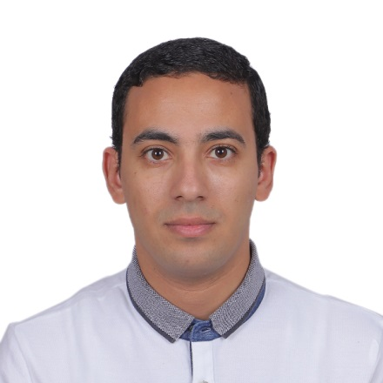
I am Abanoub Sliem Abdelmalak , Assistant lecturer of oral& Maxillofacial surgery at Future university in Egypt. I graduated from Faculty of Oral& Dental Medicine in 2016 after got a fully funded American scholarship from the USAID to get my bachelor degree. I studied in Western Kentucky University in 2014 in the United States and assisted there in Bluegrass oral health center in bowling green, KY. I got my Master degree in maxillofacial surgery in 2021 from a successful scholarship to fund my study and research. I am specialized in TMJ arthroscopic surgeries, Dental implantology and orthognathic surgeries. I have till now two publications and preparing my next two publications in Bone augmentation and arthrocentesis of the TMJ. I have multiple certificates in previous conferences. I have all the supporting documents in the previous mentioned data. It will be a huge honor to me to share my recent research work in arthroscopic surgeries in your conference in Dubai.

Email: abanoub.abdelmlak@fue.edu.eg
Phone no: 01223755049
Whatsapp: 01223755049

