‘Cutting off’ Dens invagination as a treatment of dens invaginatus: Case report
Dr. Yunjung Song
Seoul National University Gwanak Dental Hospictal, Seoul 08826, South Korea

Abstract (300 word limit)
The presence of complicated anatomy of root canal space, such as dens invaginatus, frequently hinders proper canal enlargement and obturation in root canal treatment, which might drive unfavorable clinical endodontic outcome. It would be a decent way to remove only the invaginated portion and proceed typical endodontic treatment. This report describes a clinical case of patient with dens invaginatus with apical periodontitis. The treatment was achieved by means of modifying complicated root anatomy with removing invaginated hard tissue and orthograde obturation with mineralized trioxide aggregate(MTA). ‘Cutting off’ invaginated tooth structure can provide sufficient vision which will lead practitioner to achieve favorable canal irrigation and obturation. Anatomical analysis via cone beam CT(CBCT) will help dentists to treat properly.

Image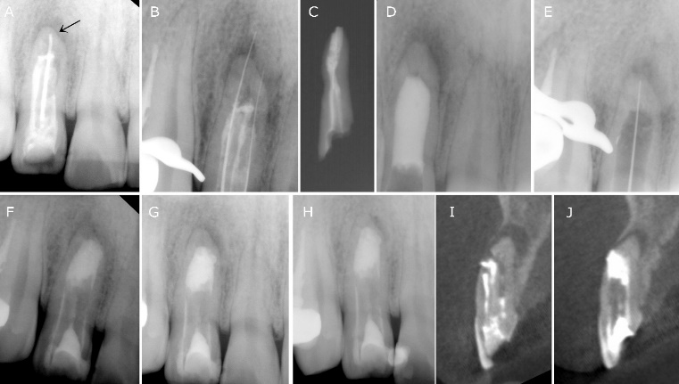

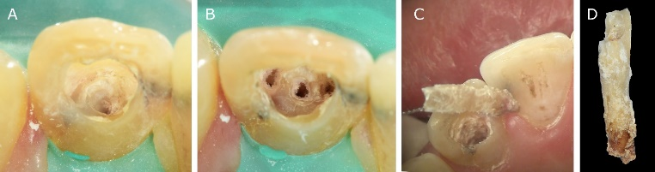

Photograph

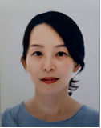
Dr. Song finished her certificate program of Endodontics in Yonsei University Dental Hospital on 2004 and has completed her PhD at the age of 34 years from Yonsei Universitye, Seoul,Korea. She worked as a clinical full time faculty at Hallym University since 2006 and now she is clinical professor of Seoul National University Gwanak Dental Hospital.

Email: sungjumo@gmail.com

Notes/Comments:

