Title:

“ Total Approach Concept for atrophic maxilla treatment: Nasal, Pterygoid and Zygomatic implants using a Minimally Invasive Technique with piezoelectric strumentation “

Author:
Andrea Tedesco
University of Pisa, Italy
Research Fellow, Oral Surgery Department
Mobile number: +303355414837
Email: tedescoandrea25@gmail.com
Category: Oral Presentation

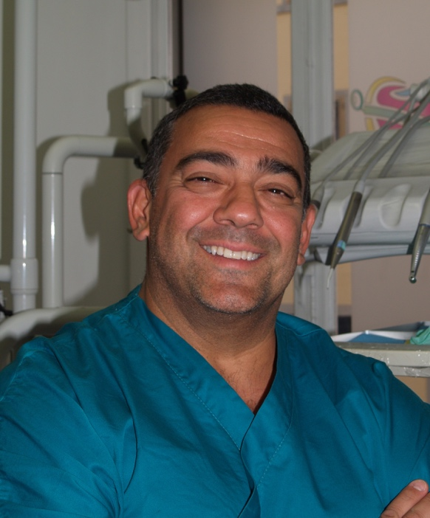

Key words: zygomatic implants, edentulous, atrophic, piezoelectric surgery.

Objectives

The nasal, zygomatic and pterygoid implants represent a valid alternative to regenerative surgery of severe maxillary atrophies. With a right clinical indication and a correct training for the operator it is possible to treat complex cases with immediate loading to reduce the patient's discomfort.
The Minimally Invasive Technique developed by Author with ESACROM (Imola Italy), using piezoelectric dedicated inserts, helps the surgeon to realize an easy surgery, less demolishing, more predictable because the osteotomy preparation is always outside the sinus, totally using the piezoelectric strumentation.

Usually, the zygomatic implant site preparation is still performed with long drills difficult to control.
In addition, the classic intrasinus approach involves the maxillary sinus, increasing the morbidity, the operating times, and other complications difficult to resolve.
The aim of this work is to evaluate a new Minimally Invasive Technique using piezoelectric dedicated inserts and extrasinusal approach.

Methods
A total of 64 conventional implants were placed together with 55 zygomatic implants.
The patients, 17 male and 10 female, no smokers, in good health, with a removable prosthesis, were followed up 24 months. After Tc Cone Beam and software planning design, each surgery was performed placing for each patient two or four straight implants in the frontal area and two zygomatic implants in the zygomatic bone. Some cases have been treated with 4 zygomatic implants, and other with nasal implants. Only one surgery was performed placing a oncology zygomatic implant.
After planning the surgery a stereolithographic model was created for each patient.
The insertion torque was over 35 Nc. The surgeries was performed under general anesthesia.

Results
No zygomatic implants was lost during the observation period.
The survival rate for the zygomatic implants was 100% over an average of 24 months observation period.
Two conventional implants were lost and there were no significant complications.

Conclusion
The zygomatic implants are a valid alternative to grafting procedure for the rehabilitation of the atrophic maxilla, in many cases using a immediate function protocols.
The zygomatic implants were placed outside the sinus and anchored in the maxillary alveolar process and in the zygomatic cortical bone.

There are many advantages about this new technique:
- Extrasinusal approach: no sinus complications
- Piezoelectric strumentation ( ESACROM, Imola Italy )
- Dedicated inserts
- No instruments vibration: No dangerous
- The surgery follows 3 steps: more accuracy
- Greater visibility
- Less time
- Less post-operative discomfort

Bibliography

1) Malevez C, Daelemans P, Adriaenssens P, Durdu F. Use of zygomatic implants to deal with resorbed posterior maxillae. Periodontology 2000. 2003;33:82-89.
2) Aparicio C, Ouazzani W, Garcia R, Arevalo X, Muela R, Fortes V: A prospective clinical study on titanium implants in the zygomatic arch for prosthetic rehabilitation of atrhophic edentulous maxilla with a follow-up of 6 months to 5 years. Clin Implant Dent Relat Res 2006;8:114-122.
3) Branemark PI, Grondahl K, Ohrnell L-O, Nilsson P, Petruson B, Svensson B, Engstrand P, Nannmark U. The zygoma option. Clinical procedure and long-term results. Scand J Plast Reconstr Surg Hand 2004;38:70-85.
4) Davò Rodriguez R, Malevez C, Rojas J. Immediate function in atrophic upper jaw using zygoma implants. Submitted to J prosthet Dent 2007;97(suppl.):s44-s51.
5) Tedesco A. Gli impianti zigomatici: attualità nelle riabilitazioni implanto-protesiche dei mascellari atrofici. Quintessenza Edizioni 2017

