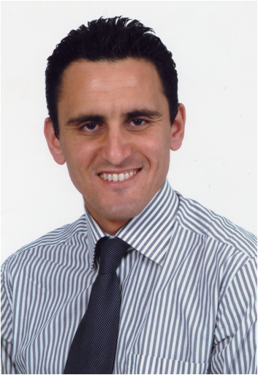

Title : Success Keys in Fixed Prosthesis

Abstract :

The aim of any prosthetic treatment is to restore aesthetics and oral function.
To achieve this result, a reasoned clinical approach must be followed from the clinical examination until the placement of the prosthesis. From a diagnosis, different solutions can be determined and clearly explained to the patient to reach, with his consent, a concerted therapeutic decision. The chosen treatment must then be conducted in accordance with a perfectly codified work program. Prosthetic designs for maximum preservation of mineralized dental tissues based on adhesive techniques and implantology are progressively supplanting mechanistic approaches. The aim of modern restorative dentistry are multiple:
• Ensure and maintain long-term oral function
• Maintain what is present rather than at all costs and systematically replace what is missing
• Provide the most predictable, minimally invasive, least risky and cost-effective care • Providing care based on evidence-based dental medicine.
This lecture will develop this clinical approach by illustrating our remarks by several clinical cases

CV :
Doctor of Dental Medicine
Professor , Dental faculty of Casablanca, Morocco
Head of prosthodontics department
CES biomaterials option
CES fixed prosthesis option
DEA of Biomaterials
Diploma in statistics and epidemiology applied to medicine
Author of several publications
Speaker
Member of several national and international scientific associations

