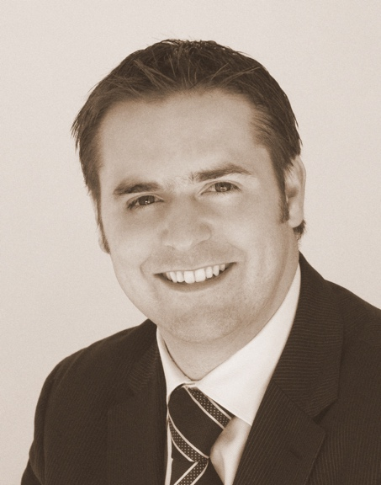
Title: “Synthetic graft materials in Implant dentistry”
Name: Dr Michael H. Ainsworth.

Private Practice.
The dental Referral Centre,
Dronfield UK.

The use of grafting materials in implant detistry is widespread. Membrane use in Guided bone regeneration is often considered to be a fundimental requirement to stop soft tissue ingrownth and stabilise the graft material. Whilst this holds true for many materials, the development of fully synthetic (alloplastic) materials has obviated the need to use membranes in most cases. Grafts containg Beta ricalcium Phosphate and Calcium sulphate offer a Stable, Setting, Cell occlusive medium in which host bone can develop. The direct apposition of periostium to the graft means that there is no barrier to the periostial blood supply in healing. Specific Protocols have been deveoloped around the unique properties of these matierals.

Dr Ainsworth has used these materials exclusively for over 10 years and in hundreds of procedures and will share the applications, from single tooth placement to more complex including sinus augmentation including recent research. He has found that utilisation of Alloplastic materials that are highly biocompatable can reduce post operative pain and shorten treatment times.

Biography

Dr Ainsworth was awarded his Dental Degree From the Univeristy of Birmingham, UK in 2002. He is currenly completing his a Msc in Periodontology from the University of Central Lancashire. He completed a year course on Harley Street a has been placing and restorng Implants since 2003. In 2007 He moved to Spain as Principal of a practice for 5 years during this time he was mentored by Peter Fairbairn who introduced him to Alloplastic materials. On returning to the uk he worked in various clinics plcaing dental implants before becoming principal of the Dental referral centre in Dronfield UK.
He has spoken at many events nationally about this subject including ADI meetings.
Presenting author details
Full name: Michael (Harrison) AINSWORTH
Contact number: 00447939554404
Affiliation: University of central Lancshire.
Country: UK
Phone Number: 00447939554404
Mail ID: Michael_H_ainsworth@yahoo.co.uk
Category: (Oral presentation)

