Abstract Title: Advances in CAD/CAM Materials and Techniques for Implant Prosthodontics
Roberto Markarian, MSc, PhD

¹ SLMandic School of Dentistry - Campinas - Brazil

Abstract (not more than 300 words)

Dental Implantology is being widely improved with CAD/CAM technologies introducing new solutions in key steps in implant therapy. Treatment planning, guided surgery, intraoral impressions, restoration fabrication can be accomplished with reduced clinical and laboratorial fabrication steps. Clinicians can now offer better final outcomes for dental implants with better fit and more aesthetic restorations, improved biocompatibility and resistance, thus avoiding inaccuracies that can occur from dental materials and reducing the chance of human errors.

Current CAD/CAM systems permit the fabrication of customized abutments using a variety of materials and design strategies. Some dental implant manufacturers recommend that Ti-based abutments should be used and onto which a monolithic crown or a mesostructure can be designed, however directly designing a customized abutment including the Implant-abutment interface could be manufactured using materials and strategies from bench-top laboratory machines.

Recent scientific findings suggest that CAD/CAM systems can provide accurate implant-abutment interface, however some manufacturing factors may interfere with such high standard adaptation, including the use of additive or subtractive strategies, the quality of the milling machine and the intrinsic properties of the preparation material.
The objective of this lecture will be to present recent advances in CAD/CAM dental abutment technologies and strategies, to the light of scientific evidence.

Keywords— dental implantology, CAD/CAM, abutments, biomaterials, implant-abutment interface.

Professional Biography (100-150 words)

Dr Roberto Markarian has obtained a PhD degree in Dental Implantology at SLMandic Dental School, a MSc degree in Dental Prosthodontics at the University of São Paulo, and is continuously engaged to Academic Postdoctoral studies in CAD/CAM materials and techniques.

Dr Markarian, has obtained the degree of Specialist in Dental Implantology and Prosthodontics. He is the director of ImplArt Odontologia, a premier dental clinic dedicated to deliver exclusively CAD/CAM services, located in São Paulo-Brazil, with expertise in several CAD/CAM systems and machines. He has published papers in reputed journals and often acts as consultant for dental implant manufacturers.

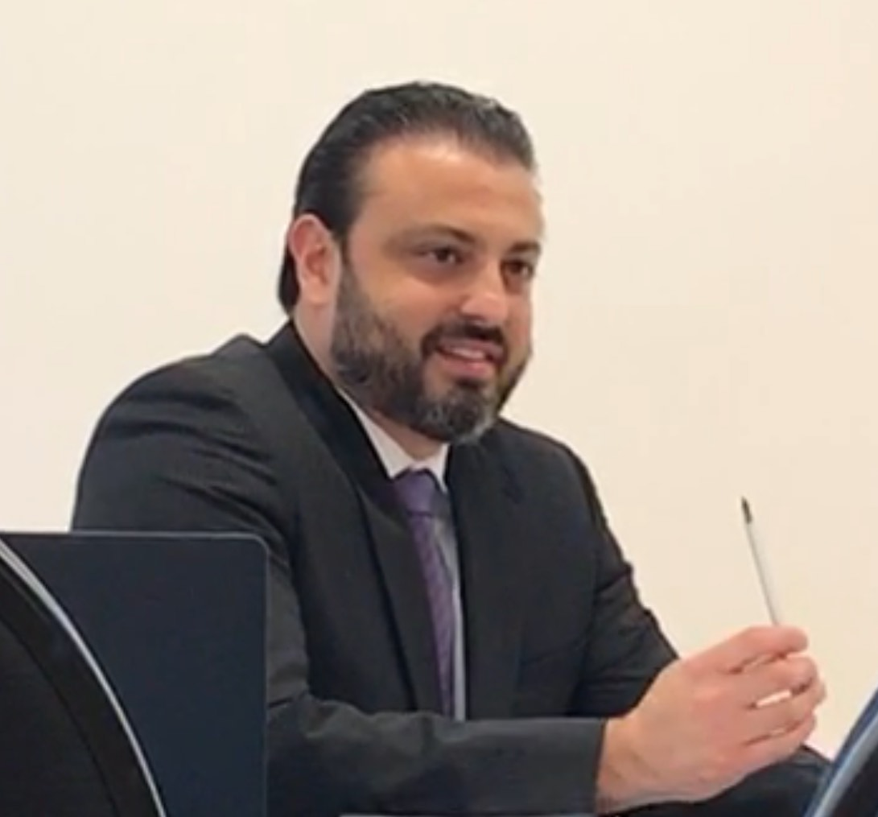
Paste your Photograph here

Name: Roberto Markarian
Email: Roberto@markarian.com.br
Number: +55 11 3262-4750 (work)/ 96059-8088 (mobile)
Category: (Oral presentation)

