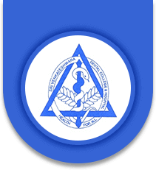
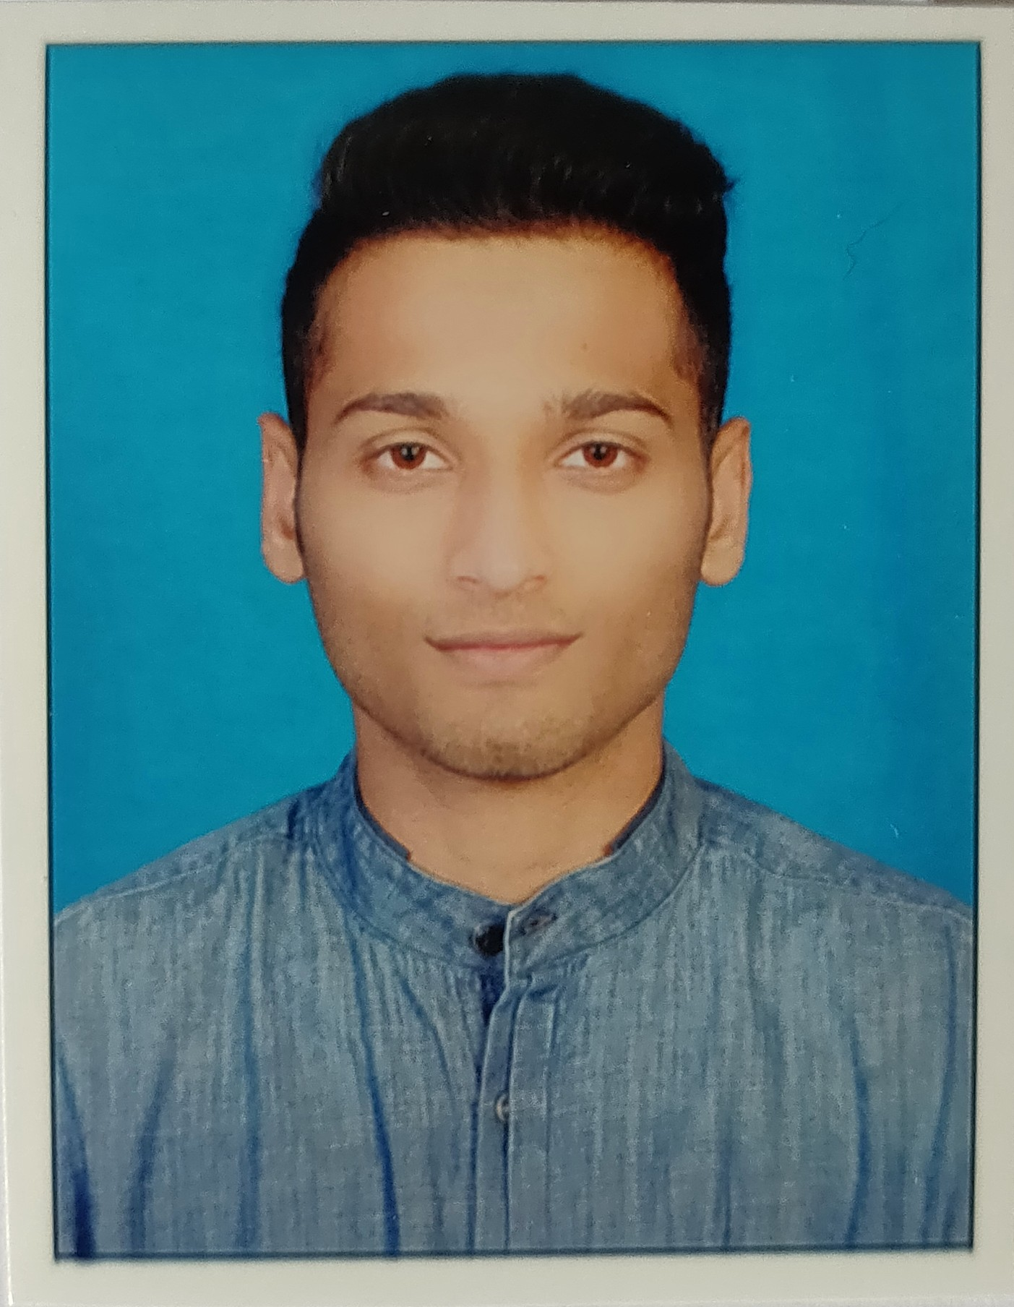

TITLE : EFFICACY OF CAR T-CELL THERAPY IN HEAD AND NECK CANCERS : A META-ANALYSIS…!!!

Name: Dr. AVISESH MANOHAR,
NSVK SRI VENKATESHWARA DENTAL COLLEGE & HOSPITAL, ANEKAL ROAD, BANGALORE, KARNATAKA, INDIA 560083

ABSTRACT

Cancer, according to the World Health Organization is defined as a large group of diseases characterized by the growth of abnormal cells beyond their usual boundaries that can then invade adjoining parts of the body and/or spread to other organs.

From extensive surgical excisions, radiotherapy, laser therapy to immunotherapies, various treatment strategies have been proposed and implemented so far but unfortunately none could improve the five year survival rate of the patients globally.

Immunotherapy, being one amongst them, is a type of cancer treatment that boosts the body's natural defenses to fight against cancer.The current concept of immunotherapy involves Chimeric antigen receptor or the CAR T-Cell therapy which involves alterations and modifications of T cells to fight cancer cells better.

Until recently, the use of CAR T-cell therapy has been restricted to small clinical trials, largely in patients with advanced blood cancers and has also shown a promising window of hope in head & neck (especially oral) cancers as well. But these treatments have nevertheless captured the attention of the people because of the remarkable responses they have produced in some patients for whom all other treatments had stopped working.

- AIM OF THE STUDY: Assessment of efficacy of Car T-Cell Therapy in head & neck Malignancies

- RESEARCH HYPOTHESIS: Is Car T-Cell Therapy actually effective in treating head & neck cancers?

- MATERIALS & METHODOLOGY: Study sample included review of research articles, based on scientific data bases from the English literature based COCHRANE collaboration having a definite RCT (Randomized Control Trial). The literature was studied, analyzed and assessed; comparison was made on their p (probability) values between various techniques in terms of their sensitivity and specificity.

- RESULT & CONCLUSION: Since the study is still in progress, the result and conclusion will be discussed on the day of the presentation at the venue.

BIOGRAPHY

- Dr. Avisesh Manohar is currently persuing his internship (house surgeon) at NSVK Sri Venkateshwara Dental College & Hospital, Bangalore, Karnataka, India.
- Total CDE programmes and Scientific Conferences attended till 17th october 2018 : 8.
- Winner of best paper at the IAOMR UG CONVENTION 2018.
- 2nd highest rank in 1st year and 4th year of dental degree overall in Sri Venkateshwara Dental College & Hospital, Bangalore, Karnataka, India.

Presenting author details
Full name: AVISESH MANOHAR
Session name/ number:
Category: E-Poster
Email id: avimanohar1996@gmail.com
Contact number: +91 9591222206

