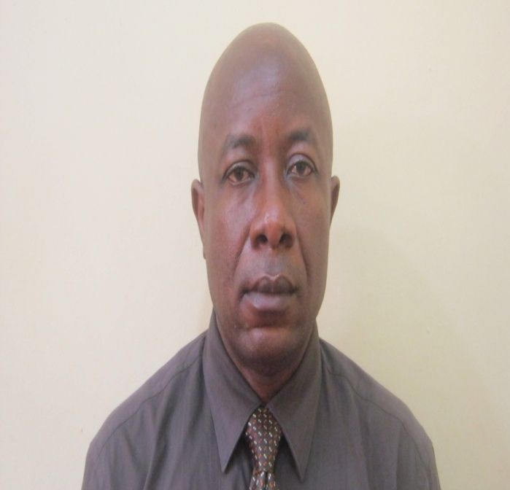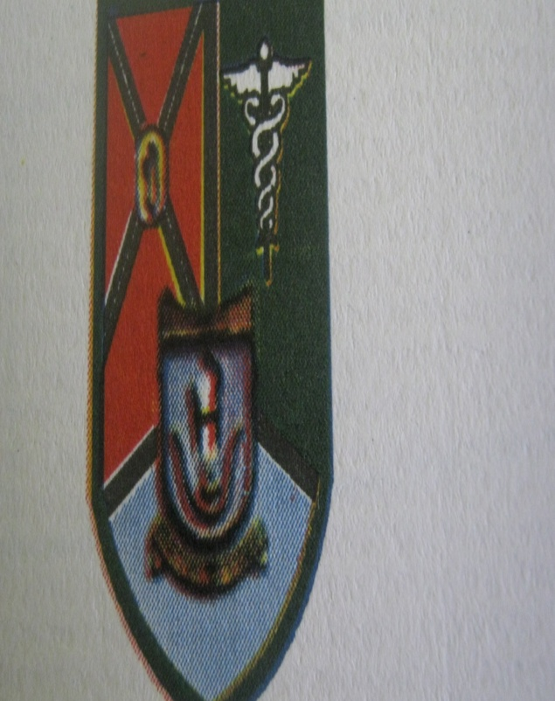
Title: Inflammatory Morbidity due to Compound Mandibular Body Fractures: Does it Have a Relationship with Treatment Outcome?
By
¹Charles E. Anyanechi, ²Birch D. Saheeb
¹ Oral and Maxillofacial Unit, Department of Dental and Maxillofacial Surgery, University of Calabar / University of Calabar Teaching Hospital, Calabar, Nigeria.
² Department of Oral and Maxillofacial Surgery, University of Benin Teaching Hospital, Nigeria.
Work attributed to: Oral and Maxillofacial Unit, Department of Dental and Maxillofacial Surgery, University of Calabar Teaching Hospital, Calabar, Nigeria.

Abstract
The inflammatory morbidities associated with mandibular fractures have led to the timing of the surgical repair of the fractured segments being a controversial issue in oral and maxillofacial surgical practice. To evaluate the relationship between the degree of pre-operative pain and trismus with the development of complications following repair of isolated unilateral compound mandibular body fractures using closed reduction technique. This was a seven-year prospective study carried out at the Dental and Maxillofacial Surgery Clinic of the University of Calabar Teaching Hospital, Calabar, Nigeria. Eighty three subjects (83; males: 66, females: 17)), were evaluated for trismus and pain in a blinded manner by a single examiner pre-operatively, and complications recorded postoperatively. The data obtained were statistically analyzed with Environmental Performance Index (EPI) info 2008 version software. Out of the 97 patients that presented, 83/97 (85.6%) were treated, while 13 (15.7%) developed complications. The male-to-female ratio was 5:1. The fractures were commonest in the age range of 21-40 years (n=45, 54.2%). The age (p= 0.02) and gender (p= 0.01) distribution of subjects were significant. The more severe the limitation of mouth opening (p= 0.03) and pain (p= 0.04) before treatment, the more complications develop; and these significantly affected treatment outcome. Impaired mastication and facial asymmetry (n= 17, 41.5%) were the most common complications. This study showed that post-trauma pain and trismus due to unilateral mandibular body fractures may be associated with the development of complications. An adequately powered prospective study treating patients at 5 or 7 days is required in order to make the case for later intervention.
Biography
Charles Anyanechi has completed his Fellowship in oral and maxillofacial surgery from West Africa Postgraduate Medical College, Lagos, Nigeria. He is the associate professor of oral and maxillofacial surgery, in the Oral and maxillofacial Unit, Department of Dental & Maxillofacial Surgery. He has published more than 60 papers in reputed journals and has been serving as head of department and editorial board member of several journals within and outside Nigeria.

Presenting author details
Full name: Dr. Charles E. Anyanechi
Session name/ number: Dental surgery and innovations/7
Category: Poster (Oral/ Poster)
Email id: ceanyanechi@gmail.com
Contact number: +2348100257825

