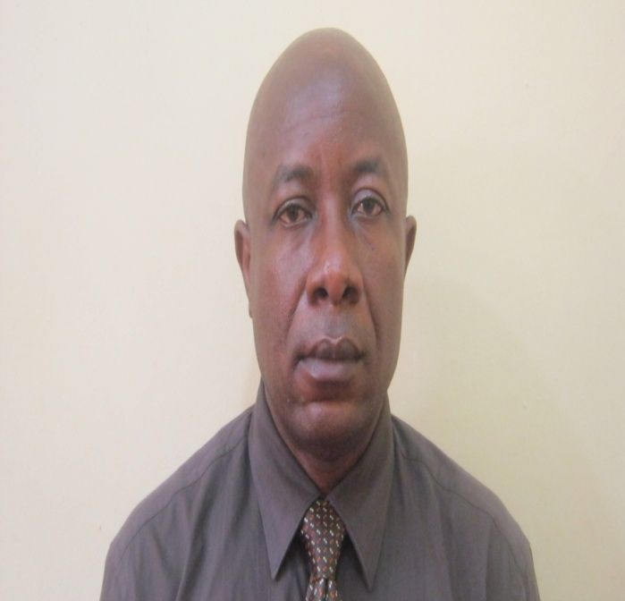
Title: Management of Extra-capsular Temporo-mandibular Joint Ankylosis: Does Conservative Approach to Treatment Have a Role?
Authors: ¹Charles E. Anyanechi, ²Otasowie D. Osunde and ³Godwin O. Bassey
Oral and Maxillofacial Unit, Department of Dental and Maxillofacial Surgery, University of Calabar/University of Calabar Teaching Hospital, Calabar, Nigeria.
Abstract
The conventional management of fibrous extra-capsular temporomandibular joint (TMJ) ankylosis is associated with surgical complication and financial burden on the patient. To assess the outcome of conservative approach to the management of fibrous extra-capsular TMJ ankylosis. This is a prospective study of patients who presented at the Dental and Maxillofacial Surgery Clinic of the University of Calabar Teaching Hospital, Nigeria during the period January 1999 to December 2012 with the history of inability to open the mouth diagnosed as fibrous extra-capsular TMJ ankylosis. Fergusson’s mouth gag and stacks of wooden spatula were used for the treatment. For patient the mouth opening is not big enough to accept the Fergusson’s mouth gag initially, padded coupland elevator and handle of dental extraction forceps were placed in between the incisor teeth and distracted until appreciable mouth opening was achieved. Twenty-one subjects were treated and their ages ranged from 11 to 22 years with mean at 15.0 years. There were 13 (61.9%) males and 8 (38.1%) females with male: female ratio of 1.6:1. In all cases, the aetiological factor that predisposed to formation of extra-capsular TMJ ankylosis was trauma. There was no facial asymmetry and the side distribution of the affliction showed 1 (4.8%) was bilateral while 20 (95.2%) were unilateral. Eight cases (38.1%) were incomplete ankylosis while the rest (n=13, 69.9%) were complete. The duration of the lesions before treatment was between 2 to 11 months. The shorter the duration of fibrous ankylosis, and the greater the initial inter-incisal distances before treatment, the better the treatment outcome. The outcome of treatment suggests that the conservative approach to management was beneficial to the patients because they presented early. However, randomized controlled clinical trials are needed to validate this treatment option.
Biography
Charles Anyanechi has completed his Fellowship in oral and maxillofacial surgery from West Africa Postgraduate Medical College, Lagos, Nigeria. He is the associate professor of oral and maxillofacial surgery, in the Oral and maxillofacial Unit, Department of Dental & Maxillofacial Surgery. He has published more than 60 papers in reputed journals and has been serving as head of department and editorial board member of several journals within and outside Nigeria.

Presenting author details
Full name: Dr. Charles E. Anyanechi
Session name/ number: Dental surgery and innovations/7
Category: Poster (Oral/ Poster)
Email id: ceanyanechi@gmail.com
Contact number: +2348100257825

