TITLE: Evaluation of Naturally Occurring Bioactive Ligands against Molecular Targets of SARS-Cov-2

Dr. Shalini Gupta, MDS, Professor, King George’s Medical University, Lucknow

Abstract
The fatal virus SARS-CoV-2 caused a global pandemic of Coronavirus disease. Identification of the naturally occurring bioactive compounds that can inhibit or modulate the proteins and enzymes of the virus SARS-CoV-2 by targeting the host cells and immune system of the human body is an instrumental approach for COVID-19 therapy. In the present study it is an effort to assess the potential of naturally occurring bioactive compounds and their derivatives against SARS-CoV-2 using molecular docking and molecular dynamics simulation studies i.e. binding affinity of the active enzymes of the host cells to bioactive compound against SARS-CoV-2. Docking and simulation studies were performed to evaluate the maximum affinity of the selected bioactive molecules along with the reference drugs Remdesivir and Ivermectin against the vital target proteins and enzymes of coronavirus. Among all selected bioactives, as per the computational docking parameters, Curcumin has shown excellent binding, especially against ACE-2 and RdRp. Apigenin also showed encouraging results against spike protein comparable to reference drugs Remdesivirand Ivermectin. Curcumin glucuronide & Apigenin-7 glucoside showed the most suitable response as they have a marvellous binding affinity with SARS-CoV-2 targets that are responsible for viral entry as well as their further replication into the host cell;they could be potential drug candidates for COVID-19 therapy.

Image
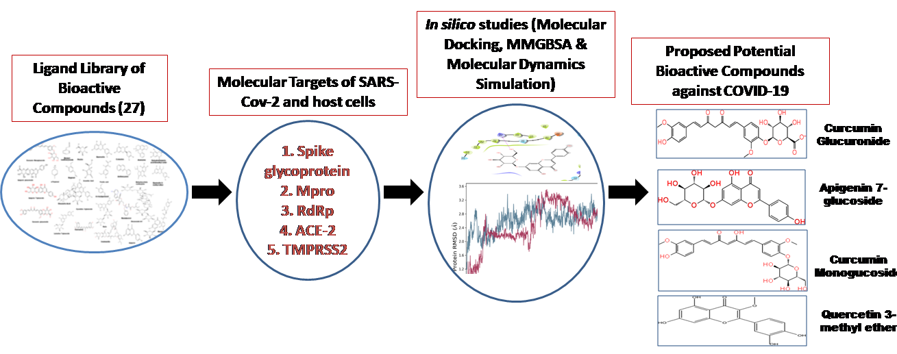
Recent Publications:
- Soni U, Singh P, Gupta OP, Gupta S, Singh SP, Singh P, Singh S, Mishra K. Lichen planus drugs re-purposing as potential anti COVID-19 therapeutics through molecular docking and molecular dynamics simulation approach. J Clin Transl Res. 2022 Mar 1;8(2):125-137. PMID: 35382132; PMCID: PMC8977209.

- Singh SP, Singh P, Gupta OP, Gupta S. Coronavirus disease: Dental review. J Oral Maxillofac Pathol 2022; 26:16-20.

- Shalini Gupta, Anoop Verma, Ranjit Patil, U,S. Singh, Navneet Kumar, Sandeep Bhattacharya. Comparison of Demirjian and Cameriere Methods and Development of Modified Cameriere and Demirjian Formula More Efficient for North Indian Population. Accepted in journal of oral and maxillofacial pathology, 26th July 22.

- Evaluation of Modified Demirjian and Cameriere Third Molar Maturity Index (I3M) On Dental Age Estimation in North Indian Population: A Comparative Study. Accepted in journal of forensic medicine and toxicology, 16th Oct 22.
- Sangwan A, Singh SP, Singh P, Gupta OP, Manas A, Gupta S. Role of molecular techniques in PMI estimation: An update. J Forensic Leg Med. 2021;83:102251. doi:10.1016/j.jflm.2021.102251.

- Gupta, S., Nigam, K., Srivastav, R.K., Ahmad, M.K., Mahdi, A.A., Sanyal, S., 2021 Mar 29. Genetic polymorphism of tumor necrosis factor alpha (TNF-α) and tumor necrosis factor beta (TNF-β) genes and risk of oral pre-cancer and cancer in North Indian population. Oral Maxillofac Surg. https://doi.org/10.1007/s10006-020-00929-5. Epub ahead of print. PMID: 33779868

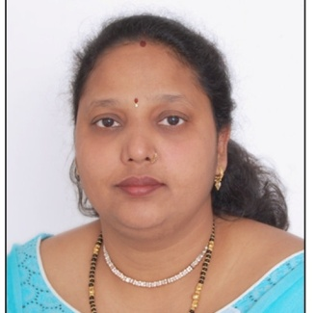
Biography:

Dr. Shalini Gupta BDS, MDS (Gold-medalist) has expertise in Oral pathology, Dentistry, oral cancer & forensic odontology. Books published: Ameloblastic Fibroma and Oral squamous cell carcinoma & p53: An Overview. 1sted.Has Received many prestigious memberships and fellowships, 109 papers published in National and International Peer reviewed indexed journals, 6 Patents filed, Executed and ongoing 12 Extramural Projects and 5 Intramural Projects, Chaired numerous scientific sessions in national and International Conferences, Organized many community outreach program like: camps and Health Melas on various social issues like Child abuse,Oral cancer/ Pre Cancer, Oral hygiene and hand hygiene, menstrual hygiene,tobacco cessation and Disaster victim Identification. Recognized expert in India on Forensic Odontology from the Regional Delegation of the International Committee of the Red Cross (ICRC)for India, Nepal, Bhutan and the Maldives

