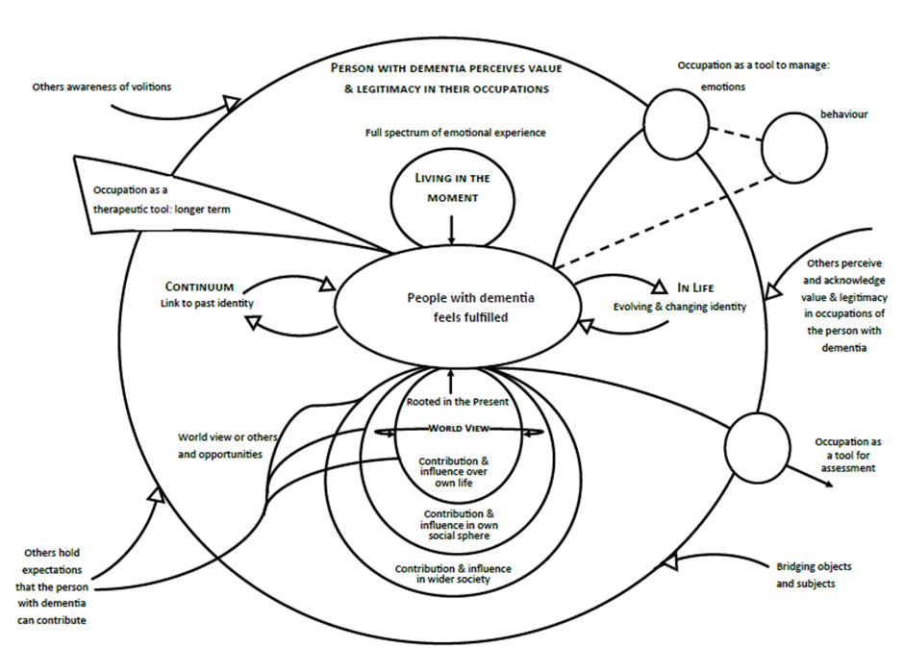
Katherine Strick, MSc
Katherine is undertaking a PhD investigating meaningful occupation for people living with dementia in residential care settings at Exeter medical School. Katherine has previously worked for the Alzheimer’s Society as part of the Side by Side project, and as an information worker. She has also worked as an activity coordinator in care homes. Her passion for supporting people with dementia to live well has led her to organise multiple charity events and volunteer with a local Dementia Action Alliance and in memory cafes. Katherine completed her MSc in Dementia Studies through the University of Bradford in 2016.
Email: KS660@exeter.ac.uk
Notes/Comments:

Figure 1: Model depicting the multiple purposes of meaningful occupation for people with dementia.
Recent Publications:
Abbott R, Orr N, McGill P, Whear R, Bethel A, Garside R, Stein K, Thompson-Coon J (2019). How do "robopets" impact the health and well-being of residents in care homes? a systematic review of qualitative and quantitative evidence. Int J Older People Nurs, 14(3).
Watkins R, Goodwin V, Abbott R, Tarrant M (In Press). Eating well in care homes: Testing the feasibility of a staff training programme aimed at improving social interaction, choice, and independence at mealtimes. International Journal of Older People Nursing
Whear, R., Thompson-Coon, J., Bethel, A., Abbott, R., Stein, K. & Garside, R. (2014) What is the impact of using outdoor spaces such as gardens on the physical and mental well-being of those with dementia? A systematic review of quantitative and qualitative evidence. JAMDA 15(10), 697-705.

Booth A, Moore G, Flemming K, Garside R, Rollins N, Tunçalp Ö, Noyes J (2019). Taking account of context in systematic reviews and guidelines considering a complexity perspective. BMJ Glob Health, 4(Suppl 1)
Noyes J, Hendry M, Booth A, Chandler J, Lewin S, Glenton C, Garside R (2016). Current use was established and Cochrane guidance on selection of social theories for systematic reviews of complex interventions was developed. J Clin Epidemiol, 75, 78-92

Abstract
Guidance for the provision of care for people with dementia asserts that occupation people find meaningful is essential for wellbeing, however definitions of meaningful occupation are often very broad with the intrinsic meaning coming from within the person rather than the activity. As such the purpose of meaningful occupation, and how to gauge its effectiveness can be inconsistent.
Through analysing the different purposes that occupation for people with dementia is perceived to have, this study created a conceptual model depicting the types of meaning that are seen as stemming from occupation.
The conceptual model was based on systematic review and evidence synthesis of 20 qualitative papers using meta-ethnography.
The fundamental purpose of occupation identified was to support the person with dementia to feel they were living a meaningful and fulfilling life. Three domains which support a person to gain a sense of fulfilment through their occupations:
A catalytic environment: For an occupation to be meaningful for a person with dementia it must be perceived by them as having value and legitimacy, this is supported by the physical and social environment around the person.
A meaningful life: Living a meaningful life involves the person with dementia continuing to maintain links from across their life course in a way which supports their sense of personal value. This is reflective of their past, though also supports their present and future identity.
Occupation as a tool: Occupation can also be used a tool by people with dementia and those supporting them as a means to bring about a desired effect e.g. relieving anxiety
Conclusions: The model proposes how occupation could support meaning in multiple ways, and considered how these forms of meaning were influenced by the world views and values of the individual, and context in which they were experienced.

Conceptual model of the purpose of meaningful occupation for people living with dementia developed through Systematic Review and Qualitative Evidence Synthesis
Katherine Strick, MSc University of Exeter
Professor Ruth Garside, University of Exeter
Dr Rebeca Abbott, University of Exeter
Professor Jo Thompson Coon, University of Exeter
Jess Randle, MSc University of Exeter.

