Eng , Zeyad Shalaby, Egypt

Abstract (300 word limit)
Data science has developed rapidly over the past decade, with advances in computing power, data storage, and machine learning algorithms driving progress. The field encompasses a wide range of techniques and methods for extracting insights from data, including statistics, machine learning, data mining, and data visualization.

Some key developments in data science over time include:

- The emergence of big data: As the volume, velocity, and variety of data grew exponentially, new technologies were developed to handle these large datasets, such as Hadoop and Spark.

- Cloud computing: Cloud platforms like AWS, Google Cloud, and Microsoft Azure have made it easier and more cost-effective to store and process large amounts of data.

- Machine learning: Advances in machine learning algorithms, particularly deep learning, have led to breakthroughs in natural language processing, image recognition, and other areas.

- Data visualization: Data visualization tools like Tableau and Power BI make it easier to explore and communicate insights from data.

- Automated machine learning: AutoML platforms like Google’s AutoML and H2O.ai automate the process of building machine learning models, making it accessible to non-experts.

- Explainable AI: With the growing importance of AI in decision-making processes, explainable AI has become an important area of research. Techniques like LIME and SHAP help to explain how machine learning models make predictions.

Overall, data science is a dynamic and rapidly evolving field that continues to drive innovation and transformation across industries.

Image
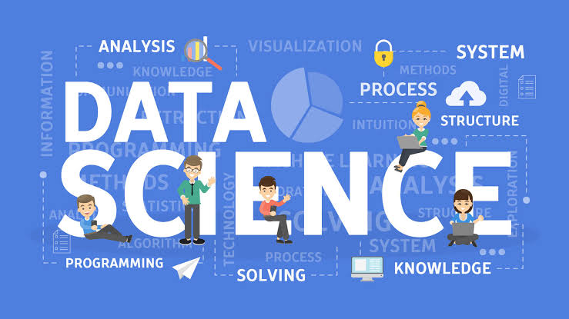
Recent Publications (minimum 5)
- An article on databases (2018) on the Oracle website
- A complete web programming learning book in Egypt (2022)
- Post web programming learning episodes on YouTube.
Improvement in the databases of Alexandria sites data
5. A full article on technology in the Arab world

Photograph

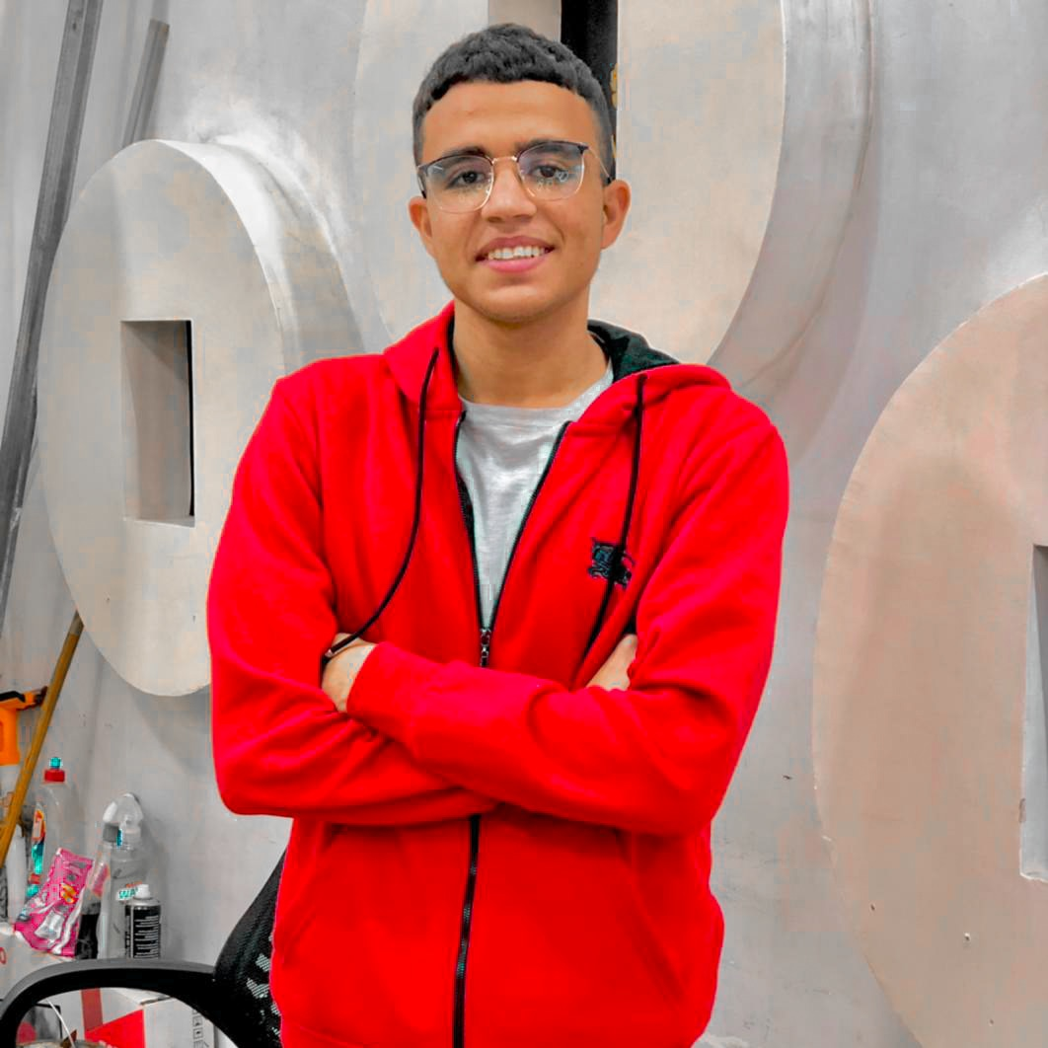Biography (150 word limit)
• I am Ziad Shalaby, a web programmer and online marketer. I hold certificates from accredited international universities and certificates in digital marketing from Google. I am responsible for several social media pages.
Email: zyad.h.shalaby@gmail.com

Notes/Comments:

