Deep Learning based CubeSat Close Proximity Detection and Attitude Estimation
Indika S.S.N. Gamage, PhD, Mississippi State University, USA

Abstract
Statement of the Problem: Detecting space objects in close proximity is a problem arising from capturing, servicing, and other proximity operations. Vision-based object detection refers to the process of localizing all objects of interest in images or videos (localization in the camera space) and determining the categories to which the objects belong (classification). The localization result can aid relative navigation. The classification result is crucial for situation assessment and high-level control, planning, and decision making. In this abstract, a method for detecting multiple 1U, 2U, 3U, and 6U CubeSats based on the faster region-based convolutional neural network (Faster R-CNN) is proposed. CubeSats detection models are developed using Web-searched and computer-aided design images. Faster R-CNN detection results contain useful information for tracking, navigation, pose estimation, and simultaneous localization and mapping. In this abstract, a coarse single-point attitude estimation method is proposed utilizing the centroids of the bounding boxes surrounding the CubeSats in the image. The centroids define the line-of-sight (LOS) vectors to the detected CubeSats in the camera frame, and the LOS vectors in the reference frame are assumed to be obtained from global positioning system (GPS). The three-axis attitude is determined from the vector observations by solving Wahba's problem. The attitude estimation concept is tested on simulated scenarios using Autodesk Maya.

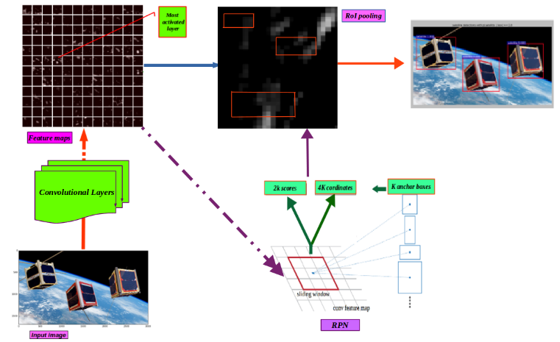
Figure 1: Shows the proposed model for Faster R-CNN based CubeSat detection. The CubeSat detection problem is to detect all CubeSats in the image but not mistake other objects or backgrounds for CubeSats. For the sake of simplicity, only four CubeSat classes are assumed in Web-searched CubeSat detection: 1U, 2U, 3U, and 6U.
References

- Samarawickrama, NGIS., (2019) Faster R-CNN based CubeSat Close Proximity Detection and Attitude estimation, ir.library.msstate.edu
- Gamage, S. and Cheng, Y., (2018) CubeSat Detection Using Convolutional Neural Networks, Space Flight Mechanics Meeting, SciTech.
- Ren, S., He, K., Girshick, R., and Sun, J., (2015) Faster R-CNN: Towards Real-Time Object Detection with Region Proposal Networks, Advances in Neural Information Processing Systems (NIPS).
- Markley, L., (1987) Attitude Determination Using Vector Observations and the Singular Value Decomposition, J. Astronaut.Sci., Vol. 38.
- Wahba, G., (1965) Least Squares Estimate of Satellite Attitude, SIAM Review, Vol. 7, No. 3, 409–409.


Indika S.S.N. Gamage has expertise in aerospace, deep-learning, data science, and artificial intelligence. He received his Ph.D. degree in Engineering (aerospace) from Mississippi State University in 2019. He developed this model after years of experience in research, evaluation, teaching, and administration both in industries and educational institutions. The foundation for this research is based on a deep-learning technique (Ren, S., He, K., Girshick, R., and Sun, J., 2015), that use to detect pre-defined objects in an image. This proposed approach provides efficient solutions for space object detection and attitude estimation.
Email: ngissujeewa@gmail.com

