Surge-Adjusted Forecasting in Temporal Data Containing Extreme Observations
Smaranya Dey, Subhadip Paul,
Uddipto Dutta, Anirban Chatterjee
Walmart Labs, India

Abstract
Forecasting in time-series data is at the core of various business decision making activities. One key characteristic of many practical time series data of different business metrics such as orders, revenue, is the presence of irregular yet moderately frequent spikes of very high intensity, commonly called extreme observation. Forecasting such spikes with high accuracy is extremely important from business standpoint as a number of planning activities such as workforce planning, financial planning, inventory planning depend on that. However, all the traditional methods for time series forecasting such as ARIMA, BSTS, are not very accurate in forecasting extreme spikes. Deep Learning techniques such as multiple variants of LSTM tend to perform better than most traditional techniques in forecasting extreme spikes, but with marginal improvement. The underlying assumption of thin tail of data distribution is one of the primary reasons for such models to falter on forecasting extreme spikes as moderately frequent extreme spikes result in heavy tail of the distribution. On the other hand, literatures, proposing methods to forecast extreme events in time series, focused only on extreme events but ignored overall forecasting accuracy. In this work we attempted to address both these problems by proposing a technique where we considered a time series signal with extreme spikes as the superposition of two independent signals - (1) a stationary time series signal without extreme spike (2) a shock signal consisting of near-zero values most of the time along with few spikes of high intensity. The high intensity spikes of the shock signal may be influenced by multiple exogenous factors. We modelled the above two signals independently to forecast values for the original time series signal. Experimental results show that the proposed technique with proper tuning of hyper-parameters outperforms other commonly used techniques in forecasting both normal and extreme events.

Results

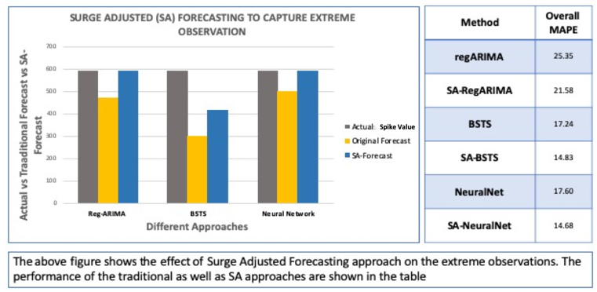
References
- Ryan D. Batt , Stephen R. Carpenter, Anthony R. Ives (2017), Extreme Events in lake ecosystem time series. Limnology and Oceanology Letters 2, 2017, 63-69.
- T.M. Christensen, A.S.Hurn, K.A.Lindsey (2012), Forecasting Spikes in Electricity Prices. International Journal of Forecasting, Volume 28, Issue 2, April-June 2012, pages 410-411.
- Daizong Ding, Mi Zhang, Xudong Pan, Min Yang, Xiangnan He (2019), Modeling Extreme Events in Time Series Prediction. KDD’19.
- Sergio Albeverio, Volker Jentsch, and Holger Kantz. (2006). Extreme events in nature and society. Springer Science & Business Media.
- Sakyasingha Dasgupta and Takayuki Osogami. (2017). Nonlinear Dynamic Boltz-mann Machines for Time-Series Prediction.. In AAAI. 1833–1839

Biography

Smaranya Dey is a Data Scientist in Walmart Labs, India. She is interested in researching the areas of forecasting analysis and natural language processing.
Email: Smaranya.dey@walmart.com

Subhadip Paul is Statistical Analyst at Walmart Labs, India. His research interest lies in Time Series Analysis, Clustering and Analysis of Graphical Data.
Email: Subhadip.paul0@walmartlabs.com

 Uddipto Dutta is a Statistical Analyst at WalmartLabs, India. Time Series Analysis and Optimization are some of the areas he is interested to do research in.
Email: uddipto.dutta@walmartlabs.com

 Anirban Chatterjee is Staff Data Scientist in WalmartLabs, India. His research interest lies in Time Series Analysis and Modeling with High Dimensional Data.
Email: Anirban.Chatterjee@walmartlabs.com

Note: All authors contributed equally to this work.

