Title: The crystallographic glance on the LATP stability
Mariam Pogosova, PhD, Skolkovo Institute of Science and Technology, Moscow, RUSSIAN FEDERATION

Abstract: 300 words
Nowadays, the interest in alternative energy sources grows rapidly. Therefore, many of studies are devoted to the development of new energy storage devices and techniques that are usually based on the ionic conductivity. Evidently, the optimal ion conductive material is expected to possess good performance. However, it is necessary to stress, that not only the performance by itself but its stability plays an essential role in the final application success. In the case of inorganic materials, the ionic conductivity is connected strictly with the crystal structure features. Thereby, one may expect that the structural stability lays the foundation to the final performance stability. Nevertheless, we have to admit that this aspect had not been studied well.
Working within a research project that is oriented on the Lithium Hybrid RedOx Flow battery market, we decided to pay attention to the lifetime of materials proposed for the lithium-conductive membrane. The Li_{1.3}Al_{0.3}Ti_{1.7}(PO₄)₃ (LATP) was chosen to be investigated as a basic material — one of the most effective lithium conductors suitable for further optimization. In spite of the LATP ceramics are usually claimed to be stable, the complex and long-term experiment carried out by our research group showed the evident structural and conductivity changes. Namely, the solid-state synthesized LATP ceramics demonstrate drastic conductivity fading that interconnects with the fine structural changes.
During the 3-months experiment, LATP ceramics were analyzed through the Powder X-Ray Diffraction analysis (PXRD) followed by the Rietveld refinement, Electrochemical Impedance Spectroscopy (EIS), Scanning Electron Microscopy (SEM), and Energy-Dispersive X-ray spectroscopy (EDS). The results obtained are supported by the calculations based on the Density Functional Theory (DFT).
Image: 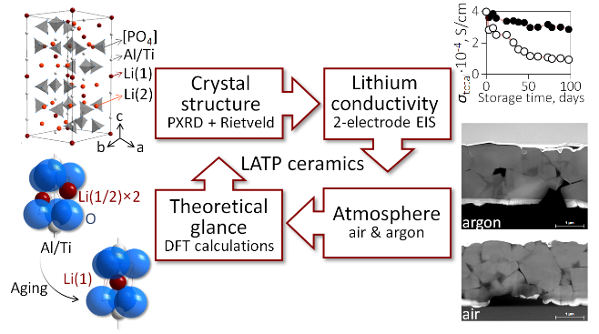
Recent Publications: (Minimum 5)
- Pogosova M, Provotorov D, Eliseev A, Jansen M, Kazin P (2015) Synthesis and characterization of the Bi-for-Ca substituted copper-based apatite pigments. Dyes and Pigments 133:109–113.
- Kazin P, Pogosova M, Trusov L, Kolesnik I, Magdysyuk O, Dinnebier R (2016) Crystal structure details of La- and Bi-substituted hydroxyapatites: Evidence for Lao+and BiO+with a very short metal-oxygen bond. Journal of Solid State Chemistry 237:349–357.
- Zykin M, Eliseev A, Pogosova M, Trusov L, Schnelle W, Felser C, Jansen M, Kazin P (2019) Impact of fluoride for hydroxide substitution on the magnetic properties of a Co-based single-ion magnet imbedded in the barium apatite crystal lattice. CrystEngComm 21(7):1193–1199.
- Pogosova M, Azarmi F, Eliseev A, Kazin P (2018) Eu and Cu co-substituted calcium vanadate — The crystal structure, luminescence and color. Dyes and Pigments 148:219–223.
- Pogosova M, González L (2018) Influence of anion substitution on the crystal structure and color properties of copper-doped strontium hydroxyapatite. Ceramics International 44(16):20140–20147.
- Pogosova M, Eliseev A, Kazin P, Azarmi F (2017) Synthesis, structure, luminescence, and color features of the Eu- and Cu-doped calcium apatite. Dyes and Pigments 141:209–216



Biography: (150 words limit)

Being a PhD graduated inorganic material scientist, Mariam Pogosova is specialized in the crystal structure analysis, including the X-Ray powder diffraction data collection and interpretation through the phase and structural analysis (Rietveld refinement). She has a big experience in the versatile analytical approach that combines structural, spectroscopic, conductive and other characteristics to reveal new interrelations and to improve the functional properties of material analyzed. As a research scientist,
she is involved in the SkolTech-MIT joint project devoted to the Hybrid Lithium RedOx Flow battery development and optimization.
(orcid.org/0000-0003-4441-8372)
Email: pogosova.m.a@yandex.ru; m.pogosova@skoltech.ru

Nowadays, the interest in alternative energy sources grows rapidly. Therefore, many of studies are devoted to the development of new energy storage devices and techniques that are usually based on the ionic conductivity. Evidently, the optimal ion conductive material is expected to possess good performance. But it is necessary to stress, that not only the performance by itself but its stability plays an essential role in the final application success. In the case of inorganic materials, the ionic conductivity is connected strictly with the crystal structure features. Thereby, one may expect that the structural stability lays the foundation to the final performance stability. Nevertheless, we have to admit that this aspect had not been studied well.
Working within a research project that is oriented on the Lithium Hybrid RedOx Flow battery market, we decided to pay attention to the lifetime of materials proposed for the lithium-conductive membrane. The Li1.3Al0.3Ti1.7(PO4)3 (LATP) was chosen to be investigated as a basic material - one of the most effective lithium conductors suitable for further optimization. In spite of the LATP ceramics are usually claimed to be stable, the complex and long-term experiment carried out by our research group showed the evident structural and conductivity changes. Namely, the solid-state synthesized LATP ceramics demonstrate drastic conductivity fading that interconnects with the fine structural changes.
During the 3-months experiment, LATP ceramics were analyzed through the Powder X-Ray Diffraction analysis followed by the Rietveld refinement, Electrochemical Impedance Spectroscopy, Scanning Electron Microscopy (SEM), and Energy-Dispersive X-ray spectroscopy (EDS). The results obtained are supported by the calculations based on the Density Functional Theory (DFT).

