Title: The crystallography and pharmacological study of a novel anticoagulant drug: donepezil and valsartan co-crystal
DU Guanhua¹，Zhang Li¹，Sheng Lisong¹，Zhang Li²，Lyu Yang²，
1 Beijing City Key Laboratory of Drug Target and Screening Research, National Center for Pharmaceutical Screening, Institute of Materia Medica, Chinese Academy of Medical Sciences and Peking Union Medical College, Beijing 100050, China
2 Peking Union Medical College, Institute of Materia Medica & Chinese Academy of Medical Sciences, Research Centre of Polymorphic Drugs, Beijing Key Laboratory of Polymorphic Drug, 100050, China

Abstract: 300 words
This paper is focus on the crystallography and pharmacological study of a novel drug-drug co-crystal combined with an angiotensin receptor inhibitor and an acetylcholinesterase inhibitor. Donepezil is an anti-Alzheimer's drug commonly used in clinical practice and belongs to acetylcholinesterase inhibitors. Valsartan is a non-peptide, orally effective angiotensin II (AT) receptor antagonist, and is currently used as a first-line antihypertensive drug. Valsartan has hydrogen bonding sites in crystal structure, and also has a carboxyl structure, which is more conducive to eutectic binding. Therefore, it is considered to design a variety of eutectic preparation methods to prepare the co-crystal of donepezil and valsartan. The co-crystal preparation of donepezil and valsartan was carried out by various physicochemical methods to form different eutectic solid states. The analysis was carried out not only by Powder X-ray Diffraction Analysis, but also by DSC, FTIR and ss-NMR. The Powder X-ray Diffraction pattern of Donepezil Valsartan co-crystal shows that it has characteristics more pronounced characteristics than the physical mixture. Donepezil Valsartan co-crystal sample in rats The kinetics of substitutions are much greater than those of physical mixtures and monomers. In the heart failure model induced by isoproterenol hydrochloride, the co-crystal of donepezil Valsartan can effectively improve the heart function and hemodynamics of model rats; while the valsartan control group has left ventricular systolic pressure and left ventricular systolic pressure. Through examination of heart function and hemodynamic parameters in rats with heart failure, it was demonstrated that the combination of donepezil with valsartan and the formation of a co-amorphous compound not only has a significant effect on the improvement of the above indicators, but also may have associated with sand The use of tannin alone and physical mixtures to improve diastolic function has the potential to be developed as a novel anticoagulant co-crystal drug.

Image:
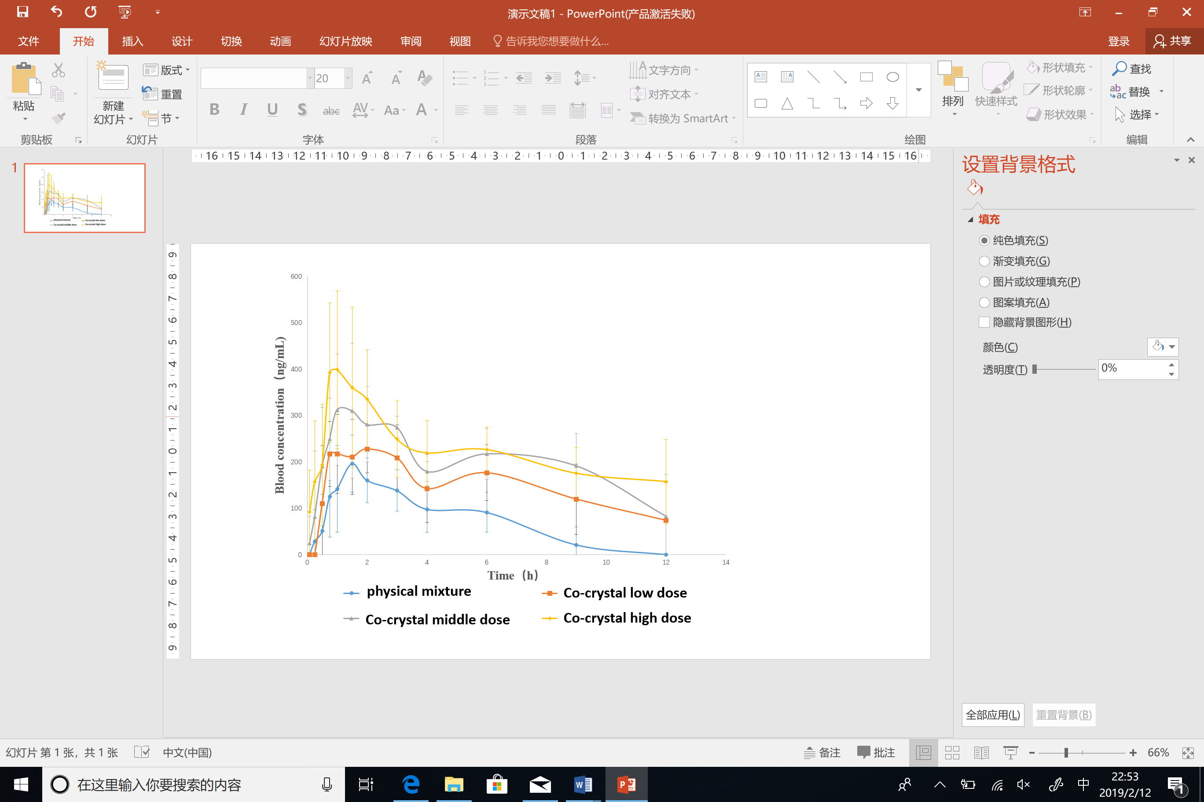
Recent Publications: (Minimum 5)
1. OKAZAKI Y, ZHENG C, LI M, et al. Effect of the cholinesterase inhibitor donepezil on cardiac remodeling and autonomic balance in rats with heart failure [J]. The Journal of Physiological Sciences, 2010, 60(1): 67-74.
2. KAKINUMA Y, AKIYAMA T, SATO T. Cholinoceptive and cholinergic properties of cardiomyocytes involving an amplification mechanism for vagal efferent effects in sparsely innervated ventricular myocardium [J]. The FEBS journal, 2009, 276(18): 5111-25.
3. HANDA T, KATARE R G, KAKINUMA Y, et al. Anti-Alzheimer's drug, donepezil, markedly improves long-term survival after chronic heart failure in mice [J]. Journal of cardiac failure, 2009, 15(9): 805-11.
4. KUBO T, SATO T, NOGUCHI T, et al. Influences of donepezil on cardiovascular system--possible therapeutic benefits for heart failure--donepezil cardiac test registry (DOCTER) study [J]. Journal of cardiovascular pharmacology, 2012, 60(3): 310-4.
5. BADAR A A, PEREZ-MORENO A C, HAWKINS N M, et al. Clinical Characteristics and Outcomes of Patients With Coronary Artery Disease and Angina: Analysis of the Irbesartan in Patients With Heart Failure and Preserved Systolic Function Trial [J]. Circulation Heart failure, 2015, 8(4): 717-24.
6. KAPLAN N M. Angiotensin II-receptor blockers: will they replace angiotensin-converting enzyme inhibitors in the treatment of hypertension? [J]. Journal of human hypertension, 2000, 14(1): S87-90.
7. TRONVIK E, STOVNER L J, HELDE G, et al. Prophylactic treatment of migraine with an angiotensin II receptor blocker: a randomized controlled trial [J]. Jama, 2003, 289(1): 65.

Biography: (150 words limit)
Ph.D. Du Guanhua has his expertise in drug crystallography research and relationship between drug polymorphism and biological activity. He is professor of Institute of Materia Medica, Chinese Academy of Medical Sciences & Peking Union Medical College (CAMS & PUMC), Director of National Center for Pharmaceutical Screening. And he is President of Chinese Pharmacological Society, Member of Asian West Pacific Pharmacologist Association Executive Committee, Member of Chinese Pharmacopoeia Commission.
Email: dugh@imm.ac.cn

