Single Crystal X-ray Structures of Coordination-Driven Self-Assemblies
Dong Hwan Kim, MS and Ki-Whan Chi*, Prof., University of Ulsan, Ulsan, Republic of Korea

Abstract:
In recent years, coordination-driven self-assembly has become a dominant method for constructing 2D and 3D supramolecular architectures. These supramolecular architectures are fascinating not only because of their structural beauty and topological importance but also because of their application in catalysis, host-guest chemistry, molecule recognition, and drug-delivery. Our group has reported a number of complex supramolecular topologies such as [2]catenane or Hopf link, Solomon links, Borromean rings, ring-in-ring and very recently a molecular knot 8₁₈ using this method. Due to the structural complexity, determination of structure by conventional spectroscopic techiques is not possible, therefore, single-crystal X-ray analysis remains the only technique to established the structure. Suitable single crystals for X-ray diffraction analysis were obtained by the vapor-diffusion method. Coordination-driven self-assembly of tetracene-based Ru(II)-acceptor and 1,4-bis(4-pyridylethynyl)tetrafluorobenzene donor along with the non-covalent interactions (CH···π and π− π) results in the formation of a molecular Borromean ring, as revealed by synchrotron X-ray diffraction analysis (Fig 1). After establishing the solid-state structure, other complimentary spectroscopic techniques such as ¹H NMR, ¹³C NMR, and ¹H DOSY, along with ESI-MS and elemental analysis were used to fully establish the structure in solid as well in solution state.

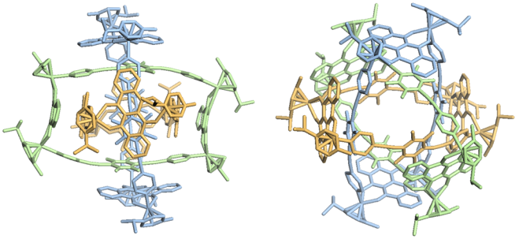
Fig 1. Crystal structure of coordination-driven self-assembly of 1,4-bis(4-pyridylethynyl)tetrafluorobenzene donor with an arene ruthenium acceptor.
Recent Publications:
- Kim D, Singh N, Oh J, Kim E, Jung J, Kim H, Chi K (2018) Coordination-Driven self-assembly of a molecular knot comprising sixteen crossings.
Angewandte Chemie International Edition 130(20): 5771-5775
- Singh N, Kim D, Kim D, Kim E, Kim H, Lah M, Chi K (2017)
Selective synthesis of iridium (III)-derived molecular Borromean rings,[2] catenane and ring-in-ring macrocycles via coordination-driven self-assembly
Dalton Transactions 46(2): 571-577
- Kim T, Singh N, Oh J, Kim E, Jung J, Kim H, Chi K (2016)
Selective synthesis of molecular Borromean rings: engineering of supramolecular topology via coordination-driven self-assembly
Journal of the American Chemical Society 138(27): 8368-8371
- Song Y, Singh N, Jung J, Kim H, Kim E, Cheong H, Kim Y, Chi K (2016)
Template-free synthesis of a molecular Solomon link by two-component self-assembly
Angewandte Chemie International Edition 128(6): 2047-2051
- Lee H, Elumalai P, Singh N, Kim H, Lee S, Chi K (2015)
Selective synthesis of ruthenium (II) metalla [2] catenane via solvent and guest dependent self-assembly
Journal of the American Chemical Society 137(14): 4674-4677

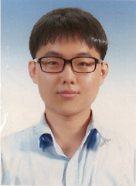
Dong Hwan Kim was born in Ulsan, Republic of Korea in 1989. He obtained his master’s degree in chemistry from the University of Ulsan in 2016 and thereafter he started his PhD studies at the same University under the guidance of Prof. Ki-Whan Chi. His research interest is in the area of molecular topology via coordination-driven self-assembly.
Email: ushj30302@naver.com
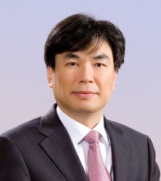
Professor Ki-Whan Chi obtained his Ph. D degree from the University of Washington in 1987 and now he is a Professor of Chemistry in the University of Ulsan, Korea. His research interests are primarily in the area of supramolecular chemistry and organic synthetic methodology.
Email: kwchi@ulsan.ac.kr

