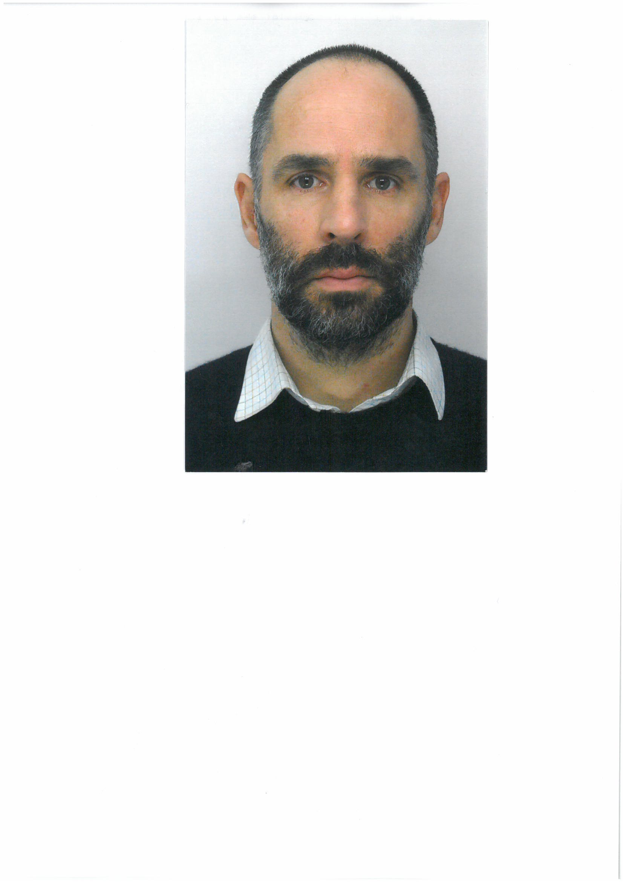Crystallite size, composition and structural feature correlations and their impact on opto-electronic properties of inorganic oxides.
Manuel GAUDON, Dr., ICMCB(UMR5026) - University of Bordeaux, France

Abstract: 300 words
From more than a decade, in the Institute of Condensed Matter Chemistry of Bordeaux, we have been trying, to elaborate new functional nanomaterials with their optical properties controlled both via the crystalline structural network (solid chemistry approach) and via the crystalline size and shape (material science approach). Especially, nano-powders for pigment applications are concerned. In this talk, the focus is made on the importance of the synthesis route for the obtaining of nano- or sub-micronic particles: mecanosynthesis, sol gel processes, coprecipitation, spray pyrolysis, Pechini process, polyol synthesis… are briefly described and compared in term of relative cost and drawbacks/benefits. Especially, the influence of the crystalline domain size on the opto-electronic properties of inorganic oxides is discussed from numerous examples:
- Influence of crystalline size on the structural parameters, on dopant solubility limit as well as on chemical homogeneity (atomic positions and unit-cell dimensions) is illustrated from the study of n-doped ZnO obtained from polyol route, [1-2]
- Influence of the crystalline size on the interstitial site symmetry (key factor governing the optical properties) and its consequence on the red chromaticity of hematites, [3]
- Influence of the crystalline size on cationic distribution inside multisite matrices, especially on the (Co²⁺, Mn²⁺) chromophore distribution inside white spinel matrix. [4-6]
- Influence on the crystalline size and shape on the 1st order phase transition pressure-temperature associated with piezochromic-thermochromic phenomenon in AMoO₄ compounds [7]
Finally, it will be shown that nowadays, such materials receive attention due to their potential applications as smart pigments, convivial temperature/pressure indicators, in the areas of safety/security improvements, gadgets, packaging, motorization, autoclaves, shock detection on fragile substrates…

Image:
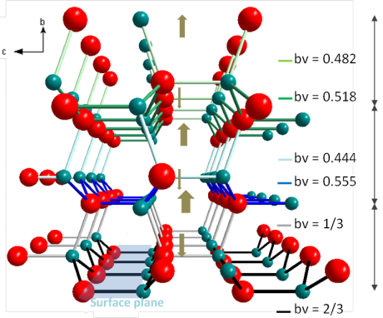
Wurtzite structure from reference [1]
Recent Publications: (Minimum 5)
- New insights into crystallite size and cell parameters correlation for ZnO nanoparticles obtained from polyol-mediated synthesis. Trenque, I., Mornet, S., Duguet, E., Gaudon, M. Inorg. Chem., 52 (21), 2013, pp. 12811-12817
- Discussion on the structural anisotropy of würtzite-type compounds. Trenque, I., Mornet, S., Villesuzanne, A., Gaudon, M. Solid State Sciences, 21, 2013, pp. 81-84.
- Impact of structural features on pigment properties of α-Fe₂O₃ haematite. Pailhé, N., Wattiaux, A., Gaudon, M., Demourgues, A. J. Solid State Chem., 181 (10), 2008, pp. 2697-2704
- Luminescence switch of Mn-Doped ZnAl₂O₄ powder with temperature. Cornu, L., Duttine, M., Gaudon, M., Jubera, V. J. Mater. Chem.C, 2 (44), 2014, pp. 9512-9522.
- Defects in divided zinc-copper aluminate spinels: Structural features and optical absorption properties. Le Nestour, A, Gaudon, M., Villeneuve, G., Daturi, M., Andriessen, R., Demourgues, A. Inorg. Chem., 46 (10), 2007, pp.4067-4078.
- Cobalt and nickel aluminate spinels: Blue and cyan pigments. Gaudon, M., Robertson, L.C., Lataste, E., (...), Ménétrier, M., Demourgues, A. Ceramics International, 40 (4), 2014, pp. 5201-5207.
- Sub-micrometric β-CoMoO₄ rods: Optical and piezochromic properties. Blanco-Gutierrez, V., Demourgues, A., Gaudon, M. Dalton Transactions, 42 (37), pp. 13622-13627.

Biography:
Dr. Manuel Gaudon, associated professor, in the University of Bordeaux, 44 years old, 73 publications (Chem. Matter, Adv. Mater., Inorg. Chem., JSSC, …), 4 proceedings, 2 book-chapters, with h-index 21, more than 20 Orals in international material conferences (MRS fall-meetings, european-MRS, RSC-conferences, Euromat…). He is specialist of inorganic pigments for X-chromic properties (thermochromic, piezochromic, photochromic) with solid-state chemist approach. Mainly, he worked on inorganic oxides with various structures as molybdates (AMoO₄), hematite (Fe₂O₃), würtzite (n-doped ZnO), vanadium oxides (V₂O₃, VO₂, V₂O₅) or aluminate spinels (CoAl₂O₄,ZnAl₂O₄, MnAl₂O₄…). Manuel Gaudon has got a wide experience in the management of individual or collaborative projects (Fr-national, European, International ones) on infrared-reflector, on irreversible thermochromic oxides for temperature detection, on shock sensors based on piezochromic transitions of AMoO₄ compounds...
Email: manuel.gaudon@icmcb.cnrs.fr

