Crystallography of novel monodithiolene molybdenum and tungsten complexes and their precusors
Chrysochos Nicolas, Benedict Elvers, Christian Fischer and Carola Schulzke, Institute of Biochemistry, University of Greifswald, Greifswald, Germany

Abstract:
Monodithiolen complexes of molybdenum and tungsten have always attracted significant scientific interest as firstly they can potentially be adapted as artificial molybdopterin/tungstopterin cofactors and secondly their crystal structures can provide powerful information about the coordination sphere in the natural Mo/W cofactor. With this information a better comprehension of the reaction mechanisms as well as the physicochemical properties of the natural enzyme can be achieved. So far the most accurate structural analogue of native molybdoenzymes´ first coordination sphere was designed by Holm et al in 2001 [1]. Today´s many challenges remain regarding the synthetic efficiency, structural accuracy and catalytic activity.
In our lab, we developed a novel synthetic strategy for establishing Mo and W monodithiolene complexes. The synthetic success was supported by some notable crystal structures of those complexes and their metalprecursors [2]. Pre-activated compounds 1 and 2 are isomorphous and crystalize in the P2₁/c space groups with clearly octahedral geometry and trans angles of 172.22(12)° to 176.38(14)° in 1 and 171.9(4)° to 176.8(4)° in 2. The Bailar twist angle in 1 ranges between 54.95° and 60.43° and in 2 between 55.34° and 59.88°. The focal molecules 3 and 4, which were synthesized from 1 and 2, respectively, by replacing the labile thf and one of the basal CO ligands, crystallize in the orthorhombic space group P2₁2₁2₁. The geometry of the final compounds changes from clearly octahedral to decidedly trigonal prismatic, which is strongly associated with dithiolene complexes as evidenced by several related crystal structures [3-8], even though such complexes are extremely rare. It has to be pointed out that in the case of 3 and 4 the nearly perfect trigonal prismatic geometry is confirmed by the Bailar twist angle. Most surprisingly in 3 and 4 the torsion angles of the P-C-C-P moiety of dppe is close to 0 with only 7.3°. This indicates an almost planar arrangement which is extraordinary for dppe complexes.

Image:
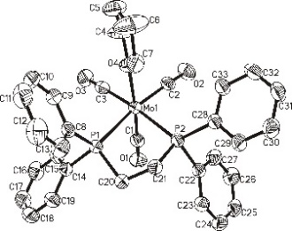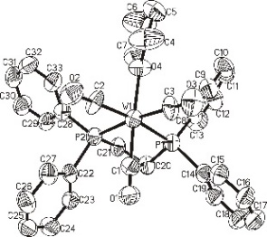
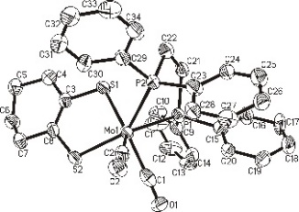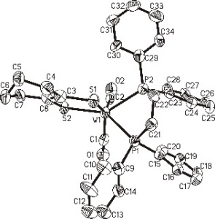
Figure 1: [Mo(CO)₃(dppe)(THF)] (1), [Wo(CO)₃(dppe)(THF)] (2) top and [Mo(CO)₂(cydt)(dppe)] (3), [Mo(CO)₂(cydt)(dppe)] (4) bottom. Thermal ellipsoids are shown at the 50% probability level. H atoms are not shown for clarity reasons.[2]
Reference :
- Lim B., Willer M., Miao M., Holm R. J. Am. Chem. Soc., 2001, 123, 8343-8349
- Elvers B., Nowack R., Schulzke C., Fischer C. in preparation.
- Yan Y., Keating C., Chandrasekaran P., Jayarathne U., Mague J., DeBeer S., Lancaster K., Sproules S., Rubtsov I., Donahue J. Inorg. Chem. 2013, 52, 6743-6751.
- Tsukada S., Abe N., Gunji T., Polyhedron 2016, 117, 73-79
- Chandrasekaran P., Arumugam K., Jayarathne U., Pérez M., Mague T., Donahue P., Inorg. Chem., 2009, 48, 2103-2112
- Baker K., Drew B., Parker E., Robertson N., Underhill A., J. Chem. Soc., Dalton Trans. 1997, 1429-1434
- Lang R., Ju T., Bryan J., Kubas G., Hoff C., Inorg. Chim. Acta 2003, 348, 157-164
- Barnard K., Wedd A., Tiekin E., Inorg. Chem. 1990, 29, 891-892

Biography:
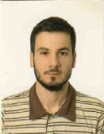 Nicolas Chrysochos received his Master degree of science in biochemistry from University of Greifswald. Since 2015 is PhD-student under supervision of Prof. Dr. Carola Schulzke at Bioinorganig Chemistry, Institute of Biochemistry, University of Greifswald. His PhD research concentrate on the development of new models for the molybdopterin and tungstopterin cofactors with focus on coordination sphere, physicochemical properties and catalytic activity of the model compounds. During his PhD is paying particular attention on the crystallography of the target models.

Email: nicolas.chrysochos@uni-greifswald.de

