Title: Femtoscope: Atomic Resonance in ATP Imposes the Necessary and Sufficient Conditions for Cancer Efficient Radiotherapy.
Edward Jimenez, Prof. Ph.D, Chemical Engineering Faculty of Central University, Quito, ECUADOR.
Nicolas Recalde, PhD(c ). MSc. Physics Department, South Carolina University, USA.

Abstract:
The success of Medical Physics and Oncology in the treatment of prostate and breast cancer, with an efficiency greater than 99%, shows us that the resonance produced by the equality of the wavelength of Rx and the Bohr radius at low energies is a sufficient condition for an efficient cancer radiation treatment, while ionization is the necessary condition. Biochemistry and Biophysics converge to demonstrate that the fundamental goal for cancer cure is to inhibit the synthesis of ATP in the cell nucleus and selectively attack tumor cells. We propose that it is possible to achieve a regeneration of ATP at the mitochondria through a resonance of the phosphorus bonds. A resonance region is created in a natural way at the K-shell between the nucleus and the electrons at S-level. The condition for the photons to enter into the resonance region is given by r_{a}>r_{n} + λ.
The efficiency of radiotherapy is a function of resonance, ionization and the effective cross-section of phosphorus within the ATP, in terms of correcting cellular metabolism in mitochondria. In addition, resonance is one of the causes of ionization and allows us to measure the efficiency of radiotherapy, which was corroborated with Monte Carlo simulation performed with Geant4. The cancers treated with low energy are cured, because resonances are created in the atom of phosphorus which is a component of the DNA. The other DNA atoms such as: H, C, N and O do not have resonances giving this way stability to the DNA. The phosphorus atom has larger X-ray resonances among the DNA components, having an energy threshold of 2146 eV according to NIST and 1992 eV according to Geant4. We then conclude that radiation cancer treatment using X-rays is efficient only when they produce resonances. We have also coined the term femtoscope which measures dimensions and interactions in the range of femtometers.

Image:
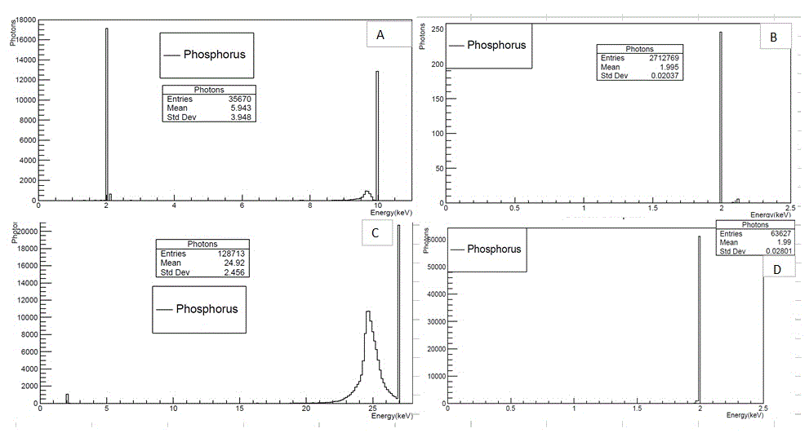
Figure 1. Phosphorus resonance peaks. We can see the resonance peaks obtained using Geant4 Monte Carlo Code for different energy limits of the primary photons. Figure A shows absorption peak at 1992 eV, which was a result of the resonance when using 10 kV primary photons. The peak at 10 keV is due to photons that did not have any interaction at phosphorus target. We also have a Compton effect peak. The graphs B, C, D also indicate resonance peaks at 1992 keV for primary photons at different energies.
Recent Publications:
[1] Wright RH, Lioutas A, Le Dily F et al. ADP-ribose-derived nuclear ATP synthesis by NUDIX5 is required for chromatin remodeling. Science. (2016).
[2] François Le Dily, Davide Baù1, Andy Pohl et al., Distinct structural transitions of chromatin topological domains correlate with coordinated hormone-induced gene regulation Genes Dev. (2017).
[3] Tong Zhang, Jhoanna G. Berrocal, Jie Yao et al. Are poly(ADP-ribosyl)ation by PARP-1 and deacetylation by Sir2 linked?. J. Biol. Chem. 287, 12405–12416. (2012).
[4] Hubbell, J.H and Seltzer, S.M. X-ray Mass Attenuation Coefficients, Radiation Division, PML, NIST, 2017. Available online: https://www.nist.gov/pml/x-ray-mass-attenuation-coefficients (accessed on 01 May 2017).
[5] Edward Jiménez, Nicolas Recalde and Esteban Jiménez, Extraction of the Proton and Electron Radii from Characteristic Atomic Lines and Entropy Principles. Entropy 2017.

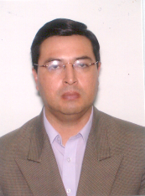
Biography:
Edward Jimenez, has experience in low-energy x-ray diffraction, in oil refining applications and especially in allophones, which is a nano clay that contains silicon and aluminum and exists in the form of powder and one of the largest reserves of allophane is in Ecuador. His main research focuses on the structure of the nuclear surface and the measurement of nuclear stability parameters, with the aim of implementing the x-ray femtoscope. Currently, he is the research director of the Faculty of Chemical Engineering of the Central University of Ecuador. In addition, he was director of research of the Petroleum Company, PETROECUADOR, 2008-2015.

Email: ehjimenez@uce.edu.ec

Nicolas Recalde, has worked for 15 years in cancer radiotherapy at Georgetown University Medical Center and Inova Health System, USA. He was Chief Medical Physicist at Potomac Radiation Center in Virgina, USA. Currently he is pursuing his doctorate degree in Physics at University of South Carolina, USA. His research is about low energy associated with miniature X-ray sources and their use for cancer treatment. He is a diplomate of the American Board of Radiology and a member of the American Association of Physicists in Medicine.
Email: recalde@email.sc.edu

