Title: The x-ray femtoscope allows us to measure the interaction between dark matter and the atomic nuclei of Cr, Xu and Tm.
Edward Jimenez, Prof. Ph.D, Chemical Engineering Faculty of Central University, Quito, ECUADOR.

Abstract:
The x-ray femtoscope measures dimensions and interactions in the range of femtometers. In this way it detects interactions at the boundary of the nuclear surface, and has even allowed measuring the radii of protons on the nuclear surface and the electrons of the K layer [1], [2]. To measure dimensions of the order of the femtometers, it uses resonance and interference of the x-rays with the nuclear surface, using only the K edge data, for each of the elements of the periodic table 11 <Z <92. Because of the non-invasive nature of low energy x-rays, we can measure a minimal abnormality of the cross section or energy (k edge) on the nuclear surface. For this reason, we can detect dark matter or WIMPs, which interact and hide on the nuclear surface [3]. Fortunately, after studying these interactions with all the elements of the periodic table, only three elements: Cr, Xe and Tm present resonances.
Dark matter (< (100±2) eV/c²) acts directly and resonantly with the excess mass, energy and cross section of the atomic nuclei of xenon, thulium and chromium, through the weak force, which is represented by the solution of the Navier Stokes equations [4]. The dark matter is hidden in the vicinity of the nuclear surface (10⁻¹⁸m), it interacts modifying the effective sections and the K edge energy [5]. We studied the total absorption of low energy x-rays (<1.16MeV) for the elements of the periodic table 11≤Z≤90, with a precision of the order of the Rydberg constant, and the radius of the neutron (0.842 (3) fm) using experimental NIST data and GEANT4 simulation for (0.993(9) <R²<0.999(6)) [6]. Finally, it was proved theoretically and experimentally that the weak force controls the circular trajectories of the nucleon layers in the atomic nucleus, the interaction with dark matter and the nuclear stability P (x, y, z).

Image:
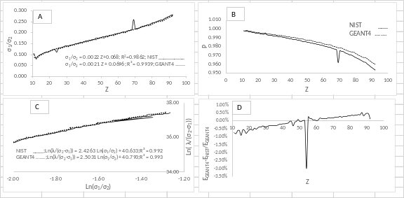
Figure 1. A.- Cross section excess measure presence of dark matter for ₂₄Cr and ₆₉Tm. B.-Evolution of nuclear stability P, depending on the ratio of the cross sections. We obtained the probability P (x, y, z, t) which is the fundamental solution of the Navier Stokes equations, measures the Nuclear stability and represents both the behavior of the atomic nucleus in equilibrium and out of equilibrium such us gamma or beta decay C.- Calculation of the Rydberg constant using Navier Stokes model. D.- Energy excess. For ₅₄Xe, we can see the resonance in energy.
Recent Publications:
[1] Jimenez, Recalde, Jimenez Chacon (2017). Extraction of the Proton and Electron Radii from Characteristic Atomic Lines and Entropy Principles. Entropy 2017.
[2] Pohl, R et al. (2010). The size of the proton. Nature 2010, 466, 213--216.
[3] M. Markevitch, A. H. Gonzalez, D. Clowe et al (2004) : DIRECT CONSTRAINTS ON THE DARK MATTER SELF-INTERACTION CROSS SECTION FROM THE. MERGING GALAXY CLUSTER 1E 0657 56. The Astrophysical Journal, 606:819--824, (2004).
[4] David Harvey F. Courbin J. P. Kneib et al. (2017) : A detection of wobbling brightest cluster galaxies within massive galaxy clusters. Monthly Notices of the Royal Astronomical Society, Volume 472, Issue 2, 1 December 2017.
[5] Masahiro Kawasaki, Kazunori Kohri and Takeo Moroi (2018): Revisiting big-bang nucleosynthesis constraints on long-lived decaying particles, PHYSICAL REVIEW D 97, 023502 (2018)
[6] E. Aprile et al. (2017) : Search for bosonic super-WIMP interactions with the XENON100 experiment,. (XENON Collaboration), Phys. Rev. D 96, 122002, (2017).


Biography:

Edward Jimenez, has experience in low-energy x-ray diffraction, in oil refining applications and especially in allophones, which is a nano clay that contains silicon and aluminum and exists in the form of powder and one of the largest reserves of allophane is in Ecuador. His main research focuses on the structure of the nuclear surface and the measurement of nuclear stability parameters, with the aim of implementing the x-ray femtoscope. Currently, he is the research director of the Faculty of Chemical Engineering of the Central University of Ecuador. In addition, he was director of research of the Petroleum Company, PETROECUADOR, 2008-2015.
Email: ehjimenez@uce.edu.ec

