Fluorination of cuspidine-related phases, Ln₄Al₂O₉ (Ln=Sm, Eu, Gd, Tb)
Aroa Morán-Ruiz*, Aitor Larrañaga, Peter Slater, Maribel Arriortua
*Postdoc, University of the Basque Country, Basque Country, SPAIN

Abstract: 300 words
The structural properties of the Ln₄Al₂O₉ (Ln=rare-earth) type phases have attracted attention because of their ionic conductivity and thermal stability [1-3]. Minerals belonging to the cuspidine group have the following general stoichiometry: M₄(Si₂O₇)X₂ (M= divalent cation; X= OH, F, O), with Ca₄(Si₂O₇)(OH,F)₂ being the archetype compound. The cuspidine structure can be described as built up of chains of edge-sharing MO₇/MO₈ polyhedra running parallel to the a-axis (in the P2₁/c space group) with tetrahedral disilicate groups, Si₂O₇, interconnecting these ribbons through the vertexes [3].
In more recent years the preparation and characterization of inorganic oxide fluorides has attracted significant interest [4]. Given the recent studies on oxide ion/proton conductivity in La₄(Ga_{2-x}Ti_{x}O_{7+x/2})O₂, illustrating the ability of the cuspidine structure to accommodate extra anions [5], we have investigated the possible incorporation of fluorine into Ln₄Al₂O₉ to give Ln₄Al₂O_{9-x}F_{2x} (Ln= Sm, Eu, Gd, Tb) (0≤x≤1). We report here on the results of the fluorination of a range of cuspidine-related phases of composition Ln₄Al₂O₉ (Ln=Sm, Eu, Gd, Tb). The introduction of fluorine (2F⁻ replace 1O²⁻) is achieved through a low-temperature (400ºC) reaction with poly(vinylidene fluoride) (PVDF) or poly(tetrafluoroethylene) (PTFE). We investigate the effects of fluorination on the starting structure by X-ray diffraction, Raman spectroscopy and X-ray photoelectron spectroscopy. The thermal stability of these samples before and after fluorination was evaluated in air.
The starting materials Ln₄Al₂O₉ (Ln=Sm, Eu, Gd, Tb) showed a monoclinic crystal structure with space group of P2₁/c (Figure 1), as was expected. The XRD patterns show that fluorination induces a shift in peak position to lower angles corresponding to an increase in unit cell sizes as the total anion content increases. The characterization of these new systems will be reported.

Image:
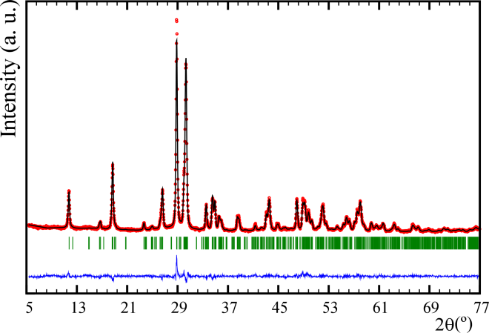
Figure 1. Rietveld refinement of the cuspidine-related Eu₄Al₂O₉ phase (space group P2₁/c).

Recent Publications: (Minimum 5)
- Ghosh S (2015) Thermal barrier ceramic coatings-a review, in: A.M.A. Mohamed (Ed.), Advanced ceramic processing, InTech.
- Zhou X, Xu Z, Fan X, Zhao S, Cao X, He L (2014) Y₄Al₂O₉ ceramics as a novel thermal barrier coating material for high-temperature applications. Materials Letter 134:146-148.
- Martín-Sedeño MC, Marrero-López D, Losilla ER, Bruque S, Núñez P, Aranda MAG (2006) Stability and oxide ion conductivity in rare-earth aluminium cuspidines. Journal of Solid State Chemistry 179:3445-3455.
- Clemens O, Slater PR (2013) Topochemical modifications of mixed metal oxide compounds by low-temperature fluorination routes. Reviews in Inorganic Chemistry 33:105-117.
- Martin-Sedeno MC, Marrero-Lopez D, Losilla ER, Leon-Reina L, Bruque S, Nunez P, Aranda MAG (2005) Structural and electrical investigations of oxide ion and proton conducting titanium cupsidines. Chemistry of Materials 17:5989-5998.


Biography: (150 words limit)

Aroa Morán-Ruiz studied Chemistry at the University of the Basque Country (UPV/EHU) (2004-2009). She has completed a master´s in Forensic Analysis at UPV/EHU (2009-2010). In 2010 she joined to the research group of Prof. Maribel Arriortua at UPV/EHU. In 2012 Aroa was granted with a PhD fellowship by the University of the Basque Country. She was a 3 month PhD visiting student at the University of Birmingham (UK) under the supervision of Prof. Peter Slater. On June 2015 she finished his PhD studies (Inorganic Chemistry) at the UPV/EHU. Aroa is currently working as a postdoctoral researcher funded by the University of the Basque Country. She is working in several topics such as synthesis and characterization of rare earth oxides. She is habitual user of X-ray powder diffractometer. Aroa has experience in Synchrotron X-ray measurements and, structural analysis by Rietveld refinement. She has knowledge of X-ray photoelectron spectroscopy and Raman spectroscopy.
Email: aroa.moran@ehu.eus

