Synthesis and crystal structure of new poly(organic-inorganig) polymers poly[Cu(NO₂‐acac)₂]_{n}

Hadi Salman Al‐Lami, PhD,
University of Basrah, Basrah, IRAQ

Abstract:
Coordination polymers are a class of polymers whose repeated units are coordination complexes. A subclass of these is the metal‐organic frameworks that are coordinated with organic ligands containing potential voids. Coordination polymers are relevant to many fields such as organic‐, inorganic‐, bio‐, electro‐chemistry; material science and pharmacology. Many potential applications led to extensive studies in the past few decades.
Coordination polymers have many applications such as dyes, molecular storages, catalysts, ion exchange, electrical conductors, bioactive molecules, sensors, and single molecule magnet. Also, they can be used in the fields of molecular electronics, medicine, luminescence and optics.
Herein, we report the synthesis of the poly{bis‐(3‐nitro‐2,4‐pentanediono)‐copper(II)} linked via nitro group as bridging agent. Thus, we believe that this moiety can be functioned as a channel for energy and electron transference, presenting the X‐ray single crystal structure of [‐Cu‐{Cu(NO2‐acac)2}3‐Cu‐]n.
The organo‐inorganic polymer, poly{bis‐(3‐nitro‐2,4‐pentanediono)‐copper(II)}, [{Cu(NO₂‐acac)₂}₃]_{n}, has been prepared and its crystal structure was determined. The structure consists of a trimeric unit in which, acetylacetone ligated symmetrically to copper atoms that pose in the center of octahedrons. The three octahedral fragments of the trimer are linked to each other through nitro group. Crystal Data: C₁₀H₁₂CuN₂O₈, Mr = 351.76, triclinic, P‐1 (No. 2), a = 5.8237(2) Å, b = 7.7963(3) Å, c = 7.8847(3) Å, α = 81.988(2)°,  = 75.294(2)°, γ = 72.217(2)°, V = 328.98(2) Å3, T = 143(2) K, Z = 1, Z' = 0.5, μ(Mo Kα) = 1.703, 3021 reflections measured, 1421 unique (R_{int} = 0.0156) which were used in all calculations. The final wR2 was 0.0686 (all data) and R1 was 0.0217 (I > 2σ (I)).
The three repeating units are linked via the nitro group as bridged moiety attached to α‐position of the acetylacetonato ligand. The base plane of each monomeric unit being formed with the four oxygen atoms, namely O₁, O^{i}₁, O₂ and O^{i}₂ belongs to the acac ligand coordinated to the central Cu‐atom. Cu atom is bonded axially to O^{ii}₃ and O^{iii}₃ of the nitro groups whose belong to the prepared monomers adopting distorted octahedral geometry in each monomer. Thus, it seems that the axial Cu‐O^{ii}₃ and Cu‐O^{iii}₃ are longer than the equatorial Cu1‐O11.9233(13) Å) and Cu1‐O2 (1.9195(13) Å) led to distorted octahedral geometry, in which the Cu atom is located at its center.
Image: 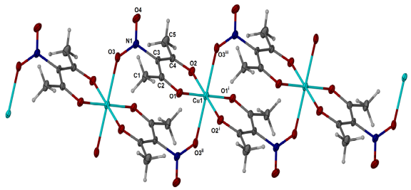
Figure. X‐ray single crystal structure of [Cu‐{Cu(NO₂‐acac)₂}₃‐ Cu]n.
Recent Publications:
- Ghali NG, Al‐Assadi MJ, Al‐Lami HS, Kadhum AH (2017) Synthesis and crystal structure of poly{bis‐(3‐nitro‐2,4‐pentanediono)‐copper(II)}. European Journal of Chemistry 8 (2): 109‐111.
- Al-Mayyahi BA, Haddad AM, Al-Lami HS (2017) Karbala International Journal of Modern Science Characterization and thermal stability of nano eight arm copolymers synthesized by atom transfer radical polymerization, 3:83-92.
- Sweah ZJ, Al-Lami HS, Haddad AM (2016) Preparation and Swelling Behavior of L-Lactide Interpenetrating Networks, Open Journal of Organic Polymer Materials, 6:119-133.
- Haider, MH, Al-Lami HS, Al-Fregi, AA (2016) Sizing and thermal stability of prepared tetraaminophthalocyaninatocopper(II) derivatives-grafted polymers. Baghdad Science Journal 13:221-234.
5. Jalal MA, Al-Lami HS (2014) New limited molecular weight polymeric dispersants prepared by melt condensation polymerization. Chemistry and Materials Research 6(2):12-18.


Biography: (150 words limit)

Hadi Salman Al-Lami is working as Professor of polymer chemistry and In addition teaches courses in advance polymer chemistry, inorganic polymers, and biomaterial chemistry and supervising many M.Sc. and Ph.D. postgraduate students. He has published about 100 peer-reviewed papers and three books, beside 10 Iraqi Patents

Email: hadisalman54@yahoo.com

