Contemporary diffraction methods in study of polycrystals

Stanko Popović, Antun Tonejc and Željko Skoko

Physics Department, Faculty of Science, University of Zagreb, Bijenička cesta 32,10002 Zagreb, POB. 331, Croatia

Diffraction in the polycrystal⁄crystalline powder is one of the most powerful techniques in study of microstructure and crystal structure of solids. This technique, in synergy with microscopic, spectroscopic and other physical techniques, enables a complete analysis of one- and multi-phase substances that are important in scientific and technological fields. Information on microstructure and crystal structure of a substance is stored in its diffraction pattern; in order to reveal this information, the diffraction pattern should be decoded by application of adequate mathematical and physical procedures which may often be rather complex. During the last decades, diffraction techniques in the polycrystal are developing rapidly due to the introduction of sophisticated instrumentation, powerful computers and by application of synchrotron radiation. This enables the collection and interpretation of diffraction data in a short real time, revealing: qualitative and quantitative phase analysis; 3D distribution of electron density (e.g. in metallic glasses); accurate measurement of periodicity in the crystalline substance; solubility limits in solid solutions; precipitation processes in supersaturated solid solutions (e.g. metallic alloys); thermal expansion; phase transitions; phase diagrams; chemical stability, decomposition of chemical compounds; crystallite size, kinetics of crystallite growth, recrystallization, strains, annealing of defects; time-resolved dynamical processes; crystal structure, 3D positions of atoms, lengths and nature of chemical bonds, coordination, conformation; resolution of lattice planes and rows of atoms in the crystal; influence of crystal structure, microstructure and defects on physical and chemical properties and on biological activity of a substance, applications in a number of fields of human activities.[1] Possibilities of diffraction techniques in the polycrystal are illustrated by examples of authors’ studies: phase transitions in TiO₂, precipitation processes in Al-alloys, metastable and stable phase diagram of Ga₂Se₃-In₂Se₃, the graphitization of petroleum coke, biomineralization processes in bivalves, phase transitions in thermosalient crystals.[2-5]
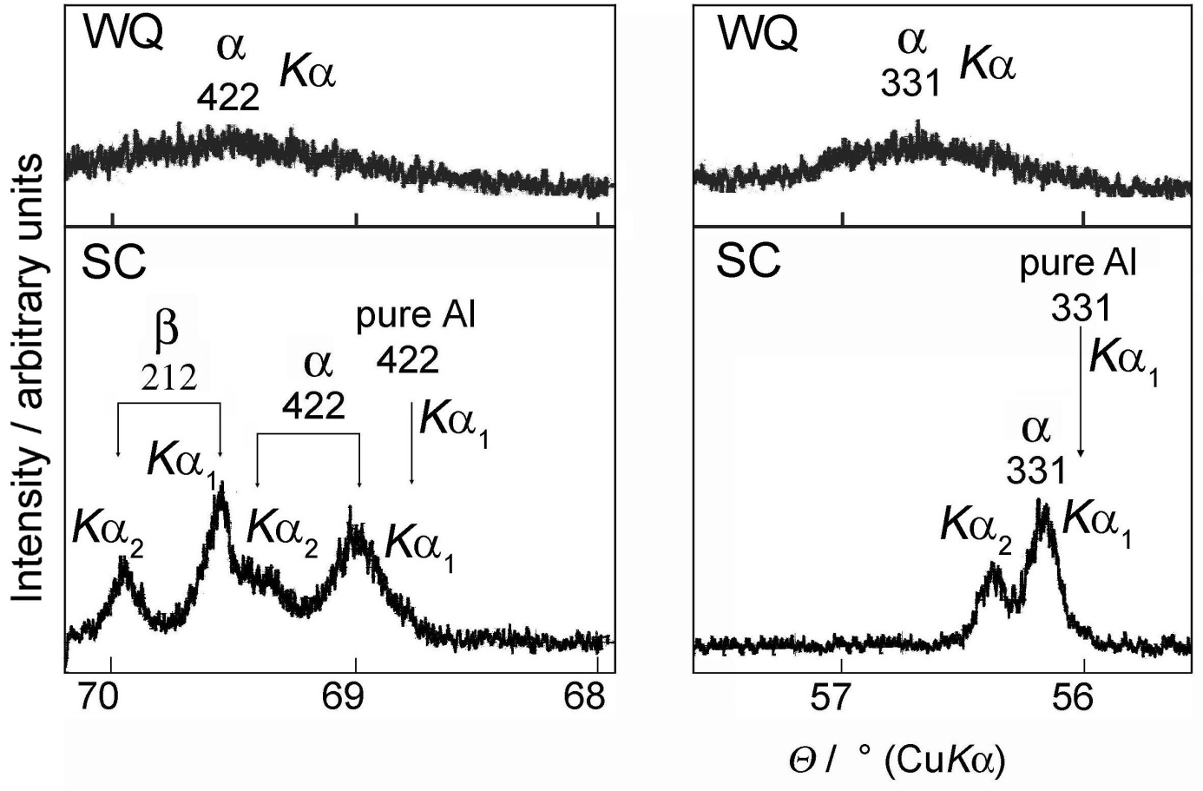Figure. Characteristic diffraction lines of rapidly (WQ) and slowly (SC) cooled Al-Zn alloy with x(Zn) = 0.48. Diffraction lines of the WQ alloy were scanned within 20 minutes after quenching. [2]

Recent publications
1. Powder Diffraction – Theory and Practice, R. E. Dinnebier and S. J. L. Billinge (Eds.), Cambridge RSC Publishing (2008); S. Popović, A. Tonejc and Ž. Skoko, Contemporary diffraction methods in study of polycrystals, Croat. Chem. Acta 88 (2015) 561-577.
2. Ž. Skoko, S. Popović and G. Štefanić, Microstructure of Al-Zn and Zn-Al alloys, Croat. Chem. Acta 82 (2009) 405-420; S. Popović, Ž. Skoko and G. Štefanić, Temperature dependence of microstructure of Al-Ag-Zn alloys, Z. Kristallogr. Suppl. 30 (2009) 309-314.
3. S. Popović and Ž. Skoko, X-ray diffraction broadening analysis, Maced. J. Chem. Chem. Eng. 34 (2015) 39-49; S. Popović, Ž. Skoko and G. Štefanić, Factors affecting diffraction broadening analysis, Z. Kristallogr.Proc. 1 (2011) 55-62; Ž. Skoko, S. Popović and G. Štefanić, Dependence of microstructure on errors in X-ray diffraction profile measurement, J. Mater. Sci. Eng. A3 (2013) 690-697.
4. Ž. Skoko, S. Zamir, P. Naumov and J. Bernstein, The thermosalient phenomenon. Jumping crystals, J. Am. Chem. Soc. 132 (2010) 14191-14202.
5. S. Popović, Quantitative phase analysis by X-ray diffraction, Maced. J. Chem. Chem. Eng. 34 (2015) 33-38.

