Complete Unilateral Cleft Lip Repair: A modification of the Mohler Surgical Technique
Dr Solano N. DDS, Head of the Craniofacial and Cleft Surgery Unit, Castillo Plaza Maternity, Maracaibo. Venezuela.

Abstract (300 word limit)
Introduction: Clefts manifested in cleft lip and palate are one of the most prevalent malformations in the craniofacial region. The objective of this study is to describe the surgical technique for the correction of unilateral cleft lip by means of a modification of the original Mohler technique with the same principle of rotation and advancement that allows us to obtain symmetry and balance on the cleft side. Patients and Methods: Two modifications were made to the original Mholer Technique, one established in the preparation of two flaps for the conformation of the floor of the nostril, with which the mucocutaneous limit of the borders of the normal and cleft lip and the conformation of the vermilion were obtained. Using Z-plasty, clinical photographic records of the surgical technique and preoperative records as well as immediate, mediate and late postoperative of the patients treated in our center were made. Results: In the patients who were treated under these modifications of Mohler Technique, the appropriate height was obtained on the cleft side compared to healthy side, both 1 week and 1 month after surgery, it was discovered that the patients did not appear a discontinuity in the mucocutaneous line or at the vermilion level, the symmetry relationships at the vermilion level have significant differences in both height and thickness 1 week after surgery that improved at the 1 month control after surgery. Conclusions: The modifications made in the Mohler technique can be applicable and flexible for complete and incomplete clefts, obtaining favorable results in the functional and esthetic parts that allow following the patients with the stage of facial growth.
Keywords: Cleft Lip, Mohler’s Technique, Z-plasty.

Image

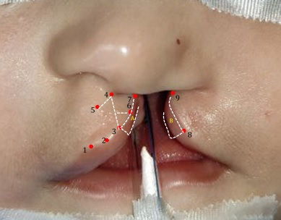
Recent Publications (minimum 5)
- Teissier N, Bennaceur, Abbeele TV. Primary Treatment of Cleft Lip and Palate. Otolayngol Cervicoac Surg. 2016; 17-01-14.
- Talmant JC, Talmant JC, Rousteau G, Lumineau JP. Labial and Palate Clefts; primary treatment. Reconstr Aesthetic Plast Surg. 2019; 27:1-24.
- Chacin T, Solano N, Gutierrez P. Guillén G, Rivera E. Complete Unilateral Cleft Lip and Palate repair: a Modification of the Millard surgical technique. Inter Ped Dent Open Acc J 5(2) – 2020.
- Giugliano C. Surgical Management of cleft lip and palate. In: Rostión CG, editor. Pediatric Surgery. 2nd Ed., Ch. 52: Mediterranean Technical Publications; 2014. P. 394-411.
365: 519-530.
5. Skyes JM, Tollefson TT. Method of cutting and suturing in the lip in complete unilateral cleft lip. Plast Reconstr Surg 2005; 13:157-67.

Photograph
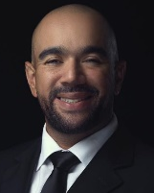

Biography (150 word limit)
Specialist in Oral and Maxilofacial Surgery with 10 years of experience, with emphasis in Dental Implants and Craniofacial Surgery, has his Expertise in Digital Planning on NemoScan and NemoFab Softwares, focused in Dental Implants and Orthognatic Surgery. Vice-president of ‘’Cambiando Vidas’’ Foundation, directed to the prevention, diagnosis and treatment of Craniofacial Malformations. Associate Professor of the Oral Surgery Postgrade of the University of Zulia, Maracaibo, Venezuela, adjunt of Maxilofacial Surgery Postgrade, Prince Lara Hospital, Carabobo, Venezuela. Private Practice on Integra Group, Maracaibo Venezuela.
Email: nicksolano@msn.com

*Name to be displayed in the certificate: Nicolas Solano
*Types of presentation: Speaking
*Email id: nicksolano@msn.com
*Contact number/WhatsApp: +58 4246065347

