Virtual planning and execution of craniofacial skull reconstruction procedures
Ulrich Meyer, MD, DMD, PhD; Craniofacial Center, Münster, Germany

Surgery of craniofacially malformed patients impose multiple difficulties. Skull reconstruction approaches are aimed to reconstruct a normal anatomy. It is difficult to define the treatment goal in these patients, since the malformed anatomy has a great deviation from norm. In all complex cases of craniosynostosis, branchial arch diseases and seldom syndromes normal reverence planes, angles and distances are missing. A high number of these patients have asymmetries, leading two dimensional planning principles behind. Three dimensional virtual planning and execution of bone surgeries are an evolving field in craniofacial surgery¹. To operate on these patients multiple aspects have to be considered: i) do we have reference systems (norm skulls) ² , ii) how to match the normal anatomy with the malformed anatomy (through overlay or mirroring procedures), iii) what kind of execution tools are available (splints, osteotomy and burr guides, PSI implants), iv) which operative strategy should be used³ and v) what is the precision of such reconstructions. The recent state of virtual surgery planning and execution in craniofacial malformation can be reached through a step-wise approach. Mathematical algorithms allow nowadays an automatic evaluation of data sets. Special emphasis is given on all steps of such treatment approaches. The generation of a normative skull database, the procedures of landmark detection, the various forms of matching procedures and the subsequent planning steps are presented. Different surgical execution tools allow the precise performance of craniofacial bone surgeries. The application of these principles is demonstrated for each group of craniofacial malformations from infancy to adulthood. Craniosynostosis patients, patients suffering from branchial arch diseases (Treacher-Collins-Syndrome, Goldenhar Syndrome) as well as seldom syndromic patients (frontonasal dysplasia) can be planned and treated through this approach⁴. Control of the operative precision through a matching of the planning with the operative outcome reveal a high precision of bone movements (Figure 1)⁵. Virtual planning and execution of craniofacial bone surgery is a promising new tool in craniofacial surgery. Artificial intelligence will accelerate all single steps of planning and execution.

References
- Meyer, U. Fundamentals of Craniofacial Malformations. (2023) Vol 2 Treatment Principles. Springer-Nature, Heidelberg
- Ludwigs L, Pape C, Visse HS, Runte C, Meyer U, Dirksen D. (2023) Cross Sectional Analysis of Eurasian Skull Anatomy for 3D Cephalometry-Normative Data Reveal Four Different Skull Types. .J Pers Med. Jun 19;13(6):1018
- Hopper RA, Ettinger RE, Purnell CA, Dover MS, Pereira AR, Tunçbilek G. (2020) Thirty Years Later: What Has Craniofacial Distraction Osteogenesis Surgery Replaced? Plast Reconstr Surg. Jun;145(6):1073e-1088e.
- Meyer, U. Fundamentals of Craniofacial Malformations. (2023) Vol 3 Surgical atlas, Springer-Nature, Heidelberg
- Kerkfeld V, Schorn L, Depprich R, Lommen J, Wilkat M, Kübler N, Rana M, Meyer U. (2022) Simultaneous PSI-Based Orthognathic and PEEK Bone Augmentation Surgery Leads to Improved Symmetric Facial Appearance in Craniofacial Malformations. J Pers Med. Oct 5;12(10):1653.

Figure 1: Operative precision control through a matching of the planning data set with the operative result.
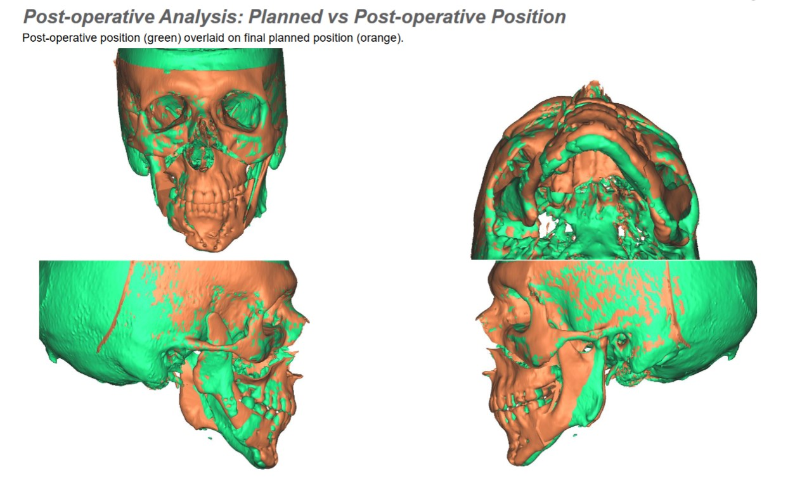

Curriculum vitae
Ulrich Meyer, DMD, MD, PhD started to work in the field of craniofacial surgery in the 1909´s, at the Department of Craniofacial Surgery, University of Münster. Germany. He performed pioneering research work in craniofacial distraction osteogenesis and tissue engineering. In 2004, he founded the interdisciplinary open-access journal Head and Face Medicine. In 2005, he was appointed university professor for life (Professorship for Plastic Facial and Craniofacial Surgery) and senior consultant and deputy clinic director at the West German Maxillary Clinic (Westdeutsche Kieferklinik), Department of Maxillofacial and Plastic Surgery, Heinrich Heine University, Düsseldorf. Based on his clinical and research expertise, he edited in 2008 the biomedical standard work Fundamentals of Tissue Engineering and Regenerative Medicine. In the course of his surgical work in Münster and Düsseldorf, Dr. Meyer developed a broad spectrum of surgical techniques. More recently, he founded the interdisciplinary Craniofacial Center (Kieferklinik Münster) in Münster, where his main focus is the treatment of patients suffering from craniofacial deformities or diseases, in very close cooperation with geneticists, biologists, pediatricians, neurosurgeons, ENT specialists, orthodontists, and others. He is the editor of the three volume standard work Fundamentals of Craniofacial Malformations.
