Computer-Aided Freehand Maxillary Repositioning: A Proof of Concept
Xiaozhen Lin, MD, DMD, Yi Sun, PhD, Xiaodong Han, DMD, Jing Wang, MD, DMD,
Ming Zhang, MD, DMD, Limin Liang MD, DMD
Department of Stomatology, 80 Jianglin Road, Sanya, Hainan Province, People’s Republic of China, 572013

Abstract (300 word limit)
Statement of the Problem: The authors aimed to test the hypothesis that in orthognathic surgery the maxilla could be repositioned using spatial distances from Glabella to 3 maxillary dental landmarks as references. Methodology & Theoretical Orientation: An asymmetric skeletal Class 3 malocclusion patient was involved and bimaxillary orthognathic surgery was planned. Virtual surgery was simulated and spatial distances from Glabella to midpoint of the upper dentition (U0) and bilateral medial-buccal cusp of the first molar (6L and 6R) were measured. These distances were used as the repositioning references and were imported intraoperatively into a digital caliper after the maxilla was mobilized, the repositioning of maxilla was manipulated till all the true spatial distances reached the references. Postoperative computed tomography head model was superimposed onto the planned head model, the maxillary repositioning error was assessed using spatial distances between the pre- and postoperative dental landmarks. Findings: The asymmetric skeletal Class 3 malocclusion was corrected through bimaxillary surgery and the errors at U0, 6R and 6L was 1.37, 1.79, and 1.45 mm. Conclusion & Significance: The maxilla could be repositioned using spatial distances from Glabella to 3 maxillary dental landmarks as references.

Image
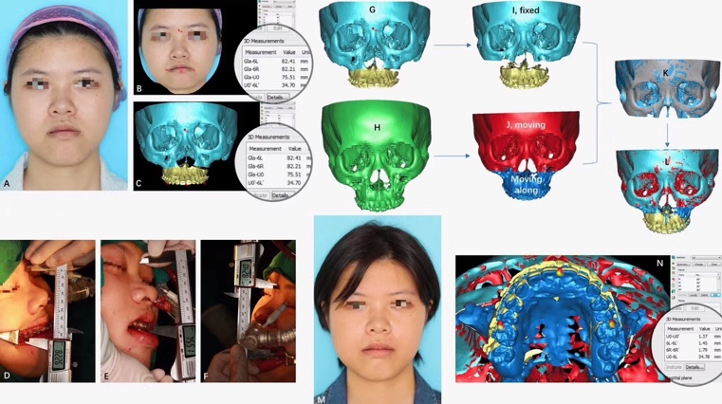
Recent Publications (minimum 5)
1. Lin X, Liang L, Shao X, Han X. Trans-oral robotic surgery of submandibular gland removal with preservation of sublingual gland and Wharton’s duct. J Craniofac Surg (accpeted)
2. Lin X, Sun Y, Han X, Wang J, Zhang M, Liang L. Computer-aided freehand maxillary repositioning: a proof-of-concept study. J Craniofac Surg. 2018;29(1):175-177.
3. Lin X, Li B, Wang X, Shen SGF. Accuracy of maxillary repositioning by computer-aided orthognathic surgery in patients with normal temporomandibular joints. Br J Oral Maxillofac Surg. 2017;55(5):504-509.
4. Lin X, Edwards SP. Changes in natural head position in response to mandibular advancement. Br J Oral Maxillofac Surg. 2017;55(5):471-475.
5. Lin X, Chen T, Liu J, Jiang T, Yu D, Shen SG. Point-based superimposition of a digital dental model on to a three-dimensional computed tomographic skull: an accuracy study in vitro. Br J Oral Maxillofac Surg. Br J Oral Maxillofac Surg. 2015;53(1):28-33.
6. Lin X, Liu Y, Edwards SP. Effect of mandibular advancement on the natural position of the head: a preliminary study of 3-dimensional cephalometric analysis. Br J Oral Maxillofac Surg. 2013;51(7):e178-e182.
7. Lin X, Zhou L, Shang H, Liu Y, Bo B. Use of an internal bidirectional distractor to elongate goats’ mandibles. Br J Oral Maxillofac Surg. 2012;50(4):e49-e52.
8. Shang H, Lin X, Du J, He L, Liu Y. Use of a new curvilinear distractor to repair mandibular defects in dogs. Br J Oral Maxillofac Surg. 2012;50(2):166-170. (first co-author)

Biography (150 word limit)

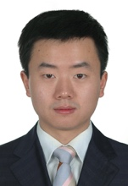
Dr. Xiaozhen Lin completed his dental and medical education and received the degree of doctor of dental surgery (DDS) at the Fourth Military Medical University (Xi’an, China). During his doctoral training program, Dr. Lin received a national support from the Chinese government to do research work at the University of Michigan School of Dentistry. After returning in 2012, he joined the Chinese People’s Liberation Army General Hospital (PLAGH), a top-rank hospital in China, to work as an official attending surgeon in oral and maxillofacial surgery (OMS). From 2013 to 2015, he completed his post-doctoral fellowship at the Ninth People’s Hospital affiliated to the Shanghai Jiaotong University School of Medicine, where the OMS have a world-renowned academic reputation. He returned to PLAGH to work an OMS surgery to present. In 2017, he was prompted to clinical associate professor.

Email: dentlin@hotmail.com

Notes/Comments:

