The prediction of the facial growth: an application of geometric morphometrics for the foetal development of the human face
Motoki Katsube, MD, Kyoto University, Japan
Shigehito Yamada, MD PhD, Kyoto University, Japan

Abstract (300 word limit)
Three-dimensional simulation has been well developed and become almost common for presurgical planning; in addition, several studies have reported on the growth evaluation of children. Nevertheless, the estimation of the facial growth of humans in the early prenatal period has still remained difficult because the facial skeletons of the human foetuses drastically change in size and shape. To quantify and simulate the shape change, we applied geometric morphometrics (GM). GM is an analysis based on the landmark coordinates and can retain complete geometric information. Materials and Methods: Magnetic resonance images were obtained from 53 human embryos and foetuses in the early foetal period. A total of 65 landmarks were defined on the surface of the facial skeleton. To standardise the mouth-opening condition, the landmarks of the mandible were rotated around the axis connecting bilateral condyles. We calculated and visualised the shape change of the facial skeleton with growth. Furthermore, we calculated the degree of the development. Results: The human midfacial skeleton developed in anterolateral direction in the early prenatal period. The mandible relatively decreases in length in the anteroposterior dimension and widens in the lateral dimension. The facial skeleton rapidly grew until around 13 weeks of gestation (gw); consequently, the human foetuses acquired the shape of the facial skeleton similar to that of the neonate around that period. Conclusion and Significance: We could quantify the growth trait of the human facial skeleton in the early foetal period and illustrate it in three dimensions; that is, we could provide the growth estimation model, which enables us to easily grasp the development intuitively. In addition, if we apply GM for the morphological analysis of young patients undergoing surgery, we may produce the prediction of the influence of the treatment in facial growth in three dimensions, as well as perform its quantification.

Image
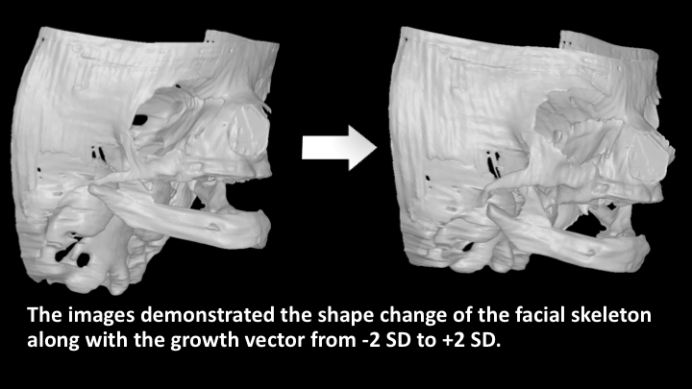
Recent Publications (minimum 5)
- Dadáková, M., Cagáňová, V., Dupej, J., Hoffmannová, E., Borský, J., & Velemínská, J. (2016). Three-dimensional evaluation of facial morphology in pre-school cleft patients following neonatal cheiloplasty. Journal of Cranio-Maxillofacial Surgery, 44(9), 1109–1116.
- Katsube, M., Yamada, S., Miyazaki, R., Yamaguchi, Y., Makishima, H., Takakuwa, T., … Suzuki, S. (2017). Quantitation of nasal development in the early prenatal period using geometric morphometrics and MRI : a new insight into the critical period of Binder phenotype. Prenatal Diagnosis, 37(9), 907–915.
- Klingenberg, C. P. (2016). Size, shape, and form: concepts of allometry in geometric morphometrics. Development Genes and Evolution, 226(3), 113–137.
- Nikkhah, D., Ponniah, A., Ruff, C., & Dunaway, D. (2013). Planning surgical reconstruction in Treacher - Collins syndrome using virtual simulation. Plastic & Reconstructive Surgery, 132, 790–805.
- Yamada, S., Uwabe, C., Nakatsu-Komatsu, T., Minekura, Y., Iwakura, M., Motoki, T., … Shiota, K. (2006). Graphic and movie illustrations of human prenatal development and their application to embryological education based on the human embryo specimens in the Kyoto collection. Developmental Dynamics: An Official Publication of the American Association of Anatomists, 235(2), 468–77.

Biography (150 word limit)
Dr. Motoki Katsube, MD, started his career as a Plastic and Reconstructive Surgeon, especially focused on craniofacial surgery. He is a Board Certified Fellow of the Japan Society of Plastic and Reconstructive Surgery, Japan Society of Cranio-Maxillo-Facial Surgery, and Japan Society for Surgical Wound Care. He is studying for a PhD at the Graduate School of Medicine, Kyoto University. He has passion in the facial growth of humans during the prenatal period and believes that such research could lead to elucidate the pathogenesis of congenital facial anomalies and contribute to the development of the fundamentals of their treatment. He applied geometric morphometrics for that quantification and will apply geometric morphometrics for clinical practice.
Email: katsube@cac.med.kyoto-u.ac.jp
Notes/Comments:

