Strategies and flap design for reconstruction of extensive skull and skul base defects

Peter M. Vogt, Tobias Mett, Viola Stögner, Ramin Ipaktchi
Dept. of Plastic, Aesthetic, Hand and Reconstructive Surgery
Hannover Medical School

Anatomic defects of the skull and skull base remain a surgical challenge. In most cases head and neck reconstructive surgery succeeds well by employing standard techniques of regional flaps or free microvascular grafts. Larger and unconventional resections however require advanced techniques to provide an adequate functional and aesthetic result. These may include pedicled or free flaps of various options to protect vulnerable anatomic structure including intracranial structures, skull base, blood vessels and the nasopharyngeal cavity.
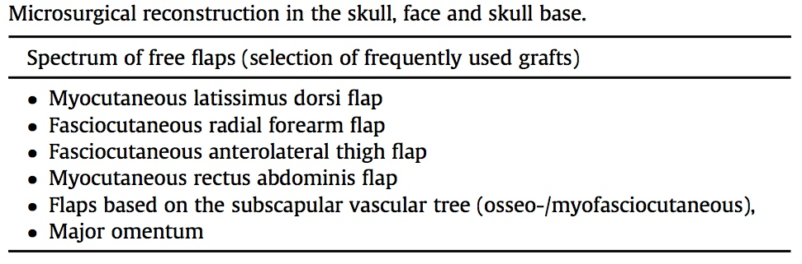
The presentation outlines complex reconstructions applicable to the skull and skull base and gives recommendations for surgical choices. Thereby it covers specific problems to be encountered and provides individualized solutions.
The authors present solutions for microvascular free tissue transfer in the „avascular neck“ by construction of arteriovenous loops for later hook up of a flap and special flap designs for difficult to access regions in the scull base.
References
P.R. Issing, H.G. Kempf, W. Heppt, M. Schonermark, T. Lenarz, Reconstructive surgery in the head-neck area with regional and free tissue transfer, Laryngo- Rhino-Otol. 75 (8) (1996) 476e482.
Vogt, P.M., et al. Interdisciplinary reconstruction of oncological resections at the skull base, scalp and facial region. Surgical Oncology 26, 318-323 (2017)

