
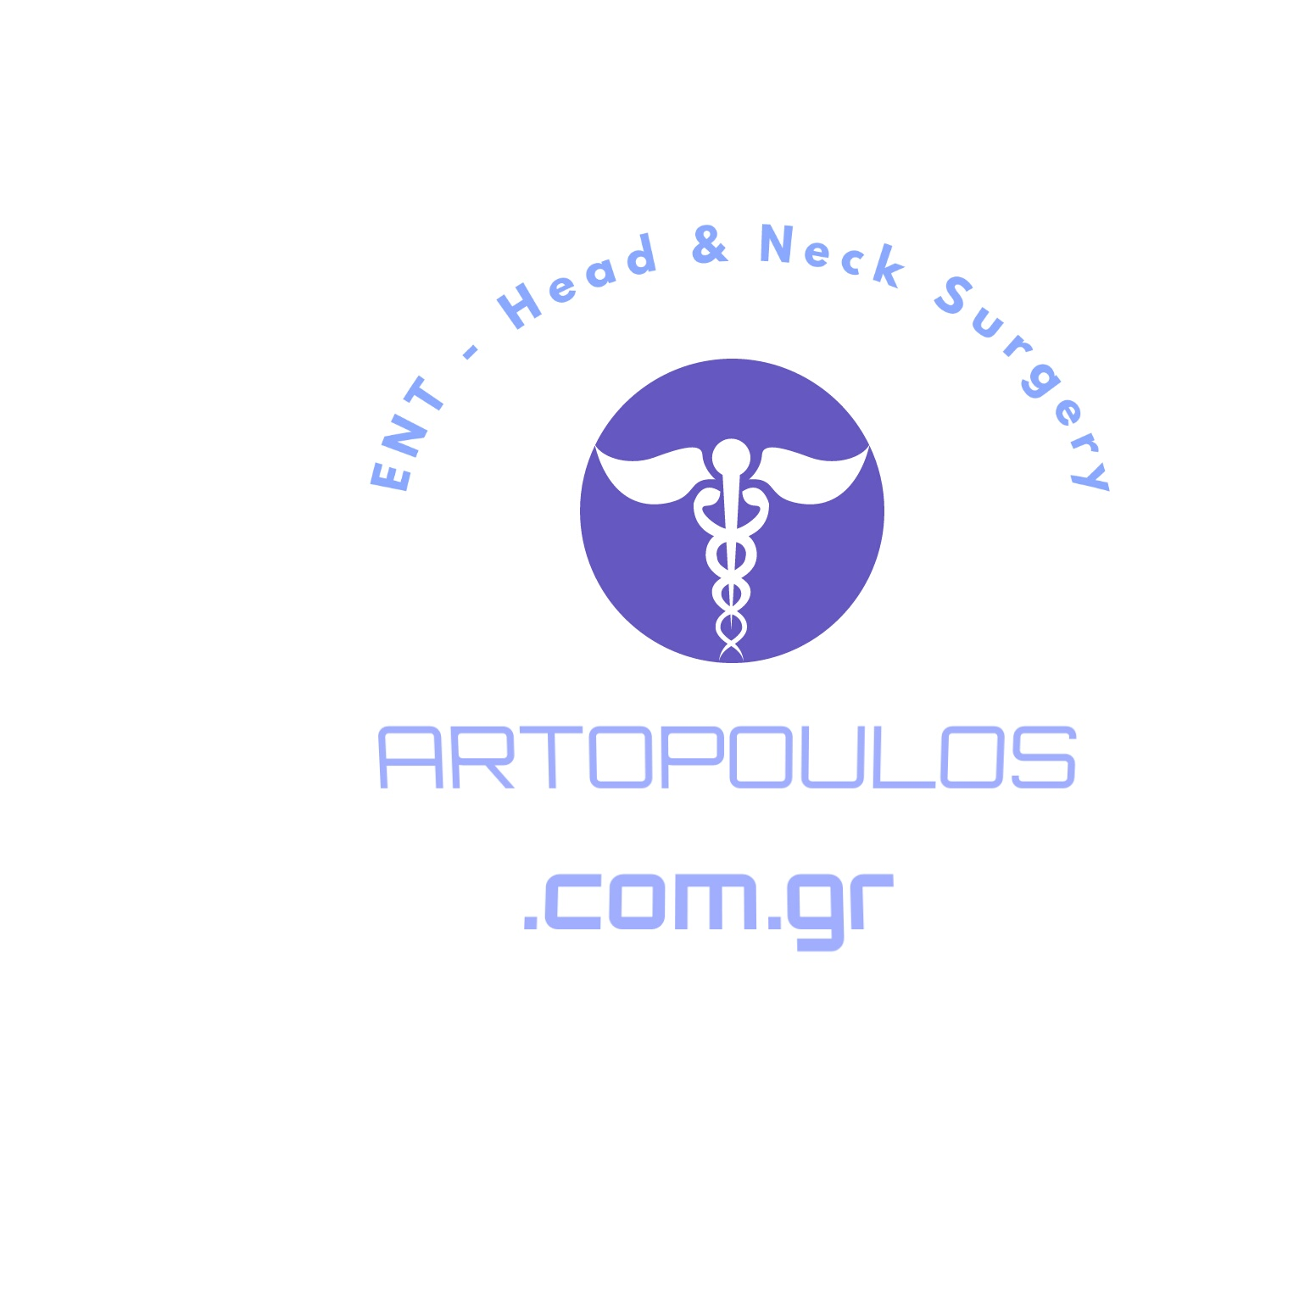

Paste your Logo here

Controversies in the Management of Thyroid Nodule
Name: Minas N. Artopoulos

MITERA General & Children’s Hospital, Athens, Greece

Few subjects in surgery have generated as much controversy as the management of thyroid nodule. The controversial issues include classification and histology, diagnostic evaluation including needle biopsy, indications for surgery, management of incidentalomas of the thyroid, the role of frozen section, extent of thyroidectomy, management of neck nodes, the role of suppressive therapy, the use of radioactive
iodine, and appropriate follow-up. The two major issues in relation to the controversies are diagnostic workup and extent of thyroidectomy. Whenever the issue related to extent of thyroidectomy is discussed, there are two strong groups believing in total thyroidectomy or less than total thyroidectomy. This has generated considerable debate and panel discussions.

Minas N. Artopoulos was born in Athens, Greece on 1972! He was trained in Otorhinolaryngology-Head & Neck Surgery in the State “Red Cross” Hospital in Athens. His present position from 2010 is Head of Neck-Thyroid Department of MITERA General & Children’s Hospital, Athens, Greece.

