Title: Transcriptome and SARS-CoV-2 biological network directed analysis to overcome various mutational and treatment limitations

Name : OM PRAKASH SHARMA, Ph.D
Affiliation : INNOPLEXUS AG, GERMANY
Co-authors : Ruchika sharma, Vinay Chandil

Abstract (up to 1000 words)

It has been almost 2 years since the first SARS-CoV-2 virus was first reported in the city of Wuhan. To date, total 4,256 interventional clinical studies are reported and 8 drugs (Remdesivir, Paxlovid, Bamlanivimab/Etesevimab, Evusheld, Molnupiravir, Regeneron and Bebtelovimab) were approved by FDA for Emergency Use Authorization. However, treatment benefits and frequent mutation are still a matter of concern. Due to the heterogeneity among various populations and diversification of covid-19 mutations, it is an alarming situation to understand the crucial target engagement of the disease and uncover various underlying disease pathophysiology based on disease severity, stage, tissues, ages and patient populations.

In order to improve therapeutic effects and minimise future covid-19 mutational driving infections, we have developed a Research graph called CovInt (a network of covid-19) that includes all biological molecules associated in the network with their directionalities collected from publicly available and patient-derived multi-omics datasets from millions of unstructured and structured datasets such as publications, patents, grants, preclinical and clinical reports. CovInt utilizes powerful traversal, clustering and centrality algorithms to identify key connections in the pathophysiology of the disease and its treatments. Leveraging 3M+ connections, important interactions among key 42 drugs, 962 biological processes and molecular functions, 926 pathways, 897 phenotypes, 7103 proteins, 61 tissues were identified. This narrowed interactome was explored further using PageRank, lovain detection & strongly connected components (SSC) algorithms. In our analysis 63, strongly connected communities were identified which gives us an understanding of hidden underlying mechanisms.

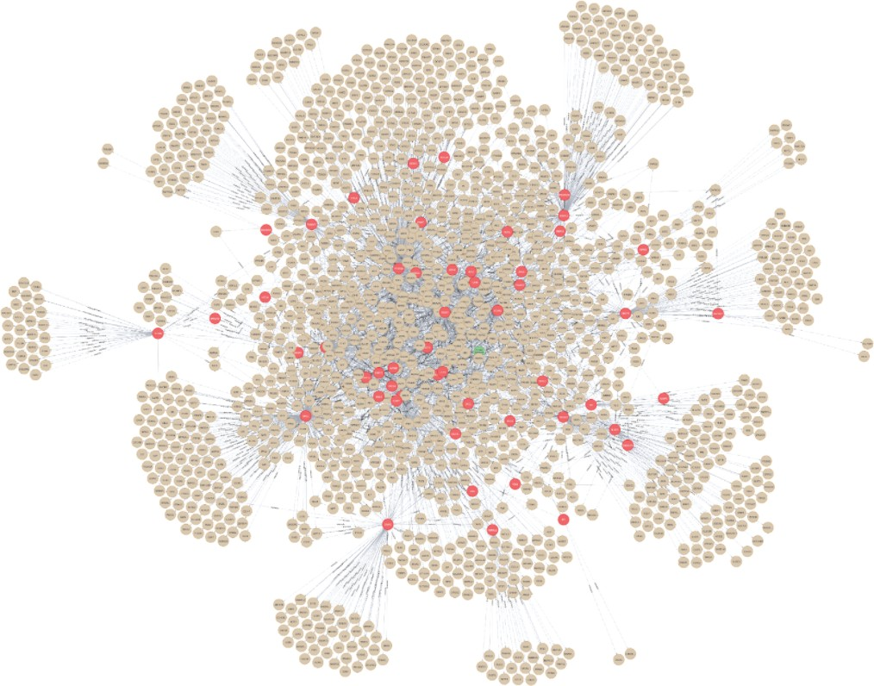

Figure: A snapshot of sub-network of CovInt, an Innate Immune system pathway where nodes depicted in red are covid19 DEGs. Molecules in green are highlighted as pathways and Protein-Protein Interactions (PPI’s) are shown as brown in colour.

We further explored this network to identify and triangulate the key proteins, metabolic pathways and associated risk factors that can regulate moderate to severe covid-19 infections. Our initial study suggests that NFKB1, IL1B, TNF, AKT1, IKBKB-G, IRF3, MIF, CCL4-5, CD14, CD28,
CD80, CD86 and TNFRSF4 are the key regulator proteins and Bradykinin receptor B1 activation, Toll-like receptor signalling, Lung fibrosis, Complement and Coagulation Cascades and ER protein chaperones Lipid biosynthesis ER-associated degradation pathway are major regulatory pathways which can be targeted for better therapeutic effects.

Biography (up to 150 words)

Dr Om Prakash Sharma is currently working as a Vice president of Bioinformatics at the Innoplexus AG in frankfurt, Germany. He has completed his PhD in Bioinformatics and Protein Crystallography from Pondicherry University, India.

In 2015, Om sharma accepted a position as a Senior Scientific Associate and developed various algorithms for Drug discovery and multi-omics platforms for pathway analysis. In 2017, Om Sharma accepted an Associated Vice President - Bioinformatics position at Innoplexus Consulting Pvt Ltd, India and established a bioinformatics department and drug discovery services. One of his innovations Ontosight® Explore won the Edison award on March 26, 2020. During this period, he and his team developed multiple early drug discovery platforms and research graphs on various drug discovery and clinical retrospective analyses.

In 2021, he moved to Germany at Innoplexus AG, where he has been since that time. He has published 19 Peer-reviewed articles and filed 18 patent applications.

Email ID : ombioinfo@gmail.com

Presenter Name : Dr Om Prakash Sharma
Type of Presentation : Speaker
Contact Number : +49-1522-375-6216

