Abstract Title: Minimal Invasive Plastic and Laser Surgery in Cosmetology
Dr. Anil Rajput ( TMU, India )
Abstract:
Aim: There are so many dermatological problems like a Basal cell carcinoma ( BCC ), Hypertrophy scar, Keloid, Sebaceous Cyst, Acne cyst, Post-acne or Post-chicken pox scar over face, Port-wine stain ( PWS) , Vitiligo scar, Hyper and Hypopigmentation etc.in face and exposed part of body. Almost all diseases are treated by either minimal invasive Plastic Surgery or Laser surgery in Outdoor patient department (OPD) for maximum patient comfort and convenience.

Methods: Instruments or Lasers which are using in this studies are fine plastic surgery instruments and lasers as 1. Er:YAG or Fractional CO2 laser 2.Radio-frequency 3.Electrolysis 4.Diode Laser 5.Nd:YAG long pulsed laser,6.Pulsed Dye Laser ( PDL ),7.Nd:YAG Q-switched laser.

Result: More than 96% cases are achieved good aesthetic and cosmetic recovery. Maximum benefit to patients, as all are out door procedures (OPD) and no stay is required in hospital, less expensive for patients, less time taking, no general or regional anesthesia needed, faster recovery and minimal follow-up.

Conclusion: According to my previous experience in Cosmetology or in Plastic Surgery, almost every dermatological problems or facial trauma are treated almost by scar less methods or minimal scarring by minimal invasive procedures or lasers.

Keywords: Dermatological Problems, BCC, PWS, Scar less treatment for facial trauma, CMN, Post-chicken pox scar.

Professional Biography:
Dr. Anil Rajput is recently working as Chief Plastic Surgeon in Teerthanker Mahaveer University, India, which is top ranked private university in India. He has honored by many awards and operated more than 15000 surgeries in Cosmetology and Plastic Surgery field. Great example in recent world, without any advertisement in paper, TV or without having any personal website or department website, He has more than 3 months waiting periods or waiting list for Plastic Surgery in elective procedures for their patients.

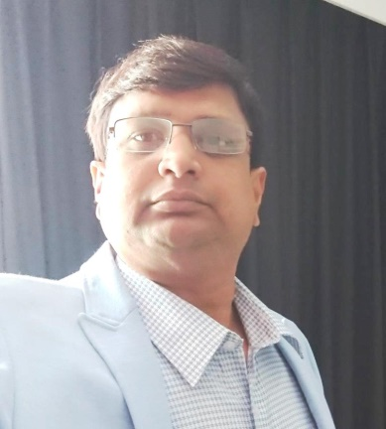

E-mail: anil_rajput93@yahoo.com
anilrajputdr@gmail.com

E.g.

- Port-wine stain (PWS) of face.

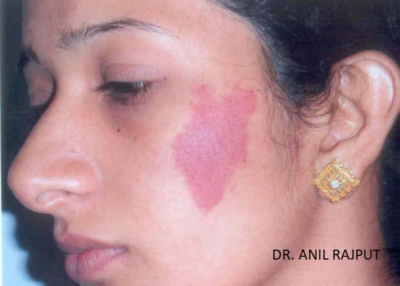

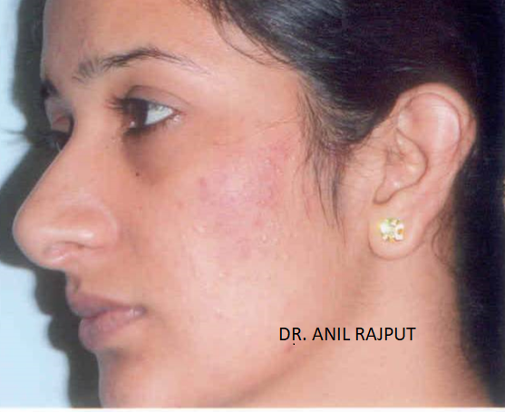

- Keloid scar over chest.

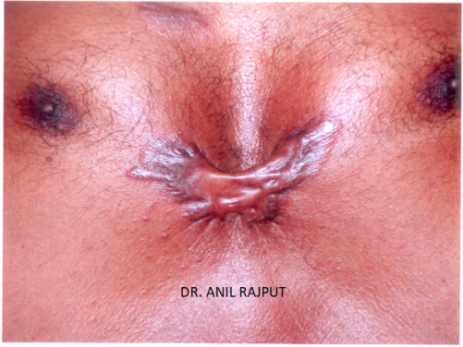

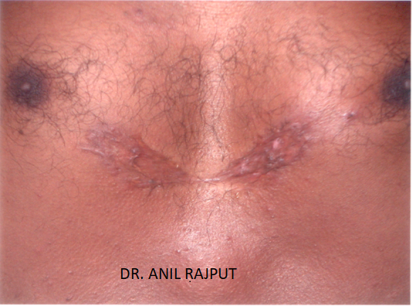

- Basal Cell Carcinoma (BCC) of face.

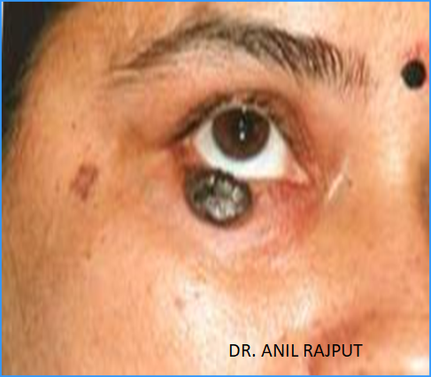

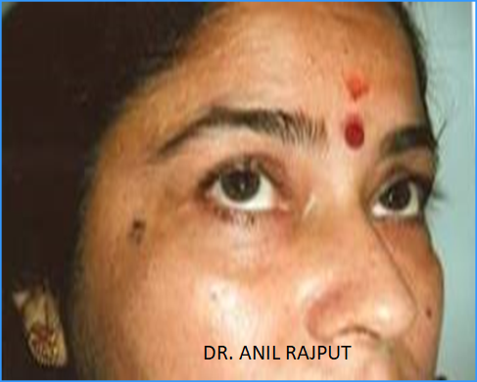

- Post-acne scar

