Psoriasis and comorbidity
Veranika Liubiankova¹, Sviatlana Makarava¹

¹ Mogilev Regional Dermatology and Venerology Centre, Belarus

Abstract.
Introduction. Psoriasis is increasingly determined as a systemic process that affects not only the skin, but also the internal organs. In recent years special attention has been paid not only to the systemic nature of the process in psoriasis, but also to its association with comorbidities. Comorbidity is a regular combination of various diseases or conditions in one patient, it occurs in many inflammatory processes.
Purpose. The study of the incidence of concomitant diseases in patients with psoriasis in relation to patients with allergic contact dermatitis.
Materials and methods. A retrospective analysis of data of 804 patients, who were treated in 2016 and in the first 10 months of 2017 in Mogilev Regional Dermatology and Venerology Centre with different forms of psoriasis, was conducted. 492 males, 312 females. The mean age was 43,05 years. The control group consisted of patients with allergic contact dermatitis, comparable in age and sex, in an amount of 397 people.
Results. The percentage and frequency of comorbidity and the changes in the laboratory tests are presented in the picture.
Significant differences between the groups were obtained for all the comorbidity except respiratory diseases.
Psoriatic polyarthritis were observed in 219 patients (27.3%), nail psoriasis – in 117 patients (14.6%). The average body mass index in the psoriasis group was 27.2, in the allergic contact dermatitis group - 25.3.
Significant differences between the groups were obtained for all the test changes except the general bilirubin, C-reactive protein and urinalysis.
Conclusions. The analysis showed that in patients with psoriasis the most frequent comorbidity are: cardiovascular and gastrointestinal diseases, endocrine disorders, polyarthritis, nail psoriasis and metabolic syndrome. A rather high risk of comorbidity is established, in comparison with the population, which can directly affects the severity of the course of the disease, the effectiveness of the therapy and life expectancy.

Keywords— Psoriasis, Comorbidity, Chronic Skin Disease, Retrospective Analysis

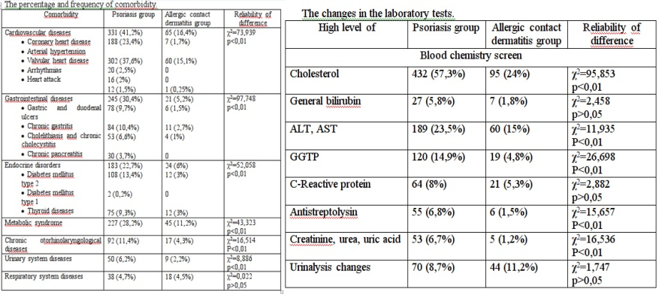

Professional Biography

Veranika Liubiankova finished Vitebsk State Medical University (Belarus) in 2011. Now she works in Mogilev Regional Dermatology and Venerology Center. She had degree of Medical Doctor in speciality: Dermatology and Venerology. Sphere of interest: psoriasis, neurosyphilis, physical therapy.

Email: lubenkova-nika@mail.ru

Sviatlana Makarava finished Gomel State Medical University (Belarus) in 2010. Now she works in Mogilev Regional Dermatology and Venerology Center. She had degree of Medical Doctor in speciality: Dermatology and Venerology. Sphere of interest: psoriasis, dermatoscopy, biopsy.


Email: svetmak19041986@gmail.com

