Abstarct Title: How to convert facial nevus from operative to non-operative methods.
Dr. Anil Rajput (Gujarat University, Gujarat, India.

Abstract:
Aim: Incidence of facial nevus in India is one in 1000 birth and in United kingdom is increase day by day because of mixed population. This is very important for cosmetologist to treat such type of cases in non-operative methods or laser therapy.

Methods: Instruments or lasers which are using in this studies are as 1.Nd:YAG ( Q-Switched) Surgical laser 1064nm and combined with KTP 532nm ,2.Er:YAG laser 2940 nm for nevus 3. Pulsed Dye Laser 595nm for hypertrophy 4. Light sheer diode laser 800 nm for hair removal and in cases those were not recovered by laser or recurrence cases were treated by conventional methods of reconstructive surgery .Rarely needs IPL and long pulsed Nd:YAG.

Result: More than 90% cases are achieved good aesthetic and cosmetic recovery by laser and 10% cases had recurrence which was recovered by reconstructive surgical procedures and hypertrophy which was recovered by steroid injection and PDL laser.

Conclusion:
According to my previous experience of more than 12 years in regarding field, for any type of nevus, recovered by laser therapy only. But some cases had recurrence of lesion and hypertrophy which were recovered by any other methods. ` .

Keywords: non-operative methods for any type of facial nevus,laser therapy for facial nevus,aesthetic procedure for facial nevus, facial nevus

Professional Biography:
Dr. Anil Rajput has completed his M.Ch.( Master of chirurgiae) in plastic surgery at the age of 29 years old from Gujarat, India.He is presently working as chief in plastic surgery department in Teerthanker Mahaveer University,India which is top ranked private university in India.He has honoured by many awards in country in related field and operated more then 15000 major cosmetic and plastic surgeries in India and surrounding countries.

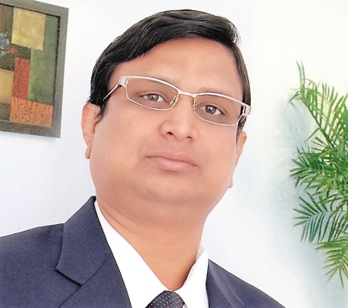

E-mail:anil_rajput93@yahoo.com
What’s up no.-0091-8938069011
Any comments: I am posting one of my patient’s photo for your review for my work.I am sure that you will definitely get something by this 10 minutes talk only in your conference,if you allow me. Because of less numbers of recognised plastic surgeon in country, we are overburden by work , so do not have enough time for publication.

