Belotero Soft ultra-superficial injections in blanching technique: anatomical aspects of Slavic and Slavic-Asian phenotypes.

Dr Yana Yutskovskaya, MD, PhD, Clinic of Professor Yutskovskaya, Russia

Abstract (300 word limit)

Skin quality is an important component of a person’s health and attractiveness. Emergent perceptual categories of skin quality: firmness, surface evenness, tone evenness, skin glow. Blanching technique is a key method of skin treatment in superficial layers.

Individual correction algorithms should consider not only gender and age, but also ethnicity of patients. Anatomical features of different ethnic groups significantly affect aging process and the treatment strategy choice.

A group of 14 experts from Russia who work with Belotero for more than 10 years conducted a two-year research, under leadership of Yana Yutskovskaya. They have proved that anatomical prerequisites explain why patients with Slavic-Asian facial phenotype have a tendency to fatigue and deformational morphotypes of aging. The anatomy of the Slavic-Asian face has some distinctive features that affect all the craniofacial structures: bones, subcutaneous fat distribution, ligament apparatus, dermis morphology. The revealed anatomical features determine their nuances when working with patients with Slavic-Asian facial phenotype.

Features of the blanching technique in the Slavic-Asian phenotype, based on the clinical experience of experts from Russia:

Belotero Soft is a priority drug for the correction of facial wrinkles in the "blanching" technique.

Considering the predominance of edematous and deformational morphotypes of aging, Belotero Soft does not increase edema regardless of the injection zone and is not accompanied by a rehabilitation period.

Suitable for patients of any age, any morphotype, any skin type and can be used in any area of the face

Belotero Soft is a preparation for strengthening the skin and gently stimulating skin remodeling. Proven effectiveness of the Belotero Soft + Radiesse combination.

Is the real ice-breaker in attraction and deduction of patients of any age, it is perfectly combined with all Belotero range, Radiesse and Xeomin in complex rejuvenation of patients as well as important subject in work with skin quality.

Image
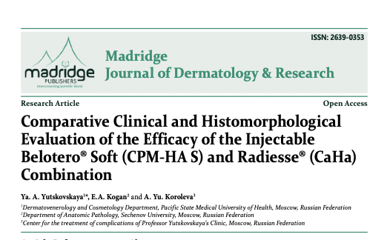
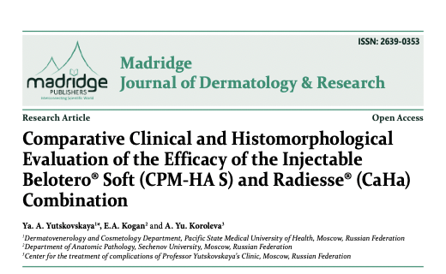
Recent Publications (minimum 5)
- Goldie K, Kerscher M, Fabi SG, Hirano C, Landau M, Lim TS, Woolery-Lloyd H, Mariwalla K, Park JY, Yutskovskaya Y. “Skin Quality – A Holistic 360⁰ View: Consensus Results.” Clinical, Cosmetic and Investigational Dermatology. 2021:14 643–654.
- Yutskovskaya YaA, Bagnenko ES, Baibarina EV, Oleinikova YuV, Gorchakova OA, Demyanova IP, Kon-Fan-San NO, Konopatkina IYu, Koshelnik OA, Saybel AV, Satardinova EE, Tokar AV, Chakhoyan LR, Shirshakova MA. Belotero Soft ultra-superficial injections (blanching technique): Anatomical aspects of Slavic and Slavic-Asian phenotypes. Plastic Surgery and Aesthetic Medicine. 2023;1:77–87.
- van Loghem J, Sattler S, Casabona G, Cotofana S, Fabi SG, Goldie K, Gout U, Kerscher M, Lim TS, de Sanctis Pecora C, Sattler G, Trindade de Almeida A, Wanitphakdeedecha R, Werschler P, Pavicic T. Consensus on the Use of Hyaluronic Acid Fillers from the Cohesive Polydensified Matrix Range: Best Practice in Specific Facial Indications. Clin Cosmet Investig Dermatol. 2021;14:1175-1199
- Prasetyo AD, Prager W, Rubin MG, Moretti EA, Nikolis A. Hyaluronic acid fillers with cohesive polydensified matrix for soft-tissue augmentation and rejuvenation: a literature review. Clin Cosmet Investig Dermatol. 2016; 9: 257-280. doi: 10.2147/CCID.S106551
- Fabi S, Pavicic T, Braz A, Green JB, Seo K, Loghem JAJ van. Combined aesthetic interventions for prevention of facial ageing, and restoration and beautification of face and body. Clin Cosmet Investig Dermatol. 2017; 10: 423-429. doi: 10.2147/CCID.S144282

Photograph

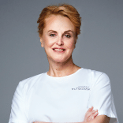 Biography (150 word limit)
Professor Yana A. Yutskovskaya, PhD, Doctor of Medicine, Board Certified Physician of the Highest Category, Global Key Opinion Leader of Merz Aesthetics, International Key Opinion Leader of ABG Lab. The total number of scientific publications is more than 500. Actively conducts her own research and clinical studies as well as participates in international projects. She is a co-author of several consensus papers, for example: “Skin Quality – A Holistic 360⁰ View: Consensus Results.”; «Global Consensus Guidelines for the Injection of Diluted and Hyperdiluted Calcium Hydroxylapatite for Skin Tightening» and others.

Owner of the Network of Clinics (Vladivostok, Moscow, Sochi). Founder of the Training Projects «School of professor Yutskovskaya« and «YuClub Global», Member of the board of directors of The National Alliance of Dermatologists and Cosmetologists. Editorial Board Member of Madridge Journal of Dermatology & Research.
Email: yutsk@mail.ru

Notes/Comments:

