Mandibular angle augmentation as the factor boosting masculinity and male gender
Dr Rinat Sitanovich, MD, Different Lab, Russia, ESAM, Ireland

Abstract
Augmentation of mandibular angle as accentuation of the most masculine point of the face is extremely demanded procedure among male patients today. Faces, where lower jaw angles are enhanced create an impression of a tough, radical temperament, independent and strong charism.
Objective: to reveal the effectiveness of lower jaw angle augmentation with the purpose of boosting male gender using fillers based on hyaluronic acid
Mandibular angle augmentation procedure was performed on the patients who had indications such as insufficient volume of lower jaw, undefined contour of lower jaw, oval, rounded, triangular shapes of the face. The protocol used at the procedure: injection of the filler based on hyaluronic acid in two separate layers of subcutaneous tissues.
The volume of the product was indicated individually, considering both anatomy of mandibular angle and patient’s expectations. Volume varied from 1 to 2 ml per side.
Procedures results evaluation was made in accordance with Global Aesthetic Improvement Scale; GAIS criteria. Objective evaluation of clinical effectiveness was confirmed by comparison of photographs made before, immediately after procedures, and 14, 21 and 90 days after procedures.
Results: 90 days after procedure patients showed significant and obvious improvement according to GAIS scale. Patients themselves admitted that the result was satisfying at the procedure and that enhanced masculinity effect was reached.
Conclusions: The protocol for injection of the filler based on hyaluronic acid in two separate layers of subcutaneous tissues can be successfully applied on male patients. The combination of needle and cannula techniques for mandibular area in subcutaneous and supraperiostal levels is reasonable because it increases volumisation effect and improves correction result. Accentuated lower jaw angles enhance male gender identity, allows masculine and tough personality impression, also can increase the demand for males and their reproductive abilities.

Image
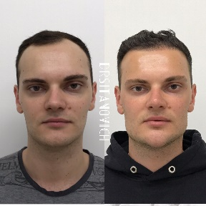
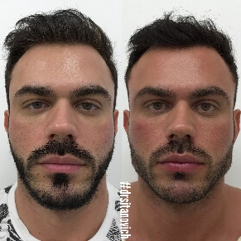

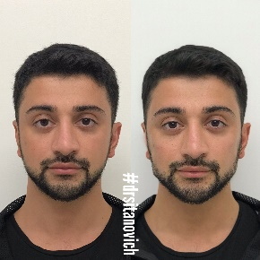
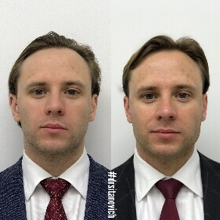
Recent Publications
- R. Sitanovich, Mens cosmetology (2021) Les nouvelles esthétiques, LNE, POLAND, 2021
- R. Sitanovich The man inside the room of cosmetic doctor (2019) AESTHETIC BUSINESS, POLAND
- R. Sitanovich 3D face volumisation: author technique (2019) KOSMETIK INTERNATIONAL
- R. Sitanovich Hyaluronic acid fillers rheology and it's application on practice (2018) KOSMETIK INTERNATIONAL
- Botullinum toxin therapy as preparation for injectable treatments (2018) KOSMETIK INTERNATIONAL
- R.Sitanovich Cannula plasty FULL FACE (2017) Image
- R. Sitanovich Areas of reserve (2017) Image

Photograph

Biography
Dr Rinat is one of the Russia’s leading experts in the field of mens medical aesthetics and cosmetic enhancements. Graduated from Orenburg Medical University with specialization in general surgery Rinat continued his post-graduate in Plastic surgery and focused his professional career on cosmetology using injectable methods. Main fields of research are Rheological properties of hyaluronic fillers and their practical application, Facial Contouring within the correction of the fatigue morphotype of aging, Image cosmetology - enhancing on gender identity, Men intimate contour plasty. He founded European School of Anti-Ageing Medicine in Moscow, in 2017 and its branch in Ireland in 2022. As scientific head he-operates with cosmetic medicine training centres in UK, Ireland, Germany, Czech Republic and Poland.
Email: drsitanovich1@gmail.com

Notes/Comments

