Efficacy and Safety of Fractional Radiofrequency Treatment for Acne and/or Acne Scars.
Dr. Jing Li MD, PhD Department of Dermatology, Beijing Jishuitan Hospital, Beijing, China
Prof. Fangfang Duan PhD Clinical Epidemiology Research Center, Beijing Jishuitan Hospital, Beijing, China
Dr. Jie Kuang MD Department of Dermatology, Beijing Jishuitan Hospital, Beijing, China

Abstract (300 word limit)
Background: Fractional radiofrequency (FRF) is increasingly used for acne scars. The common coexistence of acne scars and active acne is a challenge in the timely management of acne scarring. Aims: We conducted a systematic review and meta-analysis to compare the efficacy and safety of FRF treatment with the lasers for acne and/or acne scars. Methods: A systematic search was performed on PubMed, Embase, Ovid, Cochrane Library, and Web of Science. Compared with the lasers, a meta-analysis was conducted to assess the clinical improvement and adverse events after FRF treatment. Results: Eight randomized controlled trials were included. FRF group was more effective than the laser group in patient-evaluated acne improvement (RR = 1.35, 95% CI: 1.01 ∼ 1.80). Regardless of observer assessment or patient evaluation, the FRF group was as effective as the laser group in treating atrophic acne scars (RR = 0.92, 95% CI: 0.78 ∼ 1.08; RR =1.15, 95% CI: 0.99 ∼ 1.34). Although there was no difference in pain level and crusting time between the two groups (SMD =0.20, 95% CI: −0.72 ∼ 1.12; SMD = −0.93, 95% CI: −2.38 ∼ 0.52), PIH incidence of FRF was significantly lower than that of the laser group (RR = 0.12, 95% CI: 0.04 ∼ 0.35). The duration of erythema after FRF treatment was also obviously shorter than that after the laser treatment (SMD = −0.78, 95% CI: −1.37 ∼ −0.18). Subgroup analysis showed that at least a 12-week follow-up was required to observe the full effects of FRF. Conclusions: FRF could be a better choice for atrophic acne scar patients with active acne. FRF is superior in treating atrophic acne scar patients prone to pigmentation.

Image
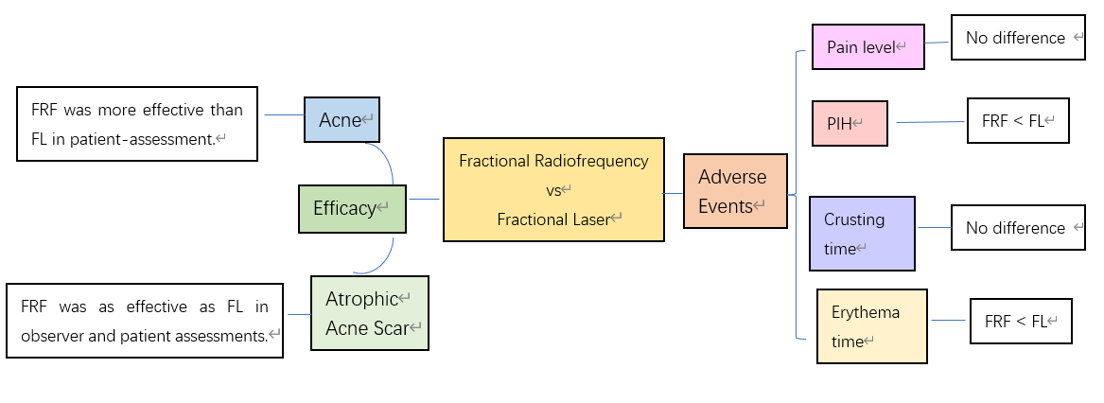
Recent Publications (minimum 5)
- Li J, Duan F, Kuang J. Meta-analysis of fractional radiofrequency treatment for acne and/or acne scars. J Cosmet Dermatol. 2022.
- Wang R, Li J, Wang M, et al. Prevalence of myasthenia gravis and associated autoantibodies in paraneoplastic pemphigus and their correlations with symptoms and prognosis. Br J Dermatol. 2015. 172(4): 968-75.76.
- Jing L, Shan Z, Yongchu H, Xixue C, Xuejun Z. Successful treatment of a paraneoplastic pemphigus in a teenager using plasmapheresis, corticosteroids and tumour resection. Clin Exp Dermatol. 2011. 36(7): 752-4.
- Li J, Bu DF, Huang YC, Zhu XJ. Role of autoantibodies against the linker subdomains of envoplakin and periplakin in the pathogenesis of paraneoplastic pemphigus. Chin Med J (Engl). 2009. 122(5): 486-95.
- Huang Y, Li J, Zhu X. Detection of anti-envoplakin and anti-periplakin autoantibodies by ELISA in patients with paraneoplastic pemphigus. Arch Dermatol Res. 2009. 301(10): 703-9.

Photograph

Biography (150 word limit)
Dr Jing Li M.D.,PhD. is an attending physician of dermatology in Beijing Jishuitan Hospital in China. She has her expertise in laser and cosmetic dermatology, especially in the treatment of acnes and scars. She has published several academic papers and has one patented invention.

Email: sophiali79@126.com

Notes/Comments:

