CONSANGUINEOUS MARRIAGES AMONG IRANIAN MANDAEANS LIVING IN SOUTH-WEST IRAN MOSTAFA SAADAT AND MAHDIS ZARGHAMI
Department of Biology, College of Sciences, Shiraz University, Iran
Summary. Several studies have indicated that consanguineous marriages (unions between biologically related persons) are associated with increased risk of autosomal recessive diseases and several multifactorial traits. Mandaeans are a closed ethno-religious community living in areas of southern Iraq and Iran (Khuzestan Province). There are currently no data on the prevalence of consanguineous marriages among Mandaeans. The present study was carried out in 2016 to determine the prevalence of consanguinity among Iranian Mandaeans living in Khuzestan Province, south-west Iran. A total of 137 couples (urban areas: 79 couples; rural areas: 58 couples) were included in the study. Information on the consanguineous marriages of the subjects was collected through direct interviews. Marriages were classified by the degree of relationship between couples as double first cousins, first cousins, first cousin once removed, second cousins and unrelated marriages. The coefficient of inbreeding (F) was calculated for each couple and the mean coefficient of inbreeding (α) estimated for the population, stratified by rural and urban areas. The overall frequency of consanguinity was found to be 50.7% in urban and 86.2% in rural areas. There was a significant difference between rural and urban areas in types of marriages (χ 2=24.8, df=4, p

I am Mahdis Zarghami. I am 27 years old and I have a lot of interest in genetics. Most of my attention on this article has been family marriage.
I was completed bachelor at the age of 23 years from Masjed Soleyman University and MSC studied from Shiraz University College of Science.
I did research on the Mandaean tribes. I was the example of the control of Arabs living in southwestern Iran.
Mandaeans were the last prophet of Yahya, and they were very religious people and had married marriages.
At the moment, I am supervisor in the diagnostic and pathology laboratory and the molecular cell.

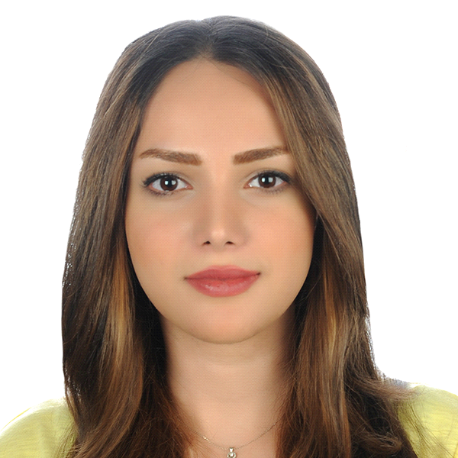

Mahdiszarghami6770@gmail.com

