Comparative analysis of the treatment of chronic daily headache with a focus on Botulinum toxin A

Nigora Kadyrkhodjayeva, PhD aspirant, Tashkent Medical Academy, Uzbekistan
Anna Prokhorova, Doctor of Medical Science, professor, cofounder and medical director of the Centre for sensory integration and speech development Tomatis-Tashkent, Uzbekistan

Abstract
Abstract
Goal: The purpose of the study was to review the efficacy, safety and tolerability of Botulinum toxin A (BTX-A) as a prophylactic treatment in adults with chronic daily headache (CDH).
Material and methods: The study involved 100 patients with CDH comparing between two groups of patients. Group I, 54 patients (31 women and 23 men) treated by BTX-A, and group II, 46 patients (27 women and 21 men) treated with the classical method, with an average age of 42 years. The patient’s condition in group I was evaluated on the third day, on the 7th day and on the 15th day after the BTX-A injection and assessed every 15 days for 3 months, in group II the patients were assessed every 15 days.
Results: After 3 months headache severity in group I: 2 (3,7%) patients had no changes, 7 (12,9%) patients with less than 50 percent reduction in pain, 23 (42,6%) reported 70 to 95 percent pain relief, and 22 (40,8%) had complete relief. Group II: 12 (26,1%) patients had no changes, 16 (34,8%) patients with less than 50 percent reduction in pain, 10 (21,7%) reported 70 to 95 percent pain relief, and 8 (17,4%) had complete relief. The mean change from baseline frequency of headaches ranged from 3 ± 1 headaches per 30‐day period in group I and 7±2 headaches in group II. The patients in group I used painkiller for an acute headache 4±1 day, compared to 10 ± 2 days for the group II per 30-day period.
Conclusion: In this study, BTX-A injections have been shown to be safe, well ‐tolerated, not any treatment-related serious adverse events reported. BTX-A injections recommended optimizing clinical outcomes for patients with CDH without using other prophylactic medications. Although, further observations are needed.
Keywords: BTX-A injection, Daily chronic headache, Primary headache.

Image
Table 1. Recommended Dose for FSFD.

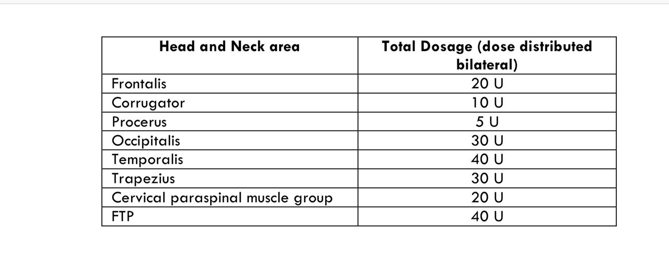

Recent Publications
- Kadyrkhodjayeva N (2017) “A new look at the problem of Tension type headache and its treatment methods”. New day in Medicine 2 (18):38. http://www.bsmi.uz/images/material_2019/yanvar/jurnal/jurnal-2-2017.pdf
- Prokhorova A, Kadyrkhodjayeva N (2017) “Use of Botulotoxin type A in the treatment of primary headache”. Journal of research in health science 1(1):50
- Kadyrkhodjayeva N, Prokhorova A (2018) “Optimization of management of primary chronic headache with the use of Botulotoxin A”. Journal of Neurology and Neuroscience Vol 9:75. EuroSciCon Conference on Neurology & Neurological Disorders.
http://www.imedpub.com/conference-abstracts-files/2171-6625-C1-009-011.pdf

- Prokhorova A, Kadyrkhodjayeva N (2019) “Botulotoxin therapy of patients with primary chronic headaches (Review)”. Bulletin of the Tashkent Medical Academy Scientific and practical journal.

- Prokhorova A, Kadyrkhodjayeva N (2019) “Use of botulinum toxin type A to optimize the treatment of primary chronic headaches”
Clinical Practice Guideline, Uzbekistan.

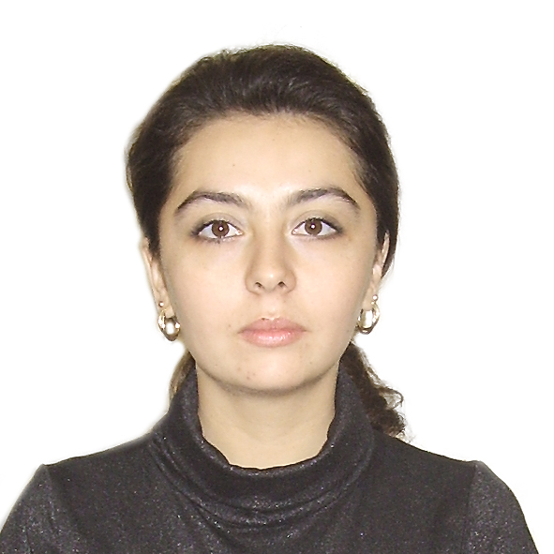Biography
Kadyrkhodjayeva Nigora Saidganievna is a PhD student at the Tashkent Medical Academy. Dr. Nigora Kadyrkhodjayeva conducts research in the field of primary chronic headaches. She received her Bachelor’s degree in Tashkent Medical Academy, Uzbekistan in 2006. In 2007, she received a specialization in psychiatry and psychotherapy at the Tashkent Institute of Postgraduate Medical Education, Uzbekistan. Dr. Nigora Kadyrkhodjayeva finished her Clinical residency of Neurology in Tashkent Institute of Postgraduate Medical Education, Uzbekistan 2009. She has more than ten years of professional experience in neurology. She passed Clinical attachment in Neurology Department of Rashid Hospital, Dubai, UAE. She has valid practice license from UAE. She has published 1 clinical practice guideline in the area primary chronic headache. She has published research articles in leading journals, conference proceedings. She successfully cleared certification course of BLS & ACLS in 2018.
kadyrkhodjayeva@hotmail.com

