Investigation of the protective effect of heparin pre-treatment on cerebral ischaemia in gerbils
QingShan Ye, KeRong Hai, WenXun Liu, Yun Wang, XiaoHong Zhou, ZhenHai Ye and Xin Liu

Abstract

The interruption of cerebral blood circulation may cause stroke characterized by high neurological deficits (NDs) as a result of neuronal dysfunction or destruction. Heparin may exert a neuroprotective effect against cerebral ischaemia/reperfusion injury. Objective: The objective of this study was to investigate the mechanism underlying the effects of heparin pre-treatment on cerebral injury in the gerbil. Materials and methods: A total of 80 healthy Mongolian gerbils were randomly divided into four groups to establish cerebral ischaemia model by bilateral carotid artery occlusion: control (no anaesthesia and surgery), sham (no occlusion), non-anticoagulation (occlusion), and anti-coagulation treatment groups (50IU/100g heparin pre-treated, occlusion). Gerbils were anesthetized with 40mg/kg pentobarbital sodium through intraperitoneal injection before operation except for the control group. Then, the ND and histopathological damage (HD) scores were determined. The percentage of tumour necrosis factor (TNF)-a- and interleukin (IL)-1b-positive cells were calculated based on immunohistochemical results. The mRNA and protein levels of caspase-9, caspase-8, FasL, and calpain were evaluated with real-time polymerase chain reaction (RT-PCR) and western blotting, respectively. Results: Compared with non-anticoagulation group, heparin pre-treatment (50IU/100g) delayed the onset of dyspnoea (p<0.05), and showed a significant decrease in ND (p<0.01), mortality rate (p<0.05), HD (p<0.01) and percentage of positive cells for TNF-a, IL-1b (p<0.01) in cerebral ischaemia gerbils. Besides, the expression levels of caspase-9, caspase-8, FasL, and calpain were reduced after pre-treatment with 50IU/100g heparin. Discussion and conclusions: The damage caused to gerbil brain was reduced upon pre-treatment with heparin, possibly through the amelioration of neuronal cell apoptosis and expression of TNF-a and IL-1b. These findings are expected to provide a new breakthrough in the study and treatment of cerebral ischaemia.

Image
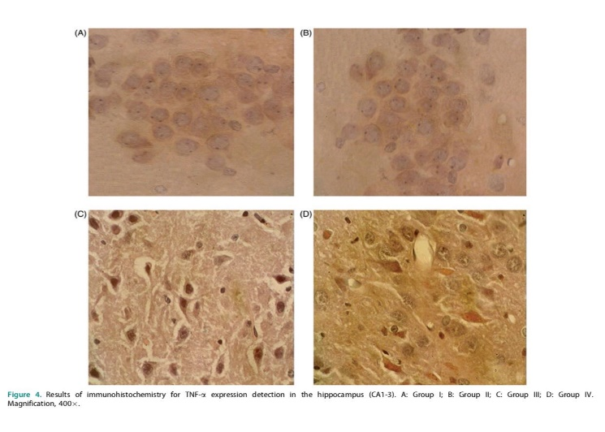
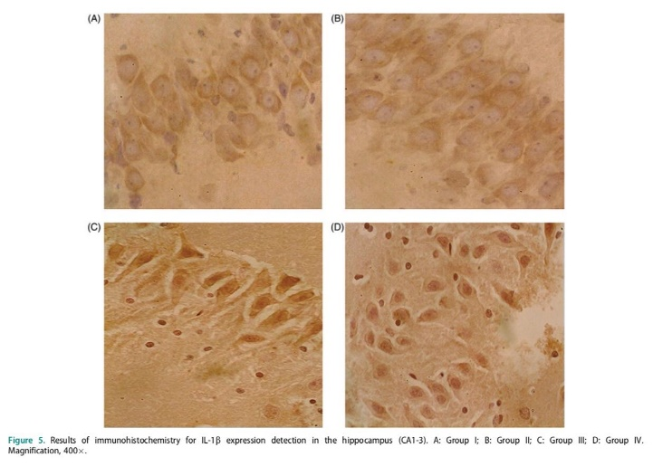
Recent Publications
- Bethea JR. 2000. Spinal cord injury-induced inflammation: a dual-
edged sword. Res Prog Brain Res. 128:33–42.
- Felderhoff-Mueser U, Taylor DL, Greenwood K, Kozma M, Stibenz D, Joashi UC, Edwards AD, Mehmet H. 2000. Fas/CD95/APO-1 can function as a death receptor for neuronal cells in vitro and in vivo and is upregulated following cerebral hypoxic-ischemic injury to the developing rat brain. Brain Pathol (Zurich). 10:17–29.
- Feng J, Wang T, Li Q, Wu X, Qin X. 2012. RNA interference against repulsive guidance molecule a improves axon sprout and neural function recovery of rats after MCAO/reperfusion. Exp Neurol. 238:235–242.
- Ferrer I, Planas AM. 2003. Signaling of cell death and cell survival following focal cerebral ischemia: life and death struggle in the penumbra. J Neuropathol Exp Neurologyneuropathol Neurol. 62:329–339.
- Fricker M, Vilalta A, Tolkovsky AM, Brown GC. 2013. Caspase inhibitors protect neurons by enabling selective necroptosis of inflamed microglia. J Biol Chem. 288:9145–9152.
- Galasso JM, Wang P, Martin D, Silverstein FS. 2000. Inhibition of TNF-alpha can attenuate or exacerbate excitotoxic injury in neonatal rat brain. Neuroreport. 11:231.
- Hao LN, Zhang QZ, Yu TG, Cheng YN, Ji SL. 2011. Antagonistic effects of ultra-low-molecular-weight heparin on Ab25-35-induced apoptosis in cultured rat cortical neurons. Brain Res. 1368:1–10.
- Harrison DC, Davis RP, Bond BC, Campbell CA, James MF, Parsons AA, Philpott KL. 2001. Caspase mRNA expression in a rat model of focal cerebral ischemia. Brain Res Mol Brain Res. 89:133.
- Inoue S, Davis DP, Drummond JC, Cole DJ, Patel PM. 2006. The combination of isoflurane and caspase 8 inhibition results in sustained neuroprotection in rats subject to focal cerebral ischemia. Anesth Analg. 102: 1548–1555.
- Jean WC, Spellman SR, Nussbaum ES, Low WC. 1998. Reperfusion injury after focal cerebral ischemia: the role of inflammation and the therapeutic horizon. Neurosurgery. 43:1382–1396.
- Kao TK, Ou YC, Kuo JS, Chen WY, Liao SL, Wu CW, Chen CJ, Ling NN, Zhang YH, Peng WH. 2006. Neuroprotection by tetramethylpyrazine against ischemic brain injury in rats. Neurochem Int. 48:166–176.
- Katz L, Ebmeyer U, Safar P, Radovsky A, Neumar R. 1995. Outcome model of asphyxial cardiac arrest in rats. J Cereb Blood Flow Metab: Off J Int Soc Cereb Blood Flow Metab. 15:1032–1039.
- Kawamoto Y, Ayaki T, Urushitani M, Ito H, Takahashi R. 2016. Activated caspase-9 immunoreactivity in glial and neuronal cytoplasmic inclusions in multiple system atrophy. Neurosci Lett. 628:207–212.
- Lever R, Page CP. 2012. Non-anticoagulant effects of heparin: an overview. Handb Exp Pharmacol. 207:281–305.
- Li J, Jiang H, Shao J. 2016. The expression of TNF-a, IL-6 and IL-1b in brain tissues of rats with cerebral ischemia reperfusion injury. J Kunming Med Univ. 37:31–35.
- Lin RJ, Green DL, Shah GL. 2018. Therapeutic anticoagulation in patients with primary brain tumors or secondary brain metastasis. Oncologist. 23: 468–473.
- Monnier PP, D’Onofrio PM, Magharious M, Hollander AC, Tassew N, Szydlowska K, Tymianski M, Koeberle PD. 2011. Involvement of caspase6 and caspase-8 in neuronal apoptosis and the regenerative failure of injured retinal ganglion cells. J Neurosci. 31:10494.
- Morita-Fujimura Y, Fujimura M, Yoshimoto T, Chan PH. 2001. Superoxide during reperfusion contributes to caspase-8 expression and apoptosis after transient focal stroke. Stroke. 32:2356–2361.
- Northington FJ, Graham EM, Martin LJ. 2005. Apoptosis in perinatal hypoxic-ischemic brain injury: how important is it and should it be inhibited? Brain Res Rev. 50:244–257.
- Ohtori S, Takahashi K, Moriya H, Myers RR. 2004. TNF-alpha and TNF-alpha receptor type 1 upregulation in glia and neurons after peripheral nerve injury: studies in murine DRG and spinal cord. Spine. 29:1082–1088.
- Paxinos G, Watson C. 1986. The rat brain in stereotaxic coordinates. San Diego (CA): Academic Press.
- Pejin B, Glumac M. 2018. A brief review of potent anti-CNS tumourics from marine sponges: covering the period from 1994 to 2014. Nat Prod Res. 32: 375–384.

Photograph

Biography
Tens of thousands of cases of anesthesia work, no patients have adverse reactions and complications. The resuscitation anesthesia of a large number of critically ill patients was successfully organized. By adhering to the principle of "never give up" until the last minute, a large number of patients were pulled back from death. He is a high-level professional and technical talent of Ningxia hui autonomous region, the director of the medical quality control center of Ningxia anesthesiology, and the person in charge of the construction of the national key clinical anesthesia department of the health department of People's Hospital of Ningxia Hui Autonomous Region.
Email: yeqingshan@hotmail.com

