Evaluation of Diaphragmatic Function after Interscalene Block with Liposomal Bupivacaine: A Randomized Controlled Trial
Aaron Berg, DO, University of Minnesota, USA

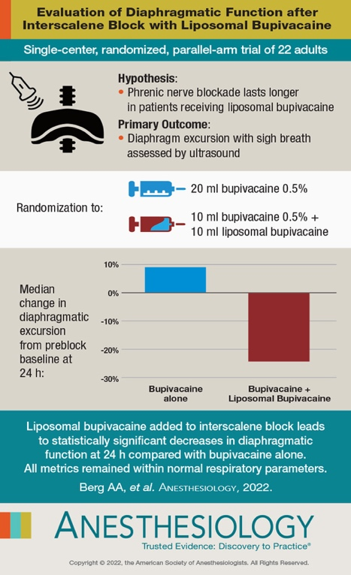

Abstract (300 word limit)
Background
Interscalene blocks provide analgesia for shoulder surgery but also cause phrenic nerve paralysis. Liposomal bupivacaine is approved for use in interscalene blocks with the potential to provide longer pain control. However, the impact of liposomal bupivacaine on the phrenic nerve has not been evaluated. It was hypothesized that patients who received an interscalene block with the addition of liposomal bupivacaine would have a decreased diaphragmatic excursion at 24h.
Methods
This was a double-blinded study of adult patients who were randomized to receive an interscalene block with either 20 ml 0.5% bupivacaine (bupivacaine group) or 10 ml 0.5% bupivacaine plus 10 ml liposomal bupivacaine. Twenty-six patients were randomized with 22 included in the analysis. Diaphragmatic excursion (via ultrasound) and spirometry were assessed before the block, in PACU, and at 24 h. The primary outcome was diaphragm excursion with sigh.
Results
At 24 h, the liposomal bupivacaine group median [25th, 75th], had a greater percent change in diaphragmatic excursion during sigh breath compared to the bupivacaine group, –24% [–30, –9] versus 9% [–8, 26], difference in location, 32 (95% CI, 12 to 52), P = 0.007. Five patients in the liposomal bupivacaine group had a greater than 25% reduction in diaphragmatic excursion at 24 h versus zero in the bupivacaine group. They also had a significantly greater percent reduction in FEV1 and FVC compared with the bupivacaine group at 24 h (median decrease of 22% vs. 2%, P = 0.006, and median decrease of 19% vs. 1%, P = 0.049, respectively).
Conclusions
The addition of liposomal bupivacaine to bupivacaine in an interscalene block results in statistically significant reductions in diaphragm excursion and pulmonary function testing 24 h after block placement when compared to bupivacaine alone. This reduction, however, falls within the range of normal diaphragmatic function.

Recent Publications
- Sommer M, de Rijke JM, van Kleef M, Kessels AG, Peters ML, Geurts JW, Gramke HF, Marcus MA: The prevalence of postoperative pain in a sample of 1490 surgical inpatients. Eur J Anaesthesiol 2008; 25:267-274
- Salviz EA, Xu D, Frulla A, Kwofie K, Shastri U, Chen J, Shariat AN, Littwin S, Lin E, Choi J, Hobeika P, Hadzic A: Continuous Interscalene Block in Patients Having Outpatient Rotator Cuff Repair Surgery: A Prospective Randomized Trial. Anesth Analg 2013; 117:1485-1492
- Ilfeld BM. Continuous Peripheral Nerve Blocks: A Review of the Published Evidence. Anesth Analg 2011; 113:904-925
- Marhofer D, Marhofer P, Triffterer L, Leonhardt M, Weber M, Zeitlinger M: Dislocation Rates of Perineural Catheters: A Volunteer Study. Br J Anaesth 2013; 111:800-806
- Vandepitte C, Kuroda M, Witvrouw R, Anne L, Bellemans J, Corten K, Vanelderen P, Mesotten D, Leunen I, Heylen M, Van Boxstael S, Van de Velde M, Knezevic NN, Hadzic A: Addition of Liposome Bupivacaine to Bupivacaine HCl Versus Bupivacaine HCl Alone for Interscalene Brachial Plexus Block in Patients Having Major Shoulder Surgery. Reg Anesth Pain Med 2017; 42:334-341

Biography
Dr Berg is an assistant professor at the University of Minnesota. After completing an anesthesiology residency at the University of Michigan, he continued his educations with a fellowship in Regional Anesthesia and Acute Pain Medicine at Minnesota and is currently the director of that fellowship. He also is involved with medical school, especially the anesthesiology rotation and serves as the medical director of the University’s west bank campus for anesthesiology. His research is focused on regional techniques, decreasing pain and ambulatory medicine looking for new ways to help prevent pain or control it.
Email: Bergx831@umn.edu

