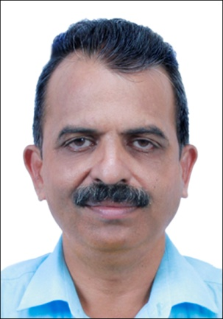

The Purpose of Temperature of Fever
K. M. Yacob (Chief Physician).
Marma Heatth Centre,Kochi ,Kerala,India

When the disease becomes threat to life or organs blood circulation decreases, Temperature of fever will emerges to increase prevailing blood circulation. And it acts as a protective covering of the body to sustain life.
When blood flow decrease to brain, the patient becomes fainted-delirious .If we try to decreases temperature of fever, the blood circulation will further reduced. Blood circulation never increases without temperature increase. Delirious can never be cured without increase in blood circulation.
The temperature of fever is not a surplus temperature or it is not to be eliminated from the body. During fever, our body temperature increases like a brooding hen`s increased body temperature.
The actual treatment to fever is to increase blood circulation. Two ways to increase blood circulation. 1. Never allow body temperature to lose 2. Apply heat from outside to the body. When the temperature produced by body due to fever and heat which we applied on the body combines together, the blood circulation increases.
Then body will stop to produce heat to increase blood circulation. And body will get extra heat from outside without any usage of energy.
How can we prove that the temperature of fever is to increase blood circulation?
If we ask any type of question related to fever by assuming that the temperature of fever is to increase blood circulation we will get a clear answer. If avoid or evade from this definition we will never get proper answer to even a single question
If we do any type of treatment by assuming that the temperature of fever is to increase blood circulation , the body will accept, at the same time body will resist whatever treatment to decrease blood circulation.
No further evidence is required to prove the temperature of fever is to increase blood circulation.

Biography

A practicing physician in the field of healthcare in the state of Kerala in India for the last 30 years and very much interested in basic research. My interest is spread across the fever , inflammation and back pain,. I am a writer. I already printed and published nine books in these subjects. I wrote hundreds of articles in various magazines.
After scientific studies we have developed 8000 affirmative cross checking questions. It can explain all queries related with fever

- Presenting author details
Full name: Yacob Mathai
Contact number:91 9847094788
Email ID: yacobkm@gmail.com

- Category: Oral presentation
- Date of Birth:10 may 1968
Postal Address
K. M. Yacob
Marma Health Centre,
kalyani Towers,
Deshabhimani,
P.O.Kaloor,
Ernakulam (Dt),
Kerala.
India
Pincode-682017
Mob: 9847094788

