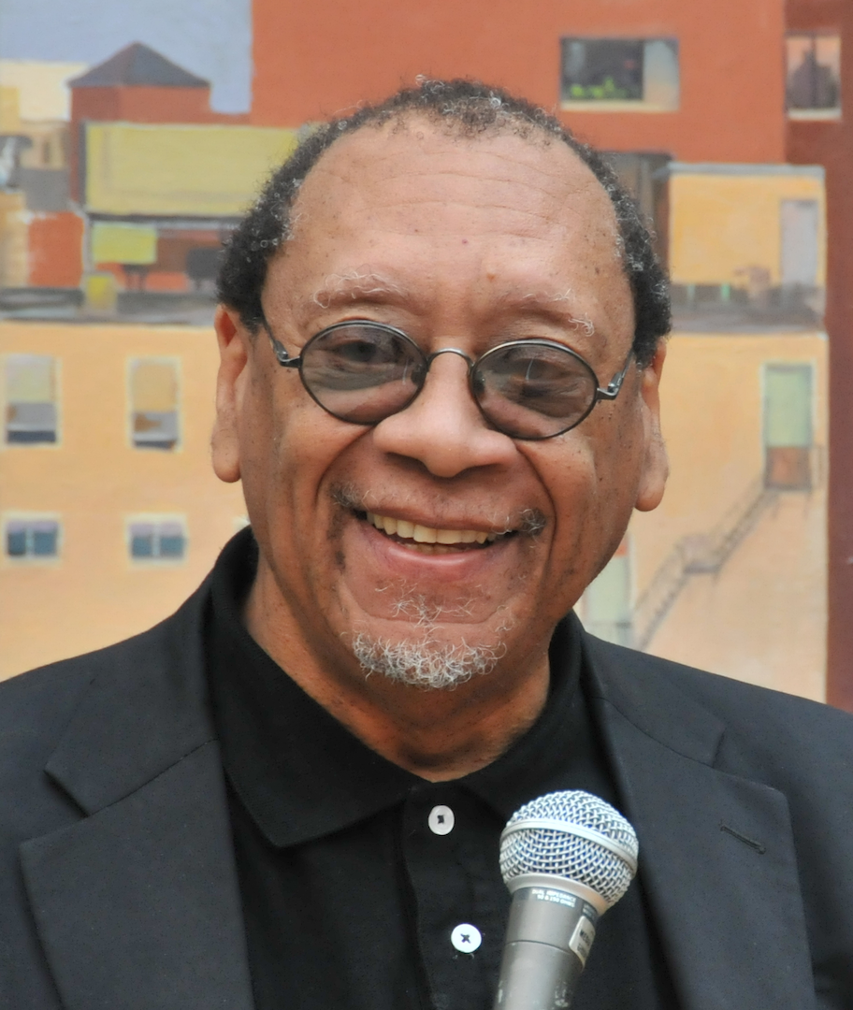

Archetypal Energies As A Humanistic Framework for Optimal Human Relations Individually and Collectively

Dr. Carroy (Cuf) Ferguson, PhD, University of Massachusetts-Boston, USA

Abstract

The focus of this presentation is to call attention to what I call Archetypal Energies in my award-winning book, Evolving The Human Race Game, and to discuss how they can be used as a humanistic framework for optimal human relations individually and collectively. The book received the 2016 Living Now Evergreen Best Book Bronze Medal Award for Spiritual Leadership. In the book, Archetypal Energies, transcending all cultures, are defined as Higher Vibrational Energies that operate deep within our psyches, at both individual and collective levels. We tend to experience them as “creative urges” to move us toward our optimal selves and optimal realities. Easily recognized terms are used to evoke a common sense of these Archetypal Energies (e.g., Trust, Love, Acceptance, Harmony, Inclusion, Patience, Wisdom, Courage, Truth). There are three types of Archetypal Energies (overall 25 of them) that establish a healthy disposition for human relations. Each Archetypal Energy has its own transcendent value, purpose, quality, and “voice” unique to the individual. To illustrate the links among Archetypal Energies and optimal human relations, I will discuss seven types of human race games we play, three of which have kept us stuck in unhealthy human relations and how we might transform them toward more optimal human relations. To assist in understanding a transition toward optimal human relations, humanistic themes and research findings will be drawn from: (a) psycho-historical information and original essays in my book, Transitions in Consciousness from an African American Perspective (e.g., Chapter 2, “Toward A Psychology of Black Mental Health”) and (b) my other writings related to choice (e.g., “The Power of ‘Yes’ and ‘No’: The Relation To Consciousness, Probable Realities, and ‘E-motions’”) and healing wounds in the psyche (e.g., “Healing Our Race-Linked Wounds”). Relevant tools and strategies for accessing Archetypal Energies will also be identified.

Publications

- Ferguson, Carroy (December 2016). Archetypal Energies As The Creative Urges Behind The Evolution Of Humanistic Psychology And Positive Psychology, Journal of Psychology and Cognition. London, United Kingdom: Allied Academies

- Ferguson, Carroy (May 2015). Healing Our Race-Linked Wounds. Anchor Magazine (Issue 3, Spring), South Boston, MA: Still Harbor.

- Ferguson, Carroy (2014; republished, 2017). Evolving The Human Race Game: A Spiritual and Soul-Centered Perspective. Tulsa, OK: Yorkshire Publishing.

- Ferguson, Carroy (March 2014). The Power of “Yes” and “No”: The Relationship To Consciousness, Probable Realities, and “E-motions.” AHP Perspective. Los Angeles, CA: Association for Humanistic Psychology.

- Ferguson, Carroy (2004). Transitions in Consciousness from an African American Perspective: Original Essays in Psycho-Historical Context. Lanham, Maryland: University Press of America.

Biography

Dr. Carroy (Cuf) Ferguson has a PhD in Psychology from Boston College. He is a tenured full professor, former dean, and currently human service program director and human service internship coordinator at University of Massachusetts-Boston. In 2006, he made history by becoming the first African American president of the Association for Humanistic Psychology, and is currently in that role again. He is an author of books and articles; a clinical practitioner; Associate Editor, Journal of Humanistic Psychology; and co-founder of two visionary organizations (Associates in Human Understanding; Interculture, Inc). His forthcoming book is titled, Living In Synchronicity: A Prequel To Evolving The Human Race Game.

Email: carroy.ferguson@umb.edu
Phone Number: 617-287-7232 (office); 857-205-1152 (cell)
Track Name: Humanistic
Type of Presentation: Oral

