Effect of Dialectical Behavior Therapy on Emotional Intelligence and Emotion Regulation of Suicidal Patients
Nazish Idrees Chaudhary, MS in Clinical Psychology (University of Central Punjab, Lahore, Pakistan)

Abstract

This study was intended to evaluate the effectiveness of dialectical behavior therapy for the enhancement in emotional intelligence and emotion regulation among suicidal patients. The following hypotheses were formulated on the basis of previous research studies- 1. Dialectical behavior therapy would increase the level of emotional intelligence among suicidal patients. 2. Dialectical behavior therapy would increase the level of emotion regulation among suicidal patients. The sample of this study was N=10, single, males and females, within the age range 20-30 years, with at least 14 years of education. The participants were diagnosed with depressive disorder with at least one suicidal attempt in the previous year. Quantitative research design, single group pre and post treatment was used. Ten sessions were conducted thrice a week for 45 minutes per session with each participant including pretest, therapy and posttest. The participants were selected by using non-probability purposive sampling. The tools of data collection were informed consent, demographic form and the following scales, Trait Emotional Intelligence Questionnaire-short form (TEI Que-SF) developed by Petrides (2003) and Emotion Regulation Questionnaire (ERQ) by Gross and John (2003). Paired sample t-test was applied to compare the difference among study variables due to dialectical behavior therapy. The differences were also significant for the increase in the level of emotional intelligence at ***P=<.001 and emotion regulation at **P=<.01 among the suicidal patients.
Keywords— Dialectical Behavior Therapy, Emotion Regulation, Emotional Intelligence, Suicidal Patients
Publication-
- Treatment Outcomes of Dialectical Behavior Therapy on the Level of Suicidal Severity and Distress Tolerance in Suicidal Patients, International Journal of Scientific and Engineering Research, Volume 8, Issue 9, September Edition 2017

Professional Biography

Nazish Idrees Chaudhary completed M.S. in clinical psychology (2016) from University of Central Punjab, Lahore, Pakistan with an honour of silver medal. She recently received an award as a token of appreciation by connected Pakistan conference August 2017 for promoting health among community voluntarily. She conducted awareness seminars, workshops, discussion groups, free mental health assessment/consultation campaigns and write blogs to eliminate stigmas/taboos associated with mental health and their victims. Her devotion started by online projects with clients around the globe as therapist, researcher/writer since 2011 at Upwork, CA. She has dealt with diverse population, provided assessment, therapeutic intervention services and improved hundreds of them. She is serving as a consultant clinical psychologist and diet advisor at Lahore Psychiatry Clinic and Khalid Clinic from last 12 months. She has done internationally certified diplomas with 150 CPD for each in Dialectical Behaviour Therapy, Nutritional and Diet Advisory & Couples/Family Therapy.

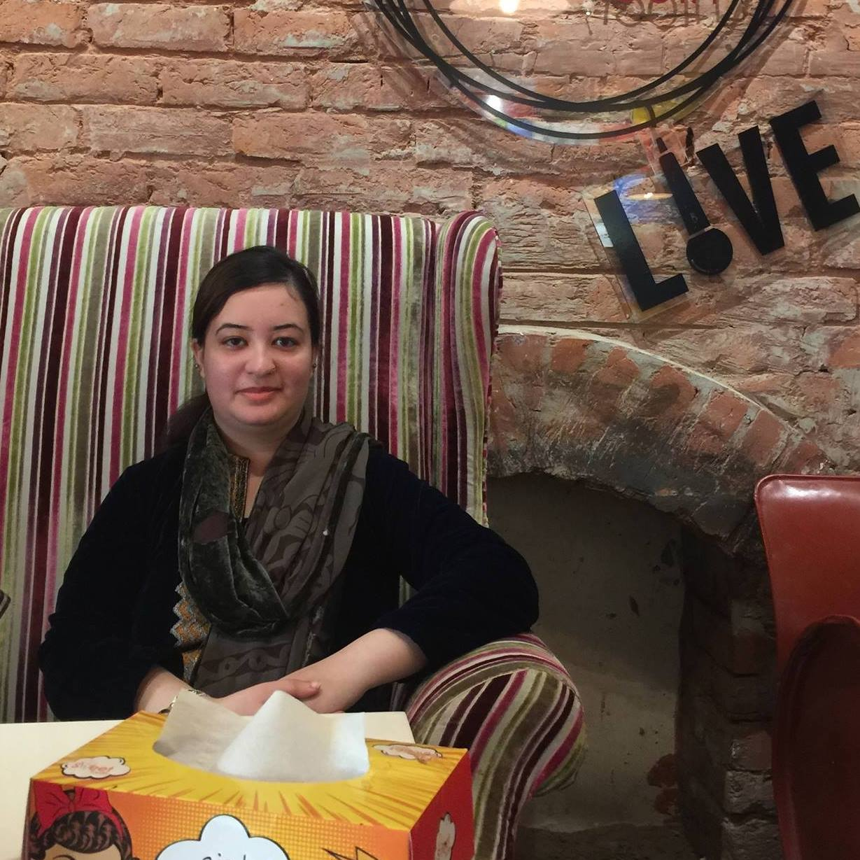

Email Id: nazsha38@gmail.com
Ph-+923224578326
University of Central Punjab

Any Comments:
It would be my pleasure to provide further information in the case of need.

