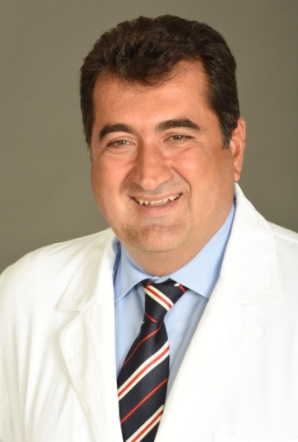

Paste your Logo here

Title: Fertility sparing surgery in early stages of cervical cancer
Name Professor Aleksandar Stefanović, MD PhD
Fertility sparing surgery in early stages of cervical cancer – the new standard of care

The concept of fertility-preserving surgery in early cervical, radical trachelectomy with stage IA2 or IB disease. Trachelectomy is a conservative oncologic operation with aim to preserve fertility in early stages of cervical cancer female patients that have realized reproduction. Excised structures in trachelectomy are: cervix, upper 1/3 of vagina, parametria and paracolpia, with preservation of uterine corpus. After removing the vaginal fornix and cervix , uterovaginal anastomosis with non resorptive suture is performed. Indications for trachelectomy are <. patients up to 45 years of age who wish to conserve fertility with negative lymph nodes, no distant metastatic disease , FIGO stage cervical cancer staged IA1, IA2, IB1 (tumour size ≤ 2cm with negative lymph nodes ), with adequate cervical length, no evidence of expansion of malignant process on the upper part of the cervical canal, squamocelular carcinoma, rarely cervical adenocarcinoma , negative lymph nodes intraoperatively, no metastatic disease, clear resected margins. There is an ongoing debate regarding the need for uterine vessels preservation. Some authors have proved that the preservation of the uterine artery is associated with more favorable restoration of the reproductive function. Others claim that preservation of the uterine vasculature is not necessary for fertility as obstetrical outcomes are similar to those of the historical vaginal radical trachelectomy cohorts. Simple trachelectomy as alternative to radical trachelectomy in selected cases (parametrial involvement rate < 1% in patients with IB1 ≤ 2cm, negative lymph nodes and stromal invasion ≤ 10mm )

Biography
Born 11.01.1963 in Belgrade, capital of Serbia, and finished Medical School University of Belgrade (1977),
M.D. (1995) PhD ( 1996). and academic special studies gynecology and obstetrics (1994)
25 years of clinical experiences, working at Clinic for Gynecology & Obstetrics Clinical Centre of Serbia, which is the biggest one in whole region, as gynecologist for 18 years.
My present position at the Clinic is Director (chairman) of Clinic for Obstetrics and Gynecology, Clinical Center of Serbia,
President of Association of gynecologists and obstetricians of Serbia, Montenegro and Republic Srpska, official FIGO member.
Dean of Medical Faculty, University of Belgrade, Serbia
-President of Expert Committee for Cervical Carcinoma Prevention and Control, also Member of Advisory Board for the implementation of Screening and Early Detection of Breast, Cervical and Colorectal Carcinoma Program, Author of National Good Practice Guidelines for Diagnosis and Treatment of Cervical Carcinoma, -Member of Multidisciplinary Team for Gynecologic Oncology, Clinic for Obstetrics and Gynecology, Clinical Center of Serbia
Representative publications is about 50 publications in CC/SCI expanded and JCR indexed, and active participant on more than 50 international congresses, with total number of publication about 150.

