Title: Digital model of the cancer cell

Zarko Vrbica
University of Dubrovnik, Dubrovnik, Croatia

The similarities between the human/cancer cell and a theoretical biological computer are presented, challenging the actual view on the cancer cell actions as random processes. The hypothesis is that cancer cell is behaving as a biological computer with programmed actions. In this model, the human cell is biological computer consisting of the input units in the cell membrane, analog/digital converters in the cytoplasm and digital processing unit in the nucleus. The result of that processing is than converted through digital/analog converters (mRNA), activating different processes in the cytoplasm or leading to the synthesis of new molecules. Normal versus erratic cell function could be compared to normal versus erroneous computer program. That program should be in the “non-coding” DNA. The permanent termination can be achieved only by blocking the program code. We have to find which part of the program code is active in cancer cell and with methods of reverse engineering find the solution to correct/debug/stop that program from execution. Tailoring research based on that premise with the tools used in analyzing the unknown program code and modified to a biological system could lead to better understanding and treatment of cancer.
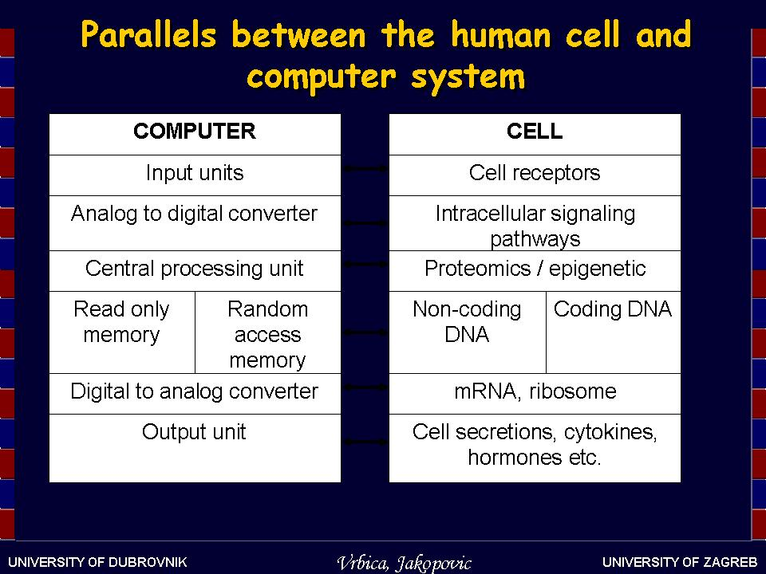

Recent Publications
- Vrbica Z, Jakopovic M (2015) Digital model of the cancer cell – is this the time for us to debug/reprogram the cancer cell? Croat Med J. 2015;56:578-80

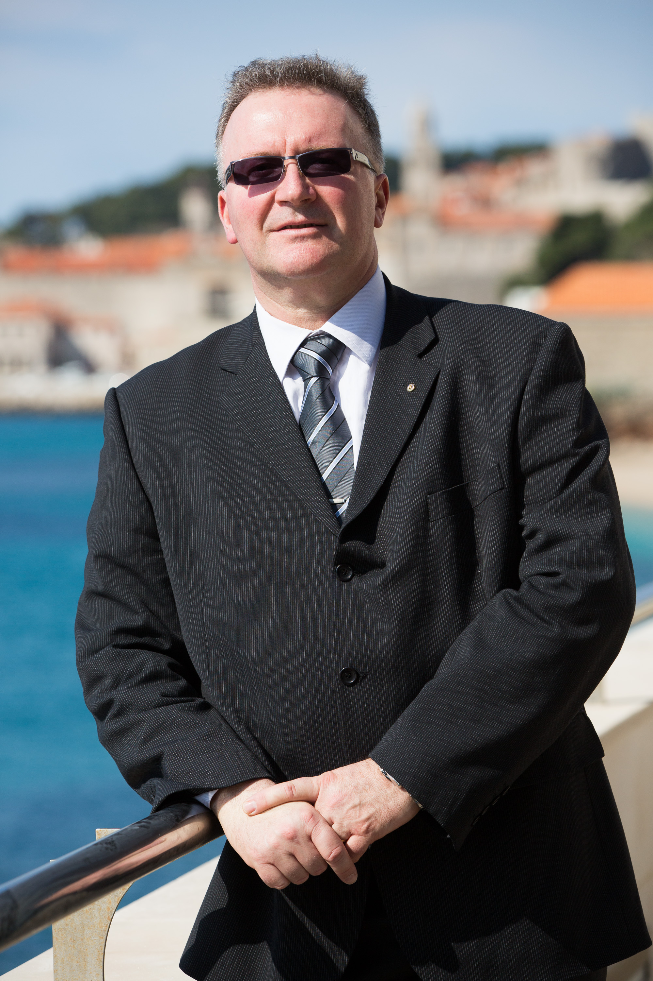

Biography
Zarko Vrbica is working as a pulmonologist in Dubrovnik General Hospital. His fields of interest are lung diseases and especially lung cancer. He has a master degree in immuno-oncology. Last few years he has formed and published the hypothesis that cancer cells are functioning as a biological computers with artificial intelligence program fighting against our efforts to control them. This hypothesis has a propensity to change our view on cancer cells with important effect on the way we should treat the cancer. His mission is to spread this idea to colleagues working in the same field in hope to improve the results of our battle with cancer.

Email: zvrbica@yahoo.com
Notes/Comments:

