NAUSEA AND POSTOPERATIVE VOMITING IN PATIENTS SUBMITTED TO BREAST SURGERY AT THE AMBULATORY SURGERY UNIT OF THE NATIONAL INSTITUTE OF CANCEROLOGY.
Dr. Giancarlo Ferretiz López.
Instituto Nacional de Cancerologia, MEX.

Abstract
Introduction: Postoperative nausea and vomiting (PONV) are a frequent problem in surgical patients, with an incidence of 50% and 30% respectively. In patients with the risk of presenting this complication, the incidence of up to 80% can be increased. PONV can prolong the length of stay in the postoperative recovery unit with the time of surgery. Each episode of vomiting can increase the stay in a postoperative recovery unit by 20 minutes. Objective: Evaluation of the incidence of postoperative nausea and vomiting in the patient in outpatient surgery of the mother in the ambulatory surgery unit of the National Cancer Institute.
Material and Methods: An observational, analytical, cross-sectional and retrospective study was carried out in which the clinical files of the patients of the National Institute of Cancerology were reviewed and a surgical procedure with the diagnosis of breast cancer in the ambulatory surgery a period comprised between May 1 and October 15, 2017. Results: 165 women were included, with an average age of 52.8 ± 11.2 years, 154 were graduated from home (93.4%), the remaining 11 patients (6.7%) required hospitalization for pain (4.2%), pain and hematoma ( 1.8%) and re-intervention (0.6%), none for PONV. A history of nausea and vomiting was observed in 21.2%. Only 3 patients presented with postoperative nausea and vomiting (1.8%). The antiemetic treatment is applied in all patients with a combination of any of the drugs (metoclopramide, dexamethasone and ondansetron). Conclusion: In our study we observed a very low rate of PONV and it was possible to demonstrate that, in an ambulatory surgery unit, the pre-medication prior to the surgical event in patients with breast cancer significantly decreases the presence and control of nausea and vomiting post operative improving comfort during your hospital stay and your immediate discharge.


Image
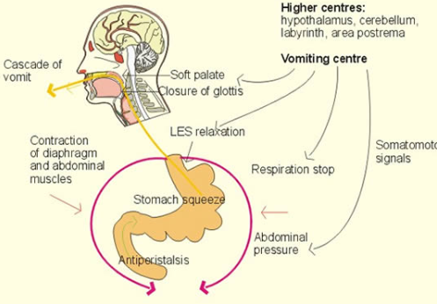
Recent Publications
- Berger MJ, Ettinger DS, Aston J, Barbour S, Bergsbaken J, Bierman PJ, et al. NCCN Guidelines Insights: Antiemesis, Version 2.2017. J Natl Compr Cancer Netw. 2017;15(7):883–93.
- Roila F, Molassiotis A, Herrstedt J, Aapro M, Gralla RJ, Bruera E, et al. 2016 MASCC and ESMO guideline update for the prevention of chemotherapy- and radiotherapy-induced nausea and vomiting and of nausea and vomiting in advanced cancer patients. Ann Oncol. 2016;27:v119–33.
- Kaye AD, Cornett EM, Chalabi J, Naim NZ, Novitch MB, Creel JB, et al. Pharmacology of Antiemetics: Update and Current Considerations in Anesthesia Practice. Vol. 35, Anesthesiology Clinics. 2017. p. e41–54.
- Hesketh PJ, Bohlke K, Lyman GH, Basch E, Chesney M, Clark-Snow RA, et al. Antiemetics: American Society of Clinical Oncology focused guideline update. J Clin Oncol. 2016;34(4):381–6.
5. Chelkeba L, Gidey K, Mamo A, Yohannes B, Matso T, Melaku T. Olanzapine for chemotherapy-induced nausea and vomiting: Systematic review and meta-analysis. Pharm Pract (Granada). 2017;15(1).




Biography
Medical Anesthesiologist-oncologist and Pain management, interested in continuing education to new generations of anesthesiologists on the importance, relevance and new evidence of knowledge and necessary considerations of all oncological patients scheduled to oncological and non-oncological surgery to develop the ideal anesthetic plan to prevent side effects (vomiting nausea or pain in the post operative) improving its evolution and timely discharge. We will know the methods and procedures performed by the oncology anesthesiology service at the National Cancer Institute of Mexico.

Email: dcferretiz@hotmail.com

Notes/Comments:

